Flight Performance Data Logging System

Group #9
Winston James
Brian Lichtman
Shaun Mosley
Tony Torres

Sponsored by L-3 Communications
Table of Contents
List of Figures v
List of Tables vii
1. Executive Summary 1
2. Project Description 2
2.1. Project Motivation 2
2.2. Goals and Objectives 2
2.3. Project Requirements 3
2.4. Project Specification 4
3. Research Related to Project Definition 9
3.1. Existing similar projects and products 9
3.2. Relevant Technologies 10
3.3 Basics of Flight 11
3.3.1 The Angle of Attack (AOA) 11
3.3.2 Dynamic Pressure – q 16
3.3.3 Force Coefficients 18
3.3.4 Moment Coefficients 25
3.4 Data Acquisition Method 29
3.4.1. In-flight Data Obtained Directly 30
3.4.2. Calculated Values Obtained Indirectly 30
3.5 Microcontroller Selection 31
3.6 Analog I/O Connectivity Design 36
4. Project Hardware and Software Design Details 39
4.1. Initial Design Architecture 39
4.2 Unmanned Aerial Vehicle (UAV) Design 40
4.3. Data Gathering Subsystem 40
4.3.1. Analog signals 42
4.3.2. Serial Peripheral Interface (SPI) 43
4.3.3. Inter-Integrated Circuit (I²C) 44
4.3.4. Data sampling 44
4.3.5. Updates to Data Gathering Subsystem 49
4.4. Data Storage Design 49
4.4.1 Memory Usage 49
4.4.2. Data Storage Method 52
4.4.3. SD Data Storage 53
4.4.4. SD Card Integration 56
4.4.5 File System I/O Library Setup 59
4.4.6. File System I/O Library Use 63
4.5. UAV Controls Subsystem 65
4.5.1. Autopilot 65
4.5.2 Manual Flight Override 74
4.6 User Interface Software Subsystem 74
5. Design Summary of Hardware and Software 75
5.1 Hardware 75
6. Project Prototype Construction and Coding 87
6.1. Various Sensor Details 87
6.1.1. 3-Axis Gyroscope 88
6.1.2. 3-Axis Accelerometer 91
6.1.3. Rotary Position Sensors 93
6.1.4. Humidity Sensor 95
6.1.5. Temperature sensor 96
6.1.6. Barometric pressure sensor 98
6.1.7. Differential pressure sensor 100
6.1.8. Force sensor 101
6.1.9 Assembly Production Updates and Changes 104
6.2. System Output 105
6.3. Software Functionality 106
6.3.1 Program Life cycle 107
6.3.2 Functions 113
6.3.3 Data Structures 114
6.3.4 Supplemental software 117
7. Project Prototype Testing 118
7.1 Hardware Test Environment 118
7.2 Software Specific Testing 119
7.3 Data Verification 120
7.3.1 MicroSD Card Data Verification 120
8. Operation Manual 122
8.1. Successfully Operating the FDL 122
9. Administrative Content 123
9.1. Project Milestones 123
9.2. Budget and Finance 125
10. Summary and Conclusion 128
Works Cited 129
Permission Emails 134

List of Figures

Figure 1: Force Axes 12
Figure 2: Rotational Axes 12
Figure 3: Axes Orientation 13
Figure 4: Aircraft Symmetry 13
Figure 5: Angle of Attack Relative to the Wing 14
Figure 6: Fighter Jet with AOA/AOS Boom 15
Figure 7: One of Space Age Control booms 15
Figure 8: Pitot-tube 17
Figure 9: Cambered Airfoil Forces Diagram 18
Figure 10: Coefficient of Lift Reference Area 19
Figure 11: Airplane Components and Functions 21
Figure 12: Force on Wing 22
Figure 13: Force Interference 22
Figure 14: Lift Relative to Vertical Force 24
Figure 15: Engine Thrust 28
Figure 16: Microchip Technologies' Microcontroller Product Selection Tool 35
Figure 17: Hardware Diagram 39
Figure 18: SPI Pin layout of a microSD card 57
Figure 19: Heap Setup Options 61
Figure 20: Library Include Paths 62
Figure 21: Attopilot Version 2.0 Control Unit 66
Figure 22: Attopilot Installed on Plane 67
Figure 23: Attopilot Computer Software 69
Figure 24: Path of an Airplane Using Autopilot 70
Figure 25: Piccolo Autopilot System 71
Figure 26: Attopilot Cube Control Unit 72
Figure 27: GUI Interface 74
Figure 28: Power Supplies 75
Figure 29: Accelerometer 76
Figure 30: Gyroscope 77
Figure 31: Angle Sensors 78
Figure 32: Force Sensors Circuit 79
Figure 33: Humidity Sensor 80
Figure 34: Microcontroller 81
Figure 35: SD Card Connector 82
Figure 37: Altitude Sensor 83
Figure 37: Gyroscope Data Reading Process 90
Figure 38: 3-Axis Gyroscope Schematic 91
Figure 39: Accelerometer Schematic 92
Figure 40: Manufactured Angle-of-Attack Sensor 94
Figure 41: Angle Sensors Schematic 94
Figure 42: Humidity Sensor Schematic 96
Figure 43: Temperature Schematic 98
Figure 44: Barometric Pressure Sensor Schematic 100
Figure 45: Differential Pressure Sensor Schematic 101
Figure 46: Force Sensor Output Chart 102
Figure 47: Force Sensor Schematic 103
Figure 48: 3D representation of manufactured PCB Board 105
Figure 49: Waterfall model diagram 108
Figure 50: Spiral model diagram 109
Figure 51: Iterative model diagram 110
Figure 52: Software Data Structures 116
Figure 53: Rotation Matrix Equations 117
Figure 54: Cost Totals Percentage Breakdown 127

List of Tables

Table 1: AeroMatic and DATCOM Abridged Inputs and Outputs Table 8
Table 2: List of Different Booms 16
Table 3: DATCOM Parameters 20
Table 4: Side Force Coefficient 25
Table 5: DATCOM Parameters in Detail 29
Table 6: Data Retrieval Order 45
Table 7: Estimated System Sample Time 46
Table 8: Microcontroller Pin Layout 48
Table 9: Specifications of SD cards of Standard Formats 54
Table 10: Specifications of SD cards of High-Capacity Formats 55
Table 11: Specifications of SD cards of SD Extended Capacity Formats 55
Table 12: Setup to use SPI4 with the memory disk drive file system library 60
Table 13: Sensor Read Order 64
Table 14: Sensor Data Output Characteristics 102
Table 15: Future Milestones 124
Table 16: Plane Parts List 125
Table 17: Autopilot Parts List 125
Table 18: Sensor Parts List 126
Table 19: Other Parts List 126
Table 20: Part List Totals 127

1. Executive Summary

This paper describes a senior design project which investigates a means to verify the accuracy of the United States Air Force Stability and Control Digital DATCOM software for L-3 Communications. L-3 Communications is a defense contractor which designs and supplies simulation and training equipment to many of the United States’ military divisions. Currently, L-3 Communications uses DATCOM to retrieve an aircraft’s coefficients of flight based on its geometry. They then use these outputs to simulate test flights in software such as FlightGear Flight Simulator. However, L-3 Communications as well as many other leading defense contractors face a common conundrum, how do they know their simulator is providing feedback equivalent to that of the actual aircraft in flight. L-3 Communications has informed us that the currently accepted method is to hire a trained pilot to fly the simulator to determine if it is performing as expected. This method tends to inefficient and not cost effective. While many times the software does prove accurate, it has never thoroughly been tested on small aircrafts, specifically, Unmanned Aerial Vehicles (UAVs). Therefore, in this paper, we describe our design of a method to record live data from a UAV in flight in order to obtain the coefficients computed by DATCOM. Our collected data is then compared with those of the DATCOM software to determine the software’s accuracy for UAVs. Due to unforeseen circumstances, our software designer is going to submit software specifications separately. If any section makes a statement regarding software behavior or any software references, they can be temporarily dismissed.

2. Project Description

L-3 Communications has expressed the ability to predict the performance of an aircraft based on data about the geometry of an aircraft, called the geometry sample. From this sample, L-3 Communications creates a simulation model of that particular aircraft for tasks such as the training of pilots. L-3 Communications would like real-time data about the performance of a UAV in flight so that they can compare real-time in-flight performance data with the predicted performance data based on their geometry technique. Therefore L-3 Communications has provided our group with data to perform the comparison, as well as fund the project as long as the costs are justifiable.

2.1. Project Motivation
The primary motivation for this project starts with the sponsor, who wishes to produce a viable, and accurate, innovative means of predicting the performance of an aircraft in flight without putting the aircraft in flight. This would eliminate the use of resources such as flight time, plane fuel, and providing a low-risk testing environment that ensures the safety of the plane, the public and the pilot.

The secondary motivation for this project comes in the form of technical expertise from the research and design team comprised of 3 computer engineering students (Brian, Tony, and Shaun) and an electrical engineering student (Winston). Winston specialized in the hardware portion of this project, Brian pursued the interfacing of the hardware and software components, Tony developed the applications that read the data from the hardware, and Shaun dedicated himself to the programming integrated circuits on the hardware

2.2. Goals and Objectives
Our goal was to produce a low-cost, portable, lightweight, & accurate product that is general enough to be capable of being installed in various aircrafts (military, commercial, even R/C models). Our product is responsible to measure various parameters that determine the flight characteristics of that aircraft such as thrust, lift, and accelerations about various axes. The in-flight parameters, in addition to the geometry parameters crucial to this project are listed later in a large table.

Our objective is therefore to populate a printed circuit board (PCB) with sensors, digital signal processing (DSP) and micro-controlling capabilities, GPS, and provide software application that programs that PCB to be able to provide:

  - Mixed Flight (manual and automatic) control.
    - Manual flight is possible via the R/C transmitter given the plane is in the range of it.
    - Automatic flight requires a flight profile of the path that is followed via GPS. Piccolo, the R/C autopilot L-3 Communications proposed, is too expensive and not used. Cheaper alternatives are still being explored.
  - Relayed flight data (altitude, pressure, force, various accelerations, etc.) to:
    - A ground receiver on a laptop or other viewing display with recording capabilities.
    - On-board memory (in the case that the plane is out of range of the ground station)
  - Flight data logger must be versatile
  - Collect as much live data as is possible. This leads to better comparisons later
  - Sponsored aircraft must be small unmanned aerial vehicle (UAV), but big as is feasible under budget.
  - Extract from the excel spreadsheets L-3 Communications provided, the physical parameters that the hardware must measure in real-time, and equivalently software must be prepared to process.

2.3. Project Requirements
Our sponsor decided that the requirements and specifications were best left to our choosing. After brainstorming idea after idea, we created a set of strict requirements to test our design. The list of requirements as follows:
- Ability to record data at speeds of up to 60 Hz
- PCB board dimensions should be no bigger than 6” x 5” x 1”
- Aircraft should be able to fly for at least 20 minutes while recording data
- Test vehicle must have a wingspan larger than 3 feet
- Must not have more than ½lb weight offset to one side
- Cost must be under $1500.00
- Must be complete and fully functional by December 15, 2011

As described before, we are tasked to design a versatile system which can measure live flight data of a small unmanned aircraft. We have been asked to collect as much in flight data as possible which shall be compared to the outputs of the simulation software used by our sponsor, L-3 Communications. As such, L-3 has provided us with several excel spreadsheets which provide the inputs as well as the outputs of their software collection. From this we have formulated the list of data we are collecting. The values from these spreadsheets are listed below.
As for how high the plane must fly, how long, and how far, L-3 Communications has not decided on these specifications because they want to do a cost analysis of the types of airplanes and sensors that are available as these materials can range vastly in price. After we collected a list of prices and specifications of different models of aircraft and sensors, they made a decision as to how much they were willing to spend.

2.4. Project Specification
As stated earlier, the United States Air Force Stability and Control Digital DATCOM is the software L-3 Communications uses to calculate in-flight data characteristics via simulation. In the following two tables we have listed an abridged list of the specifications provided to us by L-3. The main applications of interest we are comparing our data to are Aeromatic and Datacom.

AeroMatic Input |  | AeroMatic Output |  | AeroMatic Input |  | AeroMatic Output
 |  |  |  | # engines |  | speedbrake control
[engine config] |  | empty weight |  | engine type
engine type |  | CG location (x,y,z) |  | engine layout |  | CL (alpha)
horsepower,# |  | ? (X,Y,Z) (CENTER OF PRESSURE?) |  | yaw damper
afterburning |  | pilot eye location (x,y,z) |  |  |  | CL(elevator deflection)
water injection |  | landing gear nose specs |  |  |  | dCL(flap)
 |  | left landing gear specs |  | AeroMatic Output |  | dCL(speedbrake)
[propeller config] |  | right landing gear specs
engine power, # |  | engine location (x,y,z,pitch, yaw, feed) |  | generated in file (..._engine.xml) |  | Zero lift drag
rpm, # |  | thrust location (x,y,z,pitch,yaw) |  | milthrust |  | Induced Drag
pitch |  | fuel tank0 size and location (x,y,z,radius, capacity, contents) |  | max thrust |  | CD(mach)
propeller dia, # |  | fuel tank1 size and location (x,y,z,radius, capacity, contents) |  | bypass ratio |  | CD(flap)
 |  | pitch trim |  | idleN1 |  | CD(gear)
[aero config] |  | elevator control |  | MAXN1 |  | CD(speedbrakes)
aircraft type |  | roll trim |  | MAXN2 |  | CD(Sideslip)
TO weight, # |  | left aileron control |  | thrust coeff |  | CD(elevator deflection)
wingspan, # |  | right aileron control |  | idle power thrust factor vs. vel and postion
plane length,# |  | rudder command |  | military power thrust factor vs. vel and |  | Cy(beta)
AeroMatic Input |  | AeroMatic Output |  | AeroMatic Input |  | AeroMatic Output
wing area,# |  | rudder control |  | c_thrust (table) |  | Cm(elevator)
landing gear |  | flaps control |  | c_power (table) |  | Cm(pitch rate)
retractable |  | gear control |  | generated in file (..._aero.xml) |  | Cm(a dot)
 |  | roll moment, Cl, due to beta |  | horizontal tail area
generated in file (..._prop.xml) |  | Cl(roll rate) |  | horizontal tail arm |  | Yaw moment, Cn, due to beta
linear blade inches |  | Cl(yaw rate) |  | vertical tail area |  | Cn(yaw rate)
Ixx |  | Cl(aileron) |  | Ixx
min pitch |  | Cl(rudder) |  | Iyy
max pitch |  |  |  | Izz |  | Cn(rudder)
min rpm |  | Pitch moment,Cm, due to alpha,a |  | Ixz |  | Adverse Yaw
max rpm |  | Pitch moment, Cm, due to beta, b
Datcom Inputs | Comments |  | Datcom Inputs (Continued) |  | Comments
[flight conditions] |  |  | THSTCP |  | thrust coeff
NMACH | # of Mach numbers to test (max 20) |  | PHALOC |  | location of prop hub
MACH | Specific mach numbers to use (max 20) |  | PHVLOC
NALT | # of alttitudes to test (max 20) |  | PRPRAD |  | prop radius
ALT | Specific alttitude numbers to use (max 20) |  | BWAPR3 |  | prop blade width at .3 radius
NALPH | # of angles of attack to test (max 20) |  | BWAPR6 |  | prop blade width at .6 radius
ALSCHO | Specific angle of attack numbers to use (max 20) |  | BWAPR9 |  | prop blade width at .9 radius
WT | vehicle weight |  | NOPBPE |  | # prop blades per engine
GAMMA | flight path angle |  | BAPR75 |  | prop blade angle at .75 radius
LOOP | programming looping control 91=test alt+mach together, 2=mach w/fixed alt, 3=alt w/fixed mach) |  | YP |  | lateral location of engine
*VINF | values of freetsream speed |  | CROT |  | counter rotating prop (TRUE or FALSE)
*HYPERS | if typed=true and hypersonic analysis done at all mach numbers>1.4 |  | [jet] |  | JET ENGINE
*STMACH | subsoninc test mach # limit (between .6 and .99) DEFAULT = 0.6 |  | AIETLJ |  | incidence angle of engine thrust
*TSMACH | supersonic test mach # limit (between 1.01 and 1.4) DEFAULT=1.4 |  | NENGSJ |  | # engines
*TR | transition (0.0 for no transition (default) and 1.0 for transition)-for drag calculation |  | THSTCJ |  | thrust coeff
*[options] |  |  | JIALOC |  | location of jet engine
*ROUGFC | surface roughness factor DEFAULT=.00016in |  | JEALOC
*SREF | wing area |  | JIEVLOC
*CBARR |  |  | JELLOC
*BLREF | wingspan |  | JINLTA |  | jet inlet area
[aero config] |  |  | JERAD |  | jet exit radius
 |  |  | JEANGL |  | jet exit angle
[craft layout] |  |  | JEVELO |  | jet exit velocity
XCG | center of gravity location |  | AMBTMP |  | ambient static temp
ZCG |  |  | AMBSTP |  | ambient static pressure
XW | wing appex location |  | JESTMP |  | jet exit static temp
ZW |  |  | JETOTP |  | jet exit total pressure
ALIW | wing angle |  | Datcom Output |  | Comments
XH | horizontal tail location
ZH |  |  | PINF |  | pressure in freestream
XV | vertical tail location |  | TINF |  | temp in freestram
ZV |  |  | RNNUB
ALIH | horizontal tail angle
VERTUP | vertical panel above reference plane (TRUE=DEFUALT) |  | CL_Total |  | • Total Lift Coefficient due to:
[body dimension] |  |  | CLα |  | CL from Basic geometry
NX | # X locations/segments |  | CLδf |  | CL from Flap deflection
X | specific x locations |  | CLδe |  | CL from Elevator Deflection
R, P, S | half-width and/or periphery and /or area at each x |  | CLq |  | CL from Pitch Rate derivative
ZU | distance to upper body surface |  | CLαdot |  | CL from Angle of Attack Rate derivative
ZL | distance to lower body surface |  | Cd_Total |  | • Total Drag Coefficient due to:
[airfoils] |  |  | Cdα |  | Cd from Basic geometry
NACA speficied |  |  | Cdδf |  | Cd from Flap deflection
User defined (upper and lower surfaces and spefic points or man chord line and thickenss distribution at specific points) |  |  | Cdδe |  | Cd from Elevator deflection
[wing and tail specs] | need for wing, h tail, and v tail |  | Cy_Total |  | • Total Side Force Coefficient due to:
CHRDTP | chord at wing tip |  | Cnβ |  | Cy from Sideslip
CHRDR | chord at wind root |  | Cnp |  | Cy from Roll Rate derivative
SSPNE | semispan exposed panel length |  | Cnr |  | Cy from Yaw Rate derivative
SSPN | theoretical semispan exposed panel length |  | Cm_Total |  | • Total Pitching Moment Coefficient due to:
SAVSI | inboard sweep angle |  | Cmα |  | Cm from Basic geometry
CHSTAT | reference chord station (0.25) |  | Cmδf |  | Cm from Flap deflection
TWISTA | twist angle |  | Cmδe |  | Cm from Elevator deflection
DHDADI | dihedral angle |  | Cmq |  | Cm from Pitch Rate derivative
TYPE | wing shape (1=straight tapered, 2=delta,3=cranked) |  | Cmαdot |  | Cm from Angle of Attack Rate derivative
 |  |  | Cl_Total |  | • Total Rolling Moment Coefficient due to:
[Aileron, Wing Flaps, and Elevators] |  |  | Clδa |  | Cl from Aileron Deflection
NDELTA | # of deflectionangles to test |  | Clβ |  | Cl from Sideslip
DELTA | specific deflection angles |  | Clp |  | Cl from Roll Rate derivative
SPANFI | dimension of flap |  | Clr |  | Cl from Yaw Rate derivative
SPANFO |  |  | Cn_Total |  | • Total Yawing Moment Coefficient
CHRDFI |  |  | (Cyδa) |  | Cn from Aileron deflection
CHRDFO |  |  | (Cyβ) |  | Cn from Sideslip
NTYPE | nose type (1=round, 2=elliptical, 3=sharp) |  | v(Cyp) |  | Cn from Roll Rate derivative
CB | average balance chord |  | (Cyr) |  | Cn from Yaw Rate derivative
TC | average thickness |  |  |  | • Misc
PHETE | tangent of arifoil trailing edge angle 90-99%chord |  | ε |  | Horizontal Tail Downwash Angle
PHETEP | tangent of arifoil trailing edge angle 95-99%chord |  | δε/δα |  | Derivative of Downwash Angle
 |  |  | Chα |  | Elevator-surface hinge-moment derivative with respect to alpha
[power] | prop or jet but not both (no turboprop) |  | Chδ |  | Elevator-surface hinge-moment derivative due to Elevator deflection
[prop] | PROPELLER ENGINE |  |  |  | All above values calculated using a stability axis system
AIETLP | incidence angle of engine thrust |  | CN |  | Normal force coefficient (body axis)
NENGSP | # engines |  | CA |  | Axial force coefficient (body axis)
Table 1: AeroMatic and DATCOM Abridged Inputs and Outputs Table

3. Research Related to Project Definition

3.1. Existing similar projects and products
Our project is to get a unique set of force and torques measurements of an aircraft, and from our research we have not come across products or projects that does exactly what we’re pursuing, however we have come across products or projects that does a particular part of what we’re pursuing. For instance, one of the goals of our project is to measure the discrete distribution of pressure over an aircraft, so that we may have real-time measurements of forces, torques and pressures. We are planning to use relatively low cost piezoelectric sensors placed at discrete locations over the surfaces of the aircraft.
There are some wind tunnel experiments that aim measuring pressure distributions, and a common and novel method employs a small-scale model of an actual airplane like we do, coated in pressure sensitive paint (PSP). They generate a continuous pressure distribution over the aircraft’s entire surface by coating the entire plane’s surface, and utilize the principle of molecular luminescence by emitting for example ultraviolet light on the plane and measuring how much red light is emitted (1). We do not however have the budget to purchase pressure paint, the optical equipment and software, and a wind tunnel and all the other equipment to utilize this method of measuring pressure distribution. Besides, we want get the pressure distribution in actual flight and during various maneuvers, where the plane experiences up- and down-drafts or air, and air of various moisture levels, temperature, altitudes, and densities. PSP paint also doesn’t meet our requirement for a general method for instrumenting an aircraft, because after an aircraft is completely painted it’s not very simple to remove it. Thus PSP experiments are similar to our project in a sense but not exactly it.
Another thing that we found similar to our project was equipment from a company called Alpha Systems AOA with mechanical and electrical kits from $500-$1150 that simply measured AOA on an aircraft. This is just one parameter our project requires, and we neither can afford the equipment, nor does it meet our requirement for being lightweight and cheap, and removable from one plane or the other. Our project measures AOA in much the same way as their equipment in that we utilize a differential pressure sensor, Pilot-tube, and the Bernoulli principle.
Lastly the closest that we’ve come to something that approximated our project was the Autopilot systems that we research to fly our small-scale drone. Our own autopilot; the ArduPilot Mega uses much of the same parts that we utilize in our design: such as a 3D gyroscope and 3D accelerometer, Bosch barometric sensor, and optional airspeed sensor. Our design has expanded upon some autopilot’s features. The autopilot is ready to record flight paths but we record aircraft data throughout the flight path. It’s ready to measure airspeed, but we do that more accurately knowing our AOA and other crucial flight parameters. The accelerometer and gyroscope can measure the effects of net forces, pressures, and torques, but we’ll measure the distribution of forces, pressures, and torques that contribute to their respective net effects. Our microcontroller is also more powerful and prepared to do a lot more than our autopilot is capable or than our researched and rejected $5000 Kestrel autopilot’s processor is capable (2). We can therefore add more features in later revisions of our product, such as adding software, an onboard GPS receiver, and servo control ports so that it can also control the flight surfaces of an R/C aircraft and thus be its own autopilot.

3.2. Relevant Technologies
The technologies that we’ve found come primarily from optics, fluid and basic mechanics.
In order to measure pressure distribution we’ve encountered molecular luminescence, Bernoulli’s principle, Peizo -electricity & -resistivity. The last two are the relevant ones to our project because there are cheap products that employ them. Our differential, absolute pressure sensors, as well as all our force sensors rely on Peizo-technology. They are readily available, relatively cheap, and small enough to allow us to incorporate them into electrical designs with a small form factor in mind.
For AOA measurements, there are mechanical systems and electrical systems. Very widespread are booms that protrude from either the nose or some place under an aircraft wing, and they simply measure differential pressure for airspeed, and optionally uses wind vanes for AOA and/or AOS. Another solution is an electrical system like that of Alpha Systems AOA that integrates into the plane electronics and cockpit. Another method we heard of involves using the Doppler principle to build a “laser Doppler anemometer”. We felt it necessary to not delve into optical solutions because we didn’t have time to learn both aerodynamics and optics.
In order to take measurements relative to various maneuvers, we needed to record information that characterized various maneuvers, such as the orientation and motion of the aircraft relative to its to a reference coordinate system. The overwhelming method of doing this both in the R/C arena and in the commercial arena is to use gyroscopes and accelerometers. This quickly became our method also, as we learned that every parts vendor we explored carried a large number of inexpensive gyros and accelerometers. Some of the autopilots we explored have a ground station that allows a real time PC display of the gauges normally found inside an aircraft cockpit that depict the roll, pitch, and yaw of the aircraft. This feature is possible because of the gyroscopes and accelerometers on the PCBs of the autopilot grabbing that information. Therefore we use this same technology, and even extend its uses.

3.3 Basics of Flight

An aircraft aerodynamic performance is completely characterized by a few quantities that are summaries of the influences of airflow on the aircraft. An aircraft is acted on by four basic forces as seen in Figure 1. There are three basic torques that can act on an aircraft as seen in Figure 2. Dimensionless quantities summarizes the effects of airflow over an airfoil or other object due to the object/airfoils shape, inclination, and flow conditions. There are force and torque (moment) coefficients such as lift, drag, and pitching torque. There are flight surfaces, such as elevators, flaps and ailerons. There are stability and control derivatives such as the pitch rate derivative. The computer program DATCOM aims to predict the force and torque coefficients with respect to the stability and control derivatives and various flight surfaces. Below we go through the DATCOM parameters and how we plan to measure them from real flights.

According to Holy Cows Inc., the United States Air force developed Digital DATCOM to predict the stability and control of aircraft. Digital DATCOM has various dimensionless coefficients that summaries the various forces and torques acting on various parts of an aircraft. Therefore, once these aerodynamic coefficients are known, much is known about the aircraft’s aerodynamic performance. The main coefficients are for lift, drag, side force, pitching moments, rolling moments, and yawing moments.

3.3.1 The Angle of Attack (AOA)
According to Space Age Control’s National Advisory Committee for Aeronautics, AOA is defined as “the angle between the relative wind in the plane of symmetry and the longitudinal axis of the airplane.” (3) According to www.dept.aoe.vt.edu/~durham/AOE5214/Ch02.pdf, there are various types of coordinate systems and the body-fixed reference systems are normal. It’s a right-hand reference system where the 3-axes are fixed to the aircraft body at the center of gravity (CG) and rotates with the body of the aircraft. They provided a picture to illustrate this in Figure 1 on the next page.

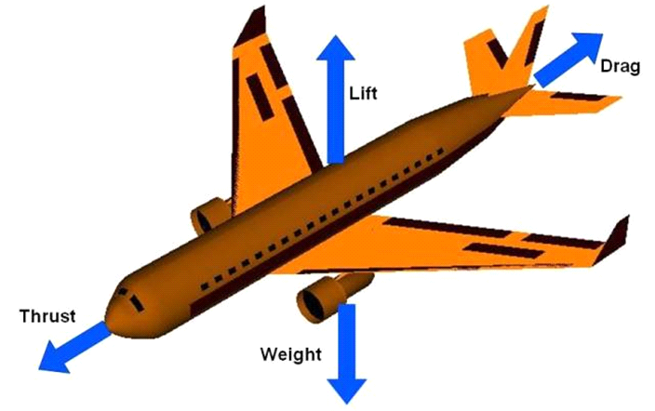

Figure 1: Force Axes

Additionally, they also illustrate the plane of symmetry (x-z plane) which is shown in Figure 2.
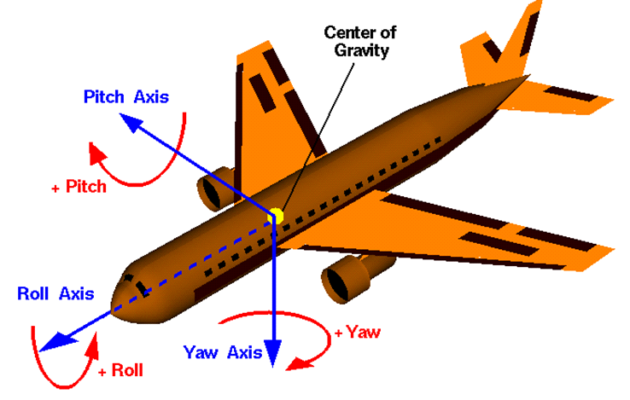
Figure 2: Rotational Axes
The next two pictures are provided courtesy of the renowned AerospaceWeb website, popular amongst aero enthusiast. Below is an actual picture which demonstrates the effects of the forces and rotations in the different axes on the fighter jet in Figure 3.
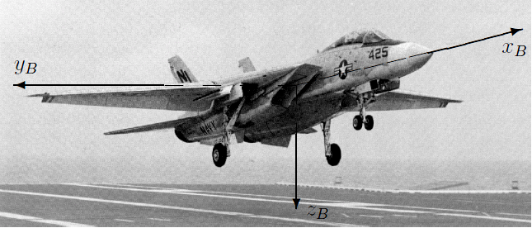
Figure 3: Axes Orientation

All of the various effects on the axes are critical to solving the multiple force coefficients, from drag and lift to the moments and torques. The Aerospaceweb photos demonstrate their Angle of Attack and Pitch angle document, the concept of relative wind and the angle between it and the longitudinal axis in the plane of symmetry is illustrated on the real plane in
Figure 4 located below.
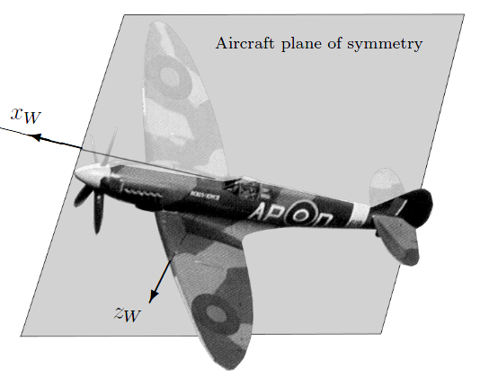
Figure 4: Aircraft Symmetry
In order to understand the how to calculate the Angle of attack and angle of sideslip, it was critical to decipher the aerospace terms and truly know how to derive our desired values. Figure 5 below illustrates what the angle of attack is relative to the aircraft.
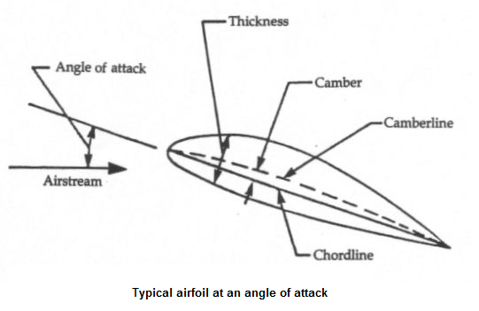
Figure 5: Angle of Attack Relative to the Wing

The pitch angle is the angle between the longitudinal axis (parallel to chordline) and the ground (horizontal), and alpha (AOA) is the angle between the longitudinal axis (x-axis) and the relative wind (airstream far ahead of the plane).

Why AOA is important
The AOA is a critical flight parameter because of its effects for fire control, cruise control, and stall warnings. It is also critical to most and almost all of the other aerodynamic parameters.

How to Measure AOA
There are several devices that are used to measure AOA; the pivoted vane, the differential pressure tube, and the null-seeking pressure tube. The pivoted vane is used in flight tests, the differential pressure tube is not used to a great extent, and the null-seeking pressure tube is used in service operation of aircraft.

It is measured via a the pivoted vane technique, and calibrated via wind tunnel tests if possible to account for position errors which is the difference in local and true AOA values given from the vane being mounted ahead of aircraft (on a boom) or locally on the aircraft (under a wing for instance). The boom is being used commercially and in the military, because Space Age Control sells them as seen in Figure 7 below, and a recent visit to the Lockheed Martin site shows a May 2011 flight of their modern F35B fighter with a boom on the front in Figure 6.

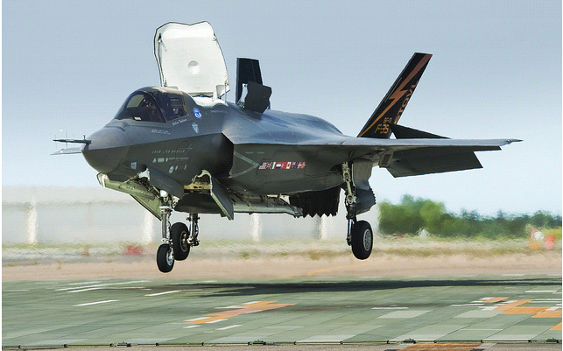
Figure 6: Fighter Jet with AOA/AOS Boom

Obviously, we plan to build our own boom, b/c the commercial ones exceed the projected cost of the entire project by far. Our vanes would be secured as seen in Figure 7, perpendicularly oriented to get the sideslip angle and AOA, and connected to two rotary position sensors inside the boom.

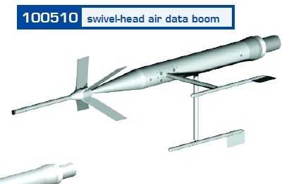
Figure 7: One of Space Age Control booms

We would also route tubes inside the boom (to measure airspeed) to a differential pressure sensor either inside or external to the boom. A small PCB could be employed to hold the differential pressure and rotary position sensors, therefore putting the circuitry inside the boom, and a simple header pin connector to interface with the boom. Table 2 describes the options in greater detail.

 |  | Aero-Instruments (bought Space Age Control) Booms Product Number
Features | Home Made | 101100  (Micro- boom) | 100400  (mini- boom) | 100386  (miniature  Vane assembly) | 100486  (vane assembly)
AOA  (Angle of Attack) | YES | YES | YES | YES | YES
AOS  (Angle of Sideslip) | YES | YES | YES | YES | YES
TAS  (True airspeed) | YES | YES | YES | NO | NO
Boom included | YES | YES | YES | NO | NO
ROTARY AND DIFFERENTIAL PRESSURE CIRCUITRY | YES | YES | YES | ROTARY ONLY | ROTARY  ONLY
LEAD TIME | NONE | 30 DAYS ARO | 30 DAYS ARO | 30 DAYS ARO | 30 DAYS ARO
COST | $150 | $4610 | $4610 | $1980 | $3220
Table 2: List of Different Booms

3.3.2 Dynamic Pressure – q
In order to understand dynamic pressure, we must review a critical formula in fluid dynamics, Bernoulli’s equation, and it’s as critical as V=IR is to electrical engineers. Bernoulli’s equation is
p+(1/2)ñV²+ñgh = constant (4), where p is pressure, ñ is density, V is velocity, g is gravitational acceleration, and his elevation.

The operating conditions for the formula are
- Any two points compared lie on the same streamline
- The fluid has constant density
- The flow is stead (not turbulent)
- There is no friction

However the insight of the formula into the balance between pressure and velocity is very useful when the formula is combined with the conservation of mass formula A₁V₁=A₂V₂ where, A is cross sectional area and V is velocity. A surface placed directly into the flow had various streamlines diverging at a point and rerouting around the body, and pressures and velocities are represented with subscript “e”. There is one streamline that is brought to a stop, and the velocity is zero at that point, and so the pressure is greatest there (to maintain the constancy of Bernoulli’s equation). This point is called the stagnation point. Thus the Bernoulli formula demonstrates that in a steady flow, the sum of the static pressure p, and another term defined as the dynamic pressure q= 0.5ñV² is always equal to the stagnation pressure, which is the max pressure in the flow, experienced by a surface that is parallel to the flow.

Why is q important?

This principle is allows us to find several things pertaining to our coefficients

- q (dynamic pressure) is simply a difference in pressures (q= p_{stagn.}- p_{static})
- True airspeed, V, of the plane.
- Force and Torque coefficients

The force coefficients are simply the ratio of the pressure caused by those forces on an area to the dynamic pressure due to the velocity of air flowing past those surfaces.

Measuring Dynamic Pressure

The Pitot-tube is the chosen method to measure q because it’s a simple, historical and accurate way of measuring airspeed, and q subsequently (5). It’s a device that simply manipulates Bernoulli’s equation to capture the stagnation and static pressures and find the difference, yielding the dynamic pressure, and subsequently the velocity of the air flow. An illustration of a Pitot-tube is given in Figure 8. P∞ and V∞ are the stagnation pressure and velocity of the freestream; freestream being the airflow far ahead of the aircraft so that the aircraft doesn’t alter the flow ahead of it (5).

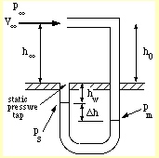
Figure 8: Pitot-tube
The plane booms that were seen earlier are devices that have two pressure ports on the tips, one directed into the flow to measure the stagnation pressure, and another perpendicular to the flow, to measure static pressure, and the difference in the pressure is q. The ports are placed on the boom tip so that they can reach out into the freestream in front of the aircraft to get the pressure difference there and get a true q reading. Since the commercial booms are too expensive, we’ll build our own from buying wind vanes, differential pressure sensors, and rotary position (angle) sensors.

3.3.3 Force Coefficients

Coefficient 1: Lift Coefficient

The way how an aircraft produces lift is yet another way of manipulating the Bernoulli principle in fluid flow. Remember that far ahead of the plane, the stagnation pressure is fixed, and for any two streamlines over/under the surface of the airfoil, the sum of the static and dynamic pressures is constant. As can be seen in Figure 9, the cambered airfoil forces the airflow upwards on the top of the airfoil, and by the conservation of mass principle, the air must speed up.

Since the air is now moving faster than the airflow under the airfoil, Bernoulli’s principle tells us that the pressure above the airfoil is lower than below it, so a net force is produced upwards on the airfoil due to the higher pressure below the airfoil. There is one more noteworthy feature of lift that is pertinent to its definition in aerodynamics. Lift is defined as the force on the plane produced by the airflow past the airfoil that is perpendicular to the direction of the relative wind on the airfoil (5).

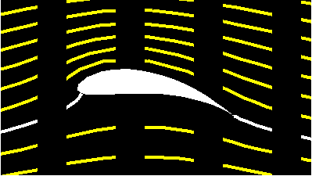
Figure 9: Cambered Airfoil Forces Diagram

The lift force is defined as L= (1/2)ñV² S_{ref} C_{L}, where rho is density, V is true airspeed, S_{ref} is the planform area or the area of the wing when viewed from above the aircraft, as in Figure 10. (6)

C_{L} is the coefficient of lift. According to NASA’s Glen Research Center (7), the equation above can be rearranged to give
Cl = 2*L/ ñV²A
= L/(qA)

Let’s take it a step further to say that the lift coefficient is the ratio of the static and dynamic pressures felt by the airfoil (P_{static}=L/A)/(P_{dynamic}=q).

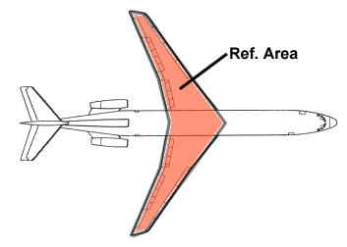
Figure 10: Coefficient of Lift Reference Area
Measuring the Lift Coefficient

Primary Method
Since the normal pressure experienced by the plane is a net force, it makes sense to simply find the static pressures being felt under and on top of the wings of the aircraft. Because the pressure on the surface of an airfoil may vary over the length of the airfoil, multiple pressure sensors must be used, and thus a pressure distribution is obtained. From this distribution one may then find the average location of and average value of the pressures above and below the airfoil. We get an estimate of the average location and that is called the center of pressure (CP), and as the distribution of pressure on the airfoil changes so does the CP location. The difference between the lower and upper pressures on the airfoil is the normal force on that airfoil. The net pressures on the two symmetrical wings can differ if the plane is in a roll maneuver, so the normal don’t have to be the same, but we still are able to compute the net total normal force. This normal force is componentized into the component acting perpendicular and parallel to the relative wind. The perpendicular component is the lift. We then find the ratio between the lift and the dynamic pressure, q, which we already know as explained earlier. Though it can be argued that the q above and below the wing are different and would lead to different lift coefficients on the top and bottom of a wing, we are not concerned about the local q, but the true q; that of the freestream ahead of the plane (8 p. 1). The reference area for this Cl is the planform area, of the wing area.

Secondary Method
The normal force can also be measured by using the accelerometer independently of the sensors that gather pressure distribution data. The acceleration recorded on the z-axis of the accelerometer is a net quantity; it’s a summation of the effects of forces that are acting on the z-axis. Knowing this, and also that the only other force that can act on the z-axis is the weight, can compute the lift on the entire plane via Newton’s law ∑F=ma law, and the AOA angle (to componentize the normal force). The pressure sensors aim to measure the left side of the equation having more than one term, and the accelerometer can compute the right side of the equation which has only one term. Note that we use the primary and secondary method to verify each other for accountability. The reference area for the Cl also be the planform area, with the assumption that lift is primarily and mostly generated by the wing surfaces. This is because they were designed not with symmetry in the x-z plane, as others parts were such as the fuselage.

In order to understand the various conditions under which DATCOM is seeking the lift coefficient, we must go to a stability and control derivative guide to explain the various terminologies of the Greek symbols subscripts, and consult Table 3 for the various sections of an airplane. After cross referencing two NASA reports, a DATCOM manual, and work from the Virginia Polytechnic Institute and State University (8) (9) (10) (11), we have come to the following explanation of the DATCOM parameters for lift:

DATCOM Parameters | Explanation
Lift Coefficient due to:
Basic geometry (CLá) | Cl due to various angles of attack
Flap deflection (CLäf) | Cl due to various flap angles
Elevator Deflection (CLäe) | Cl due to various elevator angles
Pitch Rate derivative (CLq) | Variation of Cl with pitch angular acceleration
Angle of Attack Rate derivative (CLádot) | Variation of Cl with AOA angular acceleration
Table 3: DATCOM Parameters
We have employed a gyroscope that measures the angular accelerations and we use an A/D converter and another equipment to tap into the servo voltages for the flaps and elevators to get the angular info of the RC plane flight surfaces.
Thus we measure the lift coefficients of the RC plane; one coefficient per sensor in the +z direction, and the sum of them tell us the total lift coefficient. This coefficient is vital to the calculation of the other DATCOM parameters we are calculating. Figure 11 displays how all the parts affect flight coefficients.
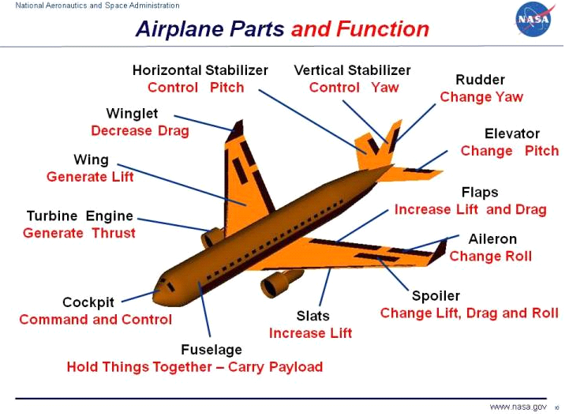
Figure 11: Airplane Components and Functions
This coefficient is a neat summary of the amount of force to expect relative to the amount of air flowing past the lifting surfaces. However, since the AOA consistently changes, and the definition of the lift is that component of the force normal to the surface in the direction perpendicular to the relative wind, the AOA has to be factored into the computation of the lift pressure on the flight surfaces facing the +z direction.

Drag Coefficient

Drag is defined as the force that acts perpendicular to the lift force in the direction of the relative wind. The resultant force seen in the Figure 12 is called the normal force, because its perpendicular to the flight surface area and the force parallel to the surface area is called the axial force. (12) As seen previously in Figure 1, there are four basic forces applicable to a plane and they are all in specific directions. However, these forces can be deceiving. Figure 1 is valid for the drag at AOA equal to zero degrees. However as seen in Figure 12, the lift and drag forces are defined not in terms of the plane’s flight path but in terms of the relative wind. The forces perpendicular and parallel to the plane’s flight path are called the normal and axial force, while the forces perpendicular and parallel to the relative wind direction are the lift and drag forces. Since a force coefficient is simply the ratio of the static pressure for which the force is responsible and the dynamic pressure across the surface, the drag coefficient is defined as follows:

Cd = D/q*S, D being the drag force, S being the surface area over which D is applying, and q being the dynamic pressure across S. (13)

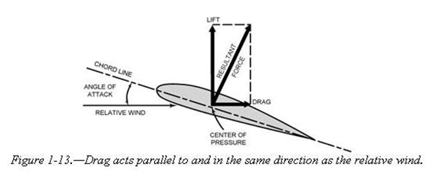
Figure 12: Force on Wing
There are two main forms of drag, induced drag and parasitic drag. Induced drag is the drag force due a surface producing lift, such as an airfoil. Therefore the surface in Figure 10 is showing induced drag which is directly a result of the normal force. Parasitic drag is the force on a surface that doesn’t produce lift. Parasitic drag can be further compartmentalized into form drag, skin friction, and interference drag (12). Skin friction is caused by shear forces parallel to surface. Form drag is due to shape of the aircraft’s surface, causing vortices and pressure differences (i.e. at front and rear of wing) of a surface. However, interference drag is formed at the boundary of two surfaces. Figure 13 shows this more clearly.

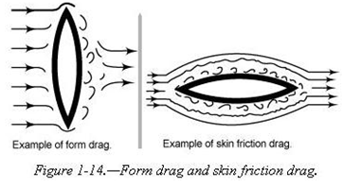
Figure 13: Force Interference

From this image, we can see that induced drag is the result of a component of the normal force and the parasitic drag is a result of the axial force.

How Drag Is Measured
It’s very important to determine the reference area for the drag coefficient. As seen in the mathematical definition of the drag coefficient, surface area ‘S’, must be computed. The surface area can be the planform or wing area, the frontal or area staring down the x-axis, or the total surface area. The areas are proportional to one another, and it’s important that if coefficients are to be compared the correct reference area is used (7). We know that the more streamline a shape is, the less parasitic drag it has. Therefore, we can easily say that the parasitic drag only accounts for a small portion of the drag in comparison to the induced drag caused by nonzero AOA angles. In other words, at an AOA of zero degrees, the drag is purely parasitic; but at larger angles, the drag is more induced than parasitic. Henceforth, because induced drag is the larger of the two, we’ll choose the planform area, or total underbody area, as the reference area.

In order to measure the induced drag, we need the normal force on the surface. This can be measured directly from force sensors on the plane’s surface by gathering the normal force readings on each of the sensors in order to obtain a force/pressure distribution. Force sensors covering the entire underbody of the plane can then obtain the total normal force in the -z-direction. However, in order to get the total normal force in the z-direction, force sensors must cover the top surfaces of the plane as well so that the +z-direction normal force can also be found. Then the net z-axis force could be computed. This normal force can be found more easily with fewer parts using the accelerometer. By knowing all the forces that are acting on the plane and eliminating the known values one at a time, we can get the desired force in the z-direction due to the wind.

The normal force can also be measured using the AOA and the accelerometer. When the normal force is measured via Newton’s law and componentized into vectors perpendicular and parallel to relative wind flow, the parallel portion is the induced drag. Therefore, using the accelerometer, AOA, the thrust produced by the propellers, and radial forces about the y-axis, using a gyroscope, we can do simple mechanics employing Newton’s law to find the total parasitic drag acting on the plane.

Procedure
Via the gyroscope, we’ll know the orientation of the 3D axis of the accelerometer’s axis. We also know that the magnitude of the weight vector and its direction can be computed using some mathematics. We also know the thrust vector to always act down the +x-direction. We also know that if the accelerometer is offset from the CG of the plane, and the plane undergoes a yaw, pitch, or roll, that the accelerometer should experience a force (V²/r = rá², r being radial distance from CG) directed along a radial line joining the CG and the accelerometer, and that force can be accounted force and eliminated, so that the remaining forces are only due to the relative wind causing normal and axial forces in the z- and x-directions respectively. The reference area is mandatorily chosen. The AOA angle is taken into the picture of the coordinate system, and the resultant forces is componentized with respect to the AOA angle and the x-axis.

Side Force Coefficient
The side force can be understood to be a force in the x-y plane that acts perpendicular to the flight path (3). A common way a side force is generated is when the plane is in a bank turn. The plane rolls about the x-axis and the normal force produced by the wings generates both a component in the vertical (relative to ground, not body axis) and in the horizontal, creating a curved motion, as seen in Figure 14.
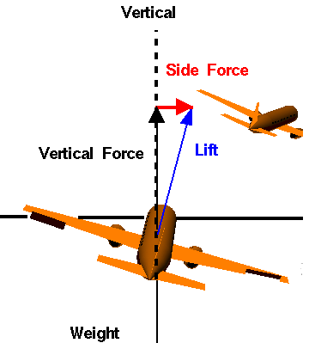

Figure 14: Lift Relative to Vertical Force
How to Measure Side Force

The side force, like many of the other forces discussed previously, is measured by first using the normal force computed earlier, but then componentizing it into projections in the z-direction and the y-direction. The component in the y-direction is the side force. The angle that is used to componentize the normal vector is the angle found from the rotation about the x-axis, which is given by integrating the angular speed with time of the gyro’s x-axis data.

The side force coefficient is computed using the same reference area for consistency. The wing area is used for ease, and because the side force is a component of the normal force and the normal is from the wing. This side force coefficient is measured under the following circumstances:

Side Force Coefficient due to: | How to assess Coefficient
Sideslip (Cnâ) | Graph Cn vs. â (AOS) given by the boom’s AOS sensor
Roll Rate derivative (Cnp) | Graph Cn vs. the roll-axis’ angular acceleration via the derivative of the gyro’s roll data
Yaw Rate derivative (Cnr) | Graph Cn vs. the yaw-axis’ angular acceleration via the derivative of the gyro’s yaw data

Table 4: Side Force Coefficient

3.3.4 Moment Coefficients

The definition of a moment coefficient is similar to that for a force coefficient. It’s defined as the torque per length of application per dynamic pressure per reference area (Cm=M/qSl, where M is moment, and l is the length of application). (14) As is well known from physics, the net force on a body can be zero, but that doesn’t mean there’s not motion of the body. The forces could be producing a torque; so therefore, the moments must be accounted for in the aerodynamics of a plane. On a plane, there can be both translational and rotational motion. A net torque produces an angular acceleration of an object and the effect and cause are related by ∑ô = Iá. We can measure the left side directly using multiple pressure sensors, but we can employ fewer parts and derive the torque via the gyroscope’s singular angular velocity derivative.

Pitching Moment Coefficient

A pitch is caused whenever there is a torque about the y-axis. The elevators on the plane are for generating such a torque.

Method 1: Pressure sensors over and under the x-y plane.
In order to measure the torque producing the pitch, we need to target those areas known to produce pitching torques. This is the elevator, and its primary function is to control the pitch of the aircraft. The forces, and thus torques produced on the larger areas of the horizontal stabilizer and the wings are supposed to oppose the torques created by the nose or the aircraft. Thus the aircraft should be stable by design.

Minimum requirement
1. Cover the elevator's top and bottom surface with sensors. This assumes the plane is stable without deflecting elevators.

Maximum requirement
1. The under and upper body of the fuselage from nose to tail is covered with discrete pressure sensors
2. The under and upper body of the horizontal stabilizer and elevators is covered.

This allowed us to see the distribution of net pressures in the x-z plane.

Method 2: Experimentally determine Moments of Inertia of plane about its three axes.

Another method is to employ the gyroscope. Before flight, we could estimate the moment of inertia, I, for all three axes independently by installing the pressure sensors for calibration purposes. We can put a pressure sensor a known distance from the known CG and apply a force, which because of the force sensor can be known, and measure the known angular acceleration of the plane from the gyroscope. We can do this for the plane's three distinct rotations; pitch, yaw, and roll. Graphing and finding the slope of ô vs. á yields the moment of inertia for all three types of rotations. Therefore once the moments of inertias are found, the force sensors could be removed, and the gyroscope can be used to get all of the torques throughout all three types of rotations.

Rolling Moment Coefficient
The rolling moment is the torque on the plane that causes it to rotate about its longitudinal or x-axis. This torque is generated by the flaps on the plane. When they are deflected in opposite directions, equal torques are generated to produce a rolling action. This roll is used for a bank turn. The rolling moment coefficient reflects the amount of rolling torque per unit area that’s producible per velocity of airspeed. It's defined the same way as any other torque coefficient.

Method1: The rolling torque is measured by placing pressure sensors on the areas that are able to produce rolling torques, which are the flaps. The flaps are used to unset the symmetric geometry of the plane deliberately to produce torque. The torques on all the other parts of the plane should be equal and opposite thus cancelling and so the net should be produced by the flaps. Therefore, the two flaps were covered with pressure sensors. Again this assumes the plane is stable with no net roll torque when the flaps are not deflected. This depends on how well the plane design is, and in this case, how well the model is scaled to the real model, as well as how well the fuselage is loaded with equipment relative to the CG.

Method 2: This is the experimental method, similar to the previous, where the moment of inertia of the wings are found via using the pressure sensors on the flaps and gyroscope to graph the torque vs. acceleration of the roll. Once the moment of inertia is found, then the torque produced by the flaps can be measured using the gyroscope only. This is again a calibration technique that is done preflight on the ground.

Yawing Moment Coefficient
The yawing moment coefficient is the moment coefficient due to a yawing rotation of the aircraft.

Method 1: It can be measured through measuring the torques on the parts of the aircraft responsible for producing torques. This would mean monitoring the pressures on the rudder and vertical stabilizer by covering each surface with pressure sensors.

Method 2: This is the familiar calibration method that seeks to calibrate a correct value for the moments of inertia for the aircraft, and in this case, rotational inertia about the z- or vertical-axis. This still employs the pressure sensors in method 1, but allows their removal after a graph of torque vs. angular acceleration is obtained from the sensors and gyroscope working together.

Importance: Method 2 is important in the special case that it's raining of extremely humid and we cannot afford any of the flight sensors to be exposed to the elements. We can grab torque and force readings via the accelerometer and gyroscope safely installed inside the plane, without the need of excessive pressure and force sensors installed all over the outside body. The pressure sensors in this project are susceptible to failure in water or very humid conditions. (15)

MISCELLANEOUS COEFFICIENTS
These are still important so here's the quick outline of how they'll be measured. We have no conclusive way of measuring the downwash angle as of yet.

Elevator-hinge moment derivative
This employs the same procedure for the pitching moment method 1; however the pressure sensors are only needed on the elevator and the moment arm to be considered is that of the elevator surface and where it pivots on the horizontal stabilizer. The variation is torque on this surface can then be found with respect to the deflection angle of the elevator, and also the AOA.

Normal Force Coefficient
This coefficient is simply found from either force sensors on the body or the accelerometer. The force sensors on the body measure forces normal to it, not shear forces parallel to it. They are not designed to be strain gauges. The accelerometer can be employed by looking at the z-axis acceleration due to forces outside the thrust and weight forces by applying the simple mechanics of Newton's second law, and geometry to take care of the angles.

Axial Force Coefficient

Our plane is using a fixed propeller. A propeller is a device that does work on the air. It exerts a force on the air and thus the air and plane accelerates in opposite directions. The accelerated air eventually returns to the freestream condition, but because the air directly behind and in front of the propeller are at different velocities, we know that the pressure before and after must also be different, from the Bernoulli principle. Thus we should be able to measure the thrust of the engine by measuring the pressure difference between the front and back of the propeller (16). Figure 15 shows the mathematical relation between pressure and thrust.

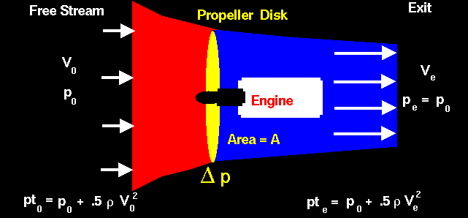
Figure 15: Engine Thrust

Though the plane has air of various speeds to pass through the propeller, the difference in pressure is independent of that flow. The difference in pressure is caused by the propeller doing work, which is related to the thrust, and so, the thrust is

F_{thrust} = ∆p*(Area=A)

A differential pressure sensor can measure the thrust constantly through flight by keeping track of the pressure differential, and the thrust is readily computed because the area A of the propeller area is constant. Furthermore, the pressure difference should be the same across the entire area of the propeller because the propeller is designed like an airfoil, with a camber and chord, front and tail end, except that it has a twist in each airfoil so that the mass rate of airflow is constant from the airfoil tips to the hub. Thus we assumed that the pressure distribution across the propeller face is constant.

Testing the pressure distribution across the propeller area

The pressure distribution is verified or checked by moving the pressure tubes across the area of the propeller while the engine is running and the plane is on the ground.

Therefore the axial coefficient is measured versus the various quantities below:

DATCOM Parameters | Explanation
Drag Coefficient due to:
Basic geometry (Cdá) | Cd vs various angles of attack
Flap deflection (Cdäf) | Cd vs various flap angles
Elevator Deflection (CLäe) | Cd vs various elevator angles
Table 5: DATCOM Parameters in Detail

3.4 Data Acquisition Method
In order to obtain flight data from a flying remote controlled aircraft we had to go through a meticulous process to fully understand our assignment. Since our project is sponsored by L-3 Corporation, we had to consistently meet and discuss the company’s wants and needs, then determine what our team would be capable of producing.
The first thing to do was describe what data we needed to record from actual flight. After a few meetings, we were provided a list of different flight parameters that they were seeking – these variables were determined from the list of parameters used in DATCOM’s software. We continued to pick through the list, determine priority of the parameters, and begin to determine the means of how to obtain this data, if they were at all possible within our available resources. After honing in on the values necessary, we proceeded to the next step.
Once everything was established we were able to continue to the next stage and determine the best means of calculating this data. This was definitely the hardest part of the process to gain enough understanding of aeronautics and abstract the thinking into an electrical and computer engineering design approach. In the list there are a few parameters that all relate to the plane’s geometry. These parameters are all simple to record do not require any advanced equipment or techniques to attain them. But on that long list of parameters, a few others were simple values, such as temperature and pressure, which could be attained directly though a simple sensor. Or in the worst case, for some of these values, they may have required a small network of sensors. For the remaining variables on L-3’s list of needs, they are mainly advanced variables that require plenty of aeronautical equations and advanced computations.
In the following sections we go more into depth to discuss the variables and how they are attained. The first section will discuss the values that we are able to record directly through the use of a sensor. To follow that, we will discuss the remaining values that are not as simple to attain. These values require the data obtained from sensors be applied to at least one or more equations to determine the desired result. Any values that cannot be simply measured or computed in one step, i.e. sensor data, is added as input to our software, which calculates the variables in our defined equations and produce the necessary numbers.

3.4.1. In-flight Data Obtained Directly
As stated previously, some of the data that is required by our sponsor can be acquired through a simple interface to a specific sensor or a physical measurement. Some of these variables can be determined by simply visually analyzing the plane and some of the motor specs. These values represent the entire of parameters needed for the Aeromatic input, which is solely based on the aircraft’s physical features. In addition to Aeromatic’s input parameters, a handful of DATCOM’s parameters are based upon bodily features of the plane as well. The remaining values are the few variables that can be computed by a sensor and presented directly to the user. All values which are computed directly are shown below.
- Wing area  - Horizontal tail area  - Vertical tail arm  - Engine location  - Roll  - Pressure | - Wing span  - Horizontal tail arm  - Center of gravity  - Engine profile  - Pitch  - Temperature | - Wing incidence  - Vertical tail area  - Landing gear  - Flight controls  - Yaw  - Force
Again some of the values above are attained through a simple measurement that take place before flight. It should also be noted that some of the values that are simple plug ins that are taken from the manufacturer’s hardware specifications. For example, the engine profile consists of different variables such as bypass ratio or maximum thrust. Due to the fact that we lack any precise and advance measuring tools, values concerning distinct motor particulars are taken from hardware datasheets as valid.
3.4.2. Calculated Values Obtained Indirectly
There is many values that we obtain indirectly. These values is found by the program. The program use the gathered sensor data to mathematically compute the values. Each value is saved for output later. Each value is given its own function to be found by the program. here there is a list of the values that need to be found: angle of attack, hysteresis limits, change in drag from ground effects, change in lift from ground effects, drag force, side force, lift force, lift from alpha, change in lift form flaps, lift from change in alpha, roll moment, pitch moment, yaw moment, normal force coefficient, and axial force coefficient.

3.5 Microcontroller Selection
When selecting a microcontroller for data collection the first concern we ran into is, does the microcontroller have the I/O capabilities we need. As described in the sensor selection section of this document, we are going to be reading from a total of 38 sensors. In addition, we are using another I/O for writing to a multimedia card. Specifically, we have chosen the use SD card.
From these sensors we also take a variety of different input types. From the 30 force sensors which is placed on the body and wings of the plane, the differential pressure sensor, the humidity sensor, and the two angle sensing potentiometers, we are reading analog input which require the use of an analog to digital converter (ADC). From the accelerometer, the barometric pressure sensor, the gyroscope, and the temperature sensor, we are receiving a digital signal. However, there are multiple means by which digital signals can be sent. For these sensors, Serial Peripheral Interface (SPI) buses are required for the accelerometer, the gyroscope, and the temperature sensor. However, our barometric pressure sensor does not support the use of SPI but instead uses an Inter-Integrated Circuit (I²C) bus. Therefore, we had to be able support both of these digital I/O bus specifications.
For writing to an SD card, digital signals must be sent from the microcontroller to the SD card in order to read and write to it. According to interfacebus.com, multimedia cards such as an SD card use a 7-pin connector for data communication. (17) Of these 7 pins, three are dedicated to the SPI serial bus. Therefore, we also needed another SPI bus for communication with this device. From the factors listed above, we can confirmed that we needed to have microcontroller that supports 34 ADC I/O, 4 SPI capable digital I/O, and 1 I²C capable digital I/O. With these minimum requirements, we could then begin our preliminary search for a suitable microcontroller.
There are three major corporations that manufacture microcontrollers for projects such as ours. There is Motorola Inc., Microchip Technologies Inc., and Texas Instruments (TI) Inc. Of these companies, only Microchip Technologies Inc. and TI offered easy access to obtain their commercial products. Microchip Technologies manufactures 8-bit, 32-bit, 64-bit PIC microcontrollers and TI manufactures MSP430, C2000, Arm Cortex M3, and Arm Cortex R4F microcontrollers. Motorola did not provide easy access to their commercial microcontrollers. As an added bonus, both TI and Microchip Technologies provide free sampling of their microcontroller. This is a big plus towards choosing one of their microcontrollers. Therefore, we have decided to narrow our microcontroller selection to TI’s and Microchip Technologies’ microcontrollers.
Now that we have narrowed down the selection of microcontrollers between two companies, a search is performed to determine which microcontroller would be best for us. Both companies provided tool to help in the microcontroller selection process based on minimum requirements needed of the microcontroller. Beginning with our first requirement of 34 ADC I/O, 4 SPI capable digital I/O, and 1 I²C I/O, we began a search. Both TI and Microchip Technologies had a multitude of microcontroller which could handle the 3 SPI capable and 1 I²C capable digital I/O. However, it seemed neither company provided a means to handle 34 ADC I/O directly. TI’s microcontrollers had a max of 24 ADC I/O ports. Microchip Technologies had a max of 32 ADC I/O ports. Neither company’s microcontrollers were going to allow us the ability to connect all of our I/O directly. Therefore, a new strategy needed to be formulated. We came up with three that could be used to solve our dilemma:
Strategy 1 – Lower our ADC I/O requirements to 32 by removing 2 of the force sensors.
Pros: All I/O devices have a direct connection to the microcontroller. This meant we would have minimal latency as well as minimal distortion from current leakage when reading the values from the sensors.
Cons: In order to accomplish this setup, we would have to sacrifice some two of our force sensors. This is something we did not want to have to do as this would decrease our ability to accurately measure all of the forces acting on the plane. In addition, should we need to add additional I/O devices in the future, we would still run into the same problem again.
Conclusion: This option is not a viable one as it would have forced us to give up some of our data collection tools. This would be an option taken as a last resort.
Strategy 2 – Lower our ADC I/O requirements to 32 by removing 2 analog sensors and finding digital equivalents to replace them.
Pros: Again, this would allow all of the I/O devices to have a direct connection thereby giving us the highest possible accuracy.
Cons: Another detailed analysis had to be done to find similar digital parts which provide output equivalent to that of our chosen analog sensors. Also, just as with strategy one, we still run into the same problem of, ‘What if we need to add more I/O devices later?’ Again, we would still run into the same problem.
Conclusion: Although with this strategy we do not lose any data because of lack of sensors, this solution is not a perfect one. There is still a large possibility of us finding ourselves short on I/O in the future. Although this path is a viable one, it is not the optimal choice.
Strategy 3 – Lower our ADC I/O requirements of our microcontroller by using a multiplexer to accommodate multiple analog I/O on one I/O port.
Pros: With a multiplexer, we can accommodate for multiple analog I/O while using fewer ports. As an example, with TI’s “Automotive Catalog 8-Channel Analog Multiplexer/Demultiplexer,” (18) we can take readings from 8 different force sensors using only one I/O port. Additionally, since we can receive multiple analog inputs using one port, we no longer had to worry about running out of analog I/O since we can always keep splitting the input lines using multiplexers.
Cons: Some of the cons that come with spiting a signal are that there is some degradation of the signal. This could potentially be a problem for certain situations. According to the specification documentation for multiplexers such as (18), TI reports that there is some loss of current from there device. However, this loss is on the microampere level, so it is very minimal. Additionally, there is a small amount of lag that occurs when the multiplexer must switch from one input source to the next. For (18) this lag is in the nanoseconds range. So again, just as with the loss that occurs in the amperage passing through the multiplexer, the effects of the lag that occur is minimal.
Conclusion: Because we only would plan to use the multiplexers for the force sensors, the signal loss cons had to be compared with this device. The force sensor we are using is the FSR 402. According the FSR 402’s specification sheet, the FSR 402 force sensors allow for the calculation of the force they receive by measuring the voltage output each sensor supplies. (19) More details can be read in the section entailing the sensors’ details. For this reason, the signal loss induced by the multiplexer should not cause a loss in the accuracy of the data received from the force sensors. In addition, although there is a small amount of lag when switching between force sensors, this was not a problem since the lag induced from the multiplexer is so small. Therefore, using multiplexers to reduce direct input into the microcontroller seems to be the optimal solution. In addition, now should we have to add any extra analog sensors or other analog I/O devices, we won’t run into the problem of running out of I/O ports.
Now that it has been determined how to handle the dilemma of limited analog I/O, we still need to make a selection as to which microcontroller to use. However, another key factor comes into play, ‘How many bits wide does the microcontroller need to be?’ For our application, that number is 16 bits. Our digital sensors output data from the range 8 to 16 bits per word depending on the sensor. For this reason, our microcontroller needs to be able to handle at least 16 bit words. This way, we are able to handle all of the I/O data directly and not have to try to split I/O reads between to calls to the sensor. Also, neither TI nor Microchip Technologies microcontrollers with a word size of less than 16 bit support SPI or I²C. Therefore, we needed a microcontroller that used a minimum of at least a 16 bit word size.
Then a choice had to be made as to which company we wanted to get our microcontroller from. Both TI and Microchip Technologies provide very similar parts. It seems pretty much anything you can find a TI microcontroller can do you can find an equivalent Microchip Technologies microcontroller capable of doing it as well and vice versa. Therefore, the choice of which chip to use was not just limited by the hardware capabilities but the support resources for the microcontrollers provided by each of these companies. TI has a large library of lesson videos to teach anyone how to use their microcontrollers and other chips as well as their software. Microchip Technologies also provides similar video resources for their products. However, one major difference found between TI and Microchip Technologies is that finding these resources on the TI website is much more difficult than on the Microchip Technologies website. Besides videos, both companies also provide libraries for their microcontrollers which can be used to help ease the programming process of their microcontroller. After a comparison of the TI and Microchip Technologies website, it seemed that Microchip Technologies had a much larger software library for their microcontrollers. In addition to this, Microchip Technologies includes detailed documentation with all of their libraries as to how to implement them. TI provides some libraries also for its microcontrollers. However, there does not seem to be much documentation as to how to use their libraries.
The next step in the decision of choosing a microcontroller from either TI or Microchip Technologies, we look into the development studio software they provide. TI provides a free version of their software, Code Composer Studio. This software however has many limitations as compared to their full version. For instance, code size is limited 16KB. Microchip Technologies provides free versions of both their software programs, HI-TECH C and MPLAB C. These free versions do not provide optimization of our C code, but there is no restriction as to how much code can be written to the microcontroller. Additionally, if the use of MPLAB C is chosen, an academic version is available which provides greater debugging support as well as full access to the libraries provided with the commercial version of the software. Therefore, given all the factors listed above, it had become a clear decision for us to go with a microcontroller from Microchip Technologies.
Using Microchip Technologies’ microcontroller selection tool, we were able to narrow down our microcontroller selection. (20) In the tool we selected that the microcontroller has at least four SPI capable I/O ports, at least one I²C I/O port, at least 8 analog I/O ports, and supports a 16 bit architecture. Because of the fact that Microchip Technologies’ 16 bit microprocessors are low on power consumption, we decided not to look at using a 32 bit microprocessor. This is of some importance as we are running off batteries to power on the microprocessor. The image of Microchip Technologies’ microcontroller selection tool we used for narrowing down our selection of microcontrollers can be seen below in Figure 16. Using this tool, we were able to narrow our microcontroller selection down to nine.
One key factor in our decision of which microcontroller to use is, ‘Is the microcontroller available for sampling?’ Microchip Technologies offers samples of many of their products for free so that businesses and corporations can test their products. This is important since this would save some cost for our sponsor and allow us to gain access to multiple microcontrollers should we damage one of the ones we are working with. As it turns out, only five of the products listed in their chart were available for sampling. The dsPIC33EP256MU806, the dsPIC33EP256MU806, the PIC24EP256GU810, the dsPIC33EP512MU810, and the PIC24EP512GU810 were the only microcontroller in their list which we could sample. This narrowed down our list further to only five microprocessors.

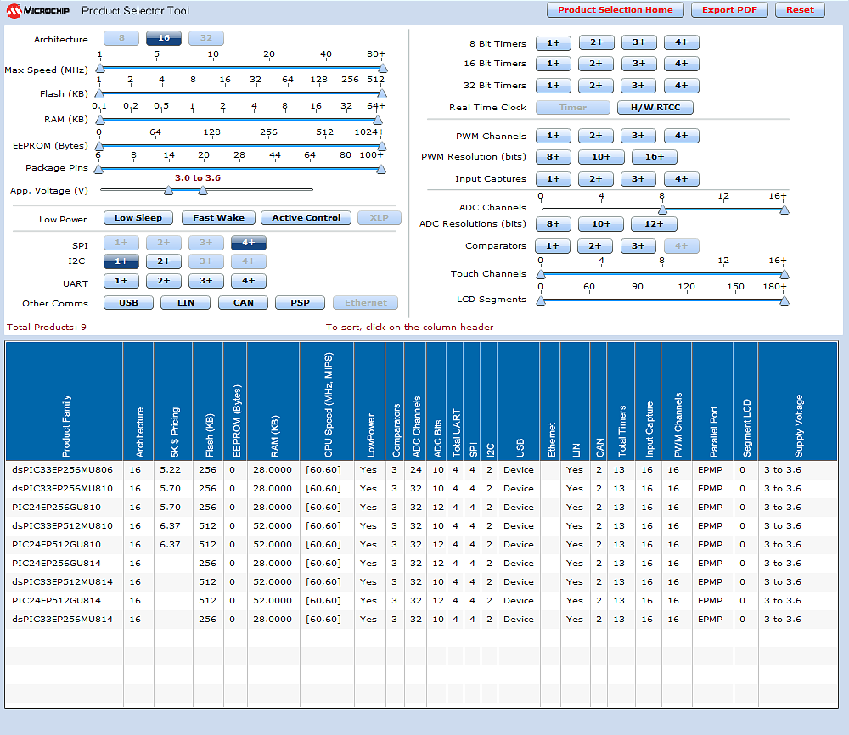
Figure 16: Microchip Technologies' Microcontroller Product Selection Tool
The next factor we used for deciding which microcontroller to use is the amount of RAM available on the microcontroller. Our two options were 256 KB of RAM or 512 KB or RAM. In data collection, we know that we have to be able process a lot of data at a very fast pace. Therefore, we didn’t want to run out of RAM should we not be able to transfer all of the data into the SD card as fast as it comes is read from the sensors. Therefore, we decided it is better to choose a microcontroller which provides us with the most memory should we run into unforeseen memory management issues. Therefore, we decided to choose a microcontroller with 512 KB of RAM. This brought our selection down to between the dsPIC33EP512MU810 and the PIC24EP512GU810.
Lastly, we did a detailed comparison of the dsPIC33EP512MU810 and the PIC24EP512GU810. It turns out that the dsPIC33EP512MU810 and the PIC24EP512GU810 are almost identical microcontrollers. (21) (22) There were very few differences between the two. The dsPIC33EP512MU810 happens to have several additional features over the PIC24EP512GU810. The main difference that caught our attention is that the dsPIC33EP512MU810 has built in instructions to do 16x16 bit fractional multiplication and division. The other microcontroller did not have this feature. Another feature missing from the PIC24EP512GU810 that the dsPIC33EP512MU810 has was the ability to do single-cycle multiplies, additions, and shift of up to 40-bit data. We determined these three features would be of great importance since we are doing real time calculations during flight. Single-cycle processing for these instructions would lead to large increase in efficiency, thereby lowering processing time and allowing for higher data collection speeds. Therefore, it had been decided that the microcontroller we are using is Microchip Technologies’ dsPIC33EP512MU810.

3.6 Analog I/O Connectivity Design
As discussed prior, for this project, our microcontroller has less ADC I/O then needed to collect data from all of our analog sensors. For this reason, it has been decided that a multiplexer needed to be used in order to accommodate all of the sensors we are using. We have four main components as far as our sensors that produce analog output go. We have 30 force sensors, a differential pressure sensor, a humidity sensor, and two angle sensing potentiometers. All of these sensors output voltages which are used to compute the features the sensors are design to obtain. First off, we need to decide how we want to break up our ADC I/O to cover all of our sensors. We came up with three strategies which could accomplish our goal.
Strategy 1 – Use a 32:1 multiplexer for the force sensors and connect the four other analog I/O directly to the microcontroller.
Pros: This plan would cover all our ADC I/O need. In addition, it would leave a lot of extra ADC I/O available should we have to add more sensors or some other ADC I/O device.
Cons: We would have to continually iterate through the 30 force sensor inputs connected to the multiplexer. Since we need to collect data from all the sensors each data collection cycle, we would be using the processor inefficiently. There would now be a large delay time between collections of data from the other ADC I/O sensors. Additionally, we would not be taking advantage of the fact that the dsPIC33EP512MU810 can handle four analog I/O accesses simultaneously. Any delay we removed, improved max data collection speed capabilities. In addition, had the multiplexer failed, we would have had a lot of problems.
Conclusion: Although using a 32:1 multiplexer is a viable option, it is not an optimal one. This strategy would cover all of our ADC I/O; however, we are giving up on efficiency for no particular reason. If the microcontroller’s ability to do four simultaneous reads was taken advantage of, it would take 33 read cycles to retrieve all the values provided by our sensors. In addition, this strategy puts heavy reliance on the multiplexer resource in order to be able to collect data from the force sensors. As the saying goes, “Don’t put all your eggs in one basket.” For these reasons, we have decided that this strategy would not be used.
Strategy 2 – Connect all the force sensors directly to the ADC I/O pins and use an 8:1 multiplexer for the four other analog sensors.
Pros: Again, this plan would cover all our ADC I/O needs. We were also able to take advantage of the dsPIC33EP512MU810 capability of handling four analog I/O accesses simultaneously.
Cons: We only left one direct ADC I/O open should more analog I/O devices need to be connected. This restricts the expandability of our current design. In addition, we have the same problem as before in Strategy 1 where we had some delay when having to iterate through the 8:1 multiplex to obtain data from its sensors.
Conclusion: In this strategy, although it is also a viable option just as Strategy 1 was, the disadvantages still outweigh the benefits. Although if we time our reads correctly we can obtain the values from the sensors in only nine read cycles, we still have the issue of very few extra ADC I/O connectors. In addition to the complication that would occur should we have to add another analog I/O device, should multiple of the I/O ports on the microcontroller fail, we would have a large problem as far as trying to find a workaround. It is always better to be over prepared than under; therefore, we have decided this strategy would not be used for splitting up the ADC I/O.
Strategy 3 – Use four 8:1 multiplexers to connect all the force sensors and connect the other analog I/O directly to the microcontroller.
Pros: With this strategy, we can divide the 30 analog I/O used for the force sensors between four 8:1 multiplexers. Because the microcontroller allows for four simultaneous analog I/O accesses, we can iterate through all the force sensors in eight read cycles through parallel reads. Then for the other four analog sensors, we can read those simultaneously also. This allows us to get reading from all of our sensors in nine read cycles. Therefore, it is much easier to account for potential ADC I/O failures should one happen to occur.
Cons: The only con that comes from this strategy is the fact that multiplexers are used which cause a small delay in obtaining the sensor readings.
Conclusion: Although there is some delay that comes with using a multiplexer, this is a problem which occurs with both Strategy 1 and Strategy 2 as well. Nonetheless, this strategy has a higher benefit to hindrance ratio than the other two strategies. With this strategy we can account for potential ADC I/O failure which the other strategies do not account much for. Therefore, we have decided Strategy 3 is our best option for splitting our ADC I/O readings.

4. Project Hardware and Software Design Details

4.1. Initial Design Architecture
It was decided that we would build hardware that wouldn’t be an autopilot because that would impose extra requirements of the project, so the autopilot has its own block. Also the as seen the autopilot or the R/C transmitter has control of the plane at any given time by controlling the motor and bank of servos that control the flight surfaces. The Sensory bank is really what we are responsible for designing and recording from them with the microcontroller. The Data Communications bank is in anticipation of an optional requirement of transmitting the sensory bank information over-the-air to ground, so no sensory information would have to be stored in the microcontroller. This is for much the same benefit as why our autopilot; the ArduPilot Mega has ground station transmitting and receiving information about the flight plan and aircraft orientation and position. Our hardware design is outlined in Figure 17
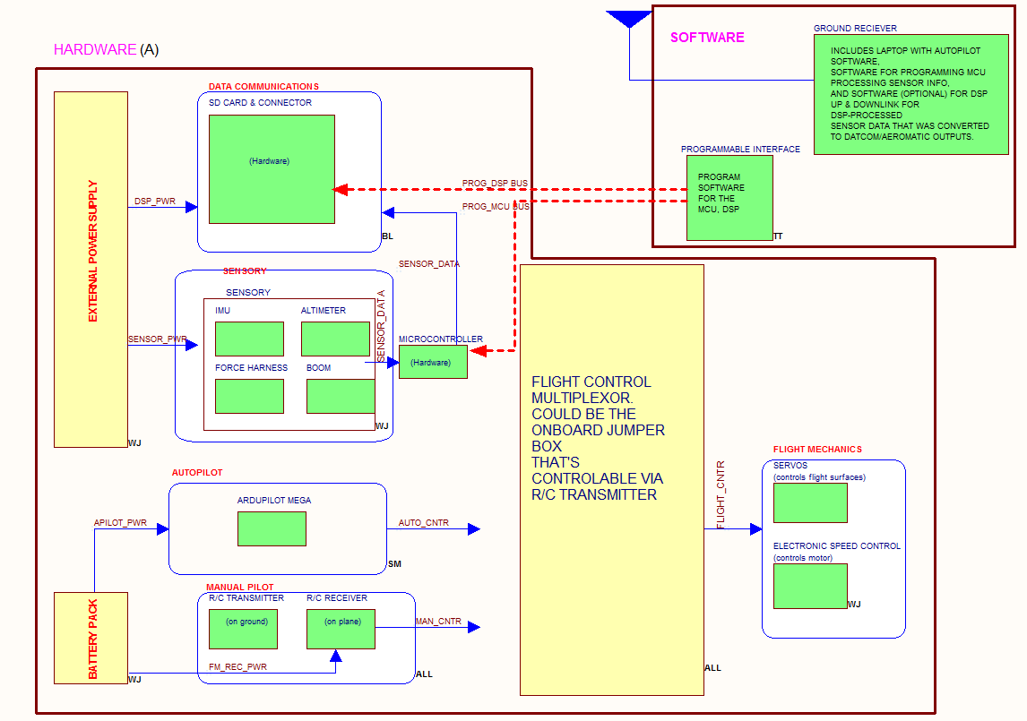
Figure 17: Hardware Diagram

4.2 Unmanned Aerial Vehicle (UAV) Design
It was to the mutual pleasure of L-3 that we pick a plane that’s a small-scale of a real-world model, because those are the planes that is flown in reality, and is worthy of consideration or simulation. We also couldn’t find another R/C plane model that was bigger than an R/C drone. Therefore we decided on the small scale model of the MQ-9 reaper drone which in reality is an impressive war machine. Our plane doesn’t require much designing as it does assembly, because it’s a plane kit. The plane has a 3.54 ft fuselage length, 8.20 ft wing span and weighs between 6-7 lbs when we fully load it with our equipment. It, like its parent is driven by a fixed, though not turbo propeller. The plane is bought as a kit containing the fuselage, wings, rods to go into the wing to interface the servos to the RX module, and the supplemental components like batteries, and electronic speed controller, motor, and propeller is bought.

4.3. Data Gathering Subsystem
Since the system has over thirty sensors along with an output for data, a decision had to be made between using multiple microcontrollers to retrieve and manage all the data. Recognizing the computational strength that microcontrollers possess, it was determined that anything over three microcontrollers would be overkill for the needs of our system. Hence the best options available worth reviewing are the use of either one, two or three microcontrollers.
Strategy 1 – Use one microcontroller to handle all computations
Pros: All of the sensor data would be obtained and maintained in one central location, making it easier to manipulate data. This setup also avoids having to deal with the problem of communication between microcontrollers for data transfer and synchronizing clocks between multiple controllers.
Cons: Since there may be multiple programmers working on the microcontroller processes, merging the different sections of code may be more difficult to do and significantly increase amount of labor required.
Strategy 2 – Use two microcontrollers to divide workload
Pros: By using two microcontrollers, one of the most obvious advantages is that we can split the workload of computation and data polling amongst two controllers. Since there is two microcontrollers to divide the task of data retrieval, the system is able to use smaller, cheaper microprocessors. This would result in faster data collection if both processors obtain flight vitals simultaneously. The layout for this system layout would resemble a master and slave configuration. Both would grab flight data but one would be responsible for other tasks; such as data storage and computation of flight statistics. The modularity provided by two microcontrollers also eases the work between programmers because their code does not need to compile together. Instead they only need to be able to share object structures and communicate effectively. Also, side by side, the processors here may be less powerful than that of a one controller design; but together they may be as effective as the first option. Not to mention this method requires less electrical power than the original strategy.
Cons: One of the big worries with using multiple chips is the amount of space they take up on the board because one of our main goals is to keep the physical dimensions of the board to a minimum in order to minimize how much the presence of the system impacts flight of the vehicle. Another minor, yet present, detriment would be the need to focus on synchronizing clock signals and ensure stable communication between the controllers.
Strategy 3 – Use three microcontrollers to divide workload
Pros: The best way to implement this system would be to have two controllers focus on synchronized and polling data simultaneously, then once the data is obtained it is pumped out to the last microcontroller. The third controller is responsible for converting the raw data into meaningful flight statistics and storing these values on the onboard removable memory. Other benefits of this layout are repeats from using two microcontrollers – task modularity, code separation, and combined processing power.
Cons: Since we are trying to utilize sample microprocessors to alleviate cost, it would be harder to obtain three free controllers. As with some of the benefits, we see the disadvantages of this strategy replicate some of the flaws in a two controller system. This includes space taken up on board, handling synchronization, and data transfer.
Conclusion: After reviewing the potential found in just one of the microcontrollers, it was instantly recognized that three microcontrollers is possible, but not necessarily the best approach for our needs. It did offer some attractive features, but not much more than we would find by using one or two processors. When making the decision between a single controller versus two, it was a lot back and forward motion between the options present. Using one chip presented the ease of data manipulation but the other presented the difficulty of merging code. On the other hand, two microcontrollers provides the ability to divvy up the computation load and eases the coding process, but demands the need to establish communication between the controllers. Both options weighed about equal, so the deciding factor was space because we need to have as small an effect of flight in order to obtain very accurate data. Hence we chose one microprocessor because it is able to handle the entire workload and not be a big burden of space.
A handful of the points made in the decision on the use of multiple microcontrollers were influenced by the article “Multiple Controllers in One Design”. (23)
The lifeline of our project is being able to successfully obtain vitals from flight, such as barometric pressure and force on several points of the plane. Since we are polling about 38 sensors for data throughout flight, it is necessary to create a strategic plan to obtain the desired data.
In order to handle grabbing data from multiple sensors, we’ll have to program the MCU to routinely go through each sensor and record vital data. Everything that the microcontroller is responsible for doing is all scheduled. In short, each sensor is polled one by one in a particular order; not by external events such as temperature change, user input, etc. Since the microcontroller user I2C interrupts to communicate with the autopilot, we briefly researched that.
The microprocessor currently picked for design is Microchip’s dsPIC33EP512MU810. There are several key features available in this chip that is dire with data polling. The most important thing about the microcontroller is learning how to handle input and output properly. Each I/O port has four registers that affect the operation of the port. The TRIS register bits determine if each port is an output or input; a 1 represents input while a 0 represents output. Initially, all of the I/O pins are set to input mode. When writing to or reading from a specific pin on a port, we need to utilize the PORT registers and specify the port that needs to be accessed. The LAT registers is very similar to the PORT register, but it is designed to avoid a read-modify-write instruction error. The only difference between the two is that a read of the PORT register gets the value on the I/O pin, whereas a read of the LAT register returns the value on a port latch. The last important register is the Open-Drain Control (ODC) register and it determines whether the output for the specified port pin gives out digital data or a voltage higher than the V_{DD}. (24) One note about the ODC is that only certain pins are designated as being able to utilize open-drain control.
Of the sensors chosen for our system, we recognize that our microcontroller must support analog voltage signals, Serial Peripheral Interface (SPI), and Inter-Integrated circuit (I²C). In the following section, we will briefly discuss the different interface protocols.
Through the different interfacing techniques available, this is how the microcontroller communicates with its surrounding world – obtaining physical data via sensors and sharing data through different forms of display. Of the different methods of interfacing, we are only discussing analog voltage, SPI, and I²C, since these are the only three we are using. Of these three, analog outputs are for the most part most basic and is covered first.

4.3.1. Analog signals
Majority of our sensors provide their data to the microcontroller in an analog signal – pure electrical voltage transferred through one cable that needs to be converted to usable units of data. The means of converting these voltages is done by the use of an analog-to-digital converter or A/D Converter or even ADC. Our microcontroller has this equipment built internally. The A/D converter takes a voltage signal, samples its value at a given rate. These sampling rates usually range from the Hz to MHz, depending on what is being recorded and the desired accuracy. The microcontroller has four A/D converters which allows for simultaneous sampling – samples of 10 bits from 4 different sensors or 12 bits from 2 different sensors. Since we have so many sensors that are connected via analog, it best suits our project to focus on getting as much done at once, not the higher resolution. Hence, the bit representing 10 or 12 bit mode, ADxCON1<10>, is set to a ‘0’ (10-bit sample mode). Although all samples are taken simultaneously, the data is converted by each converter sequentially, one after the other. Once all conversions are complete, another sample is taken and the cycle repeats. (25)
Our ADC configuration for sampling for the force sensors is set to use automatic and simultaneous sampling, so that once conversion is complete it continues sampling for data. With the goal of a 30 Hz sampling rate for all data, it is not that much strain at all on the 60 MIPS microcontroller for handling this load. We have an ADC conversion time of 10 μs for each force sensor, 5 μs for the humidity, angle, and differential pressure sensors. Since the 32 force sensors is multiplexed into 4 groups of 8 and the controller offers simultaneous sampling that allows us to take only eight sets of 10 μs samples, instead of 32 separate ones. Yet we still lose a small portion of time for having to use the mux, which causes a delay of 12 μs. And as for the four remaining analog sensors, it only takes 5 μs to read and convert their data. So the total time spent on analog sampling and conversion is 97 μs.

4.3.2. Serial Peripheral Interface (SPI)
Serial Peripheral Interface utilizes a more advanced form of data communication. First and foremost, data is sent digitally, meaning that any values an SPI device generates is delivered as a binary digit. When connecting an SPI to a master device (the microcontroller for our purposes), the SPI piece of equipment must be connected to the master through either 3 or 4 wires. The different lines included in transfer are the chip/slave select (CS), clock signal (SCLK), master data output/slave data input (serial data out or SDO for short), master data input/slave data output (serial data in or SDI). The master-to-slave and slave-to-master output data lines are also referred to as the MISO and MOSI, respectively, but for the contents of this document they is referred to as the SDO and SDI lines. (26)
As stated before, serial peripheral interface offers two options of 3 and 4 wire setups. The only difference between the two is that in a 3 wire setup the SDO and SDI data lines share one cable rather than two separate wires. Now to briefly discuss the purpose of each wire, we start with the chip select signal; it only applies to single master, multiple slave situations and it is used to determine which slave chip the master would like to establish communication with. Although it is a necessity for SPI communication, we did not have to worry about this because all of our SPI connections are connected with only a 1:1 in relation to our microcontroller, its master. The serial clock signal is simply the clock signal from the master device. When speaking of the serial data in and out, we will mention it as in respect to the microcontroller in order to avoid any confusion. The SDO is the line that the microcontroller uses in order to send messages to the device – for example, a register address or changing the contents of a register on the device. The SDI line on the other hand is purely input and it receives messages and data from the slave device. Lastly, SPI clock rate ranges anywhere from 1 to 70 MHZ. Again, this means that our demand of a 30 Hz sampling rate is most probably easily attainable. (27)

4.3.3. Inter-Integrated Circuit (I²C)
Although the I²C protocol utilizes fewer wires than the SPI protocol, this does not make it less advanced at all. I²C is just as common in embedded devices as SPI is. The most apparent differences between the two interfaces is that SPI sports 4 wires, most commonly, and inter-integrated circuits only utilize two wires. Another notable difference is that I²C does not offer the ability to use more or less wires than the standard two wires. The two wires are recognized as the serial data and serial clock, SDA and SCL, respectively. Both of these wires are bi-directional. Similar to the data line in 3-wire SPI connection, all the data to and from the device is sent through this one wire. So the process to send data is to first send a start signal, along with an address, followed by the data, and end transmission by sending a stop signal. All data sent, from addresses to actual data, is limited to 8 bits for each packet. Unfortunately, I²C enforces another limitation of 100 kHz, 400 kHz, or 3.4 MHz clock rates. Although the limitations are not highly desired for our design, even the lowest clock rates are still be suitable for our project because it does not prevent us from being able to reach our desired sampling rate of 30 Hz. The dsPIC33e512810 microcontroller offers us the ability to use up to two I²C ports and we only need one port for the barometric pressure sensor since it uses only this protocol, so there is no need to implement a multiplexer on these ports. (26)

4.3.4. Data sampling
Now that each of the relevant embedded communication protocols have been described and broken down, we will jump back to understanding how the microcontroller handles grabbing all of the required data from all of our sensors. As previously stated we have to receive data through analog, I²C, and SPI ports and has to worry about storing the data.
The microcontroller is set up to iterate through a particular process to grab data from each sensor. It has been thoroughly discussed and thought out whether to strategically read sensors one before the other or just poll in any random order. Although there is no apparent benefit from doing one method over the other for a matter of timing, we decided to stick with sampling data from the sensors in a strict order because we still have to focus on consistently storing the data in the exact same order time after time to avoid misreading flight data later. The proposed data sampling process is shown in the following Table 6.
Step | Sensor #1 | Sensor #2 | Sensor #3 | Sensor #4
1 | Force #1 | Force #2 | Force #3 | Force #4
2 | Force #5 | Force #6 | Force #7 | Force #8
3 | Force #9 | Force #10 | Force #11 | Force #12
4 | Force #13 | Force #14 | Force #15 | Force #16
5 | Force #17 | Force #18 | Force #19 | Force #20
6 | Force #21 | Force #22 | Force #23 | Force #24
7 | Force #25 | Force #26 | Force #27 | Force #28
8 | Force #29 | Force #30 | - | -
9 | Differential Pressure | Humidity | Angle #1 | Angle #2
10 | Barometric Pressure | - | - | -
11 | Temperature | - | - | -
12 | Gyroscope | - | - | -
13 | Accelerometer | - | - | -
Table 6: Data Retrieval Order
The data shown in the table above shows the ideal approach to grabbing all of the data from the sensors. As stated under the analog data retrieval section, our microcontroller allows for simultaneous recordings of analog devices with all values output into 10 bits. Thanks to that feature, we are able to reduce the sampling process from 38 individual steps, into 13 short and simple measurements. Although measurements can be coupled, the conversions still have to be done sequentially, meaning sample time is saved, but processor time is still used one by one. Another important thing to notice is that another sample cannot be taken until all conversions have been complete to make the analog-to-digital converter becomes available for use. Following Microchip’s equation for determining conversion time, we can determine the total time necessary for each sample and conversion.
$$T_{total}= T_{sample}+ n*T_{conversion}$$
Where n designates the number of readings were recorded and need to be converted.
$$T_{conversion}=T_{sample}*12$$
By using the equations provided, we determine that with a sampling rate of 1 μs and the system using four recordings, the total time to sample and convert the data is a total 49 microseconds. The same situation of a fast sampling rate at 1 μs, but instead only recording data from two sensors yields a total data receiving time of 25 μs.
The most important thing is calculating the maximal overall system sampling rate possible with all of the sensors. Since only the analog sensors have to deal with the data conversion process, the digital sensors communicating via SPI or I²C only have to deal with just receiving the desired results from the sensors. Below is a timing table for typical turnaround times for each of the sensors. For the analog signals, we use the values calculated above for the four and two sensor readings. All other values have been obtained from their respective datasheet, because they don’t have to deal with converting data in order for them to be read. The timing is broken down in detail in Table 7.
Step | Sensor | Recording Time
1 | Force #1-4 | 49 μs
2 | Force #5-8 | 49 μs
3 | Force #9-12 | 49 μs
4 | Force #13-16 | 49 μs
5 | Force #17-20 | 49 μs
6 | Force #21-24 | 49 μs
7 | Force #25-28 | 49 μs
8 | Force #29 & 30 | 25 μs
9 | Diff. Pressure/ Humid /  Angle #1 / Angle #2 | 49 μs
10 | Barometric Pressure | 294 ns $≈$1 μs
11 | Temperature | 425 μs
12 | Gyroscope | 25 μs
13 | Accelerometer | 10 μs
Total sample time |  | 879 μs
Table 7: Estimated System Sample Time
The table above shows that the total estimated time for data retrieval from all thirty-eight sensors. So based upon the aforementioned findings, our maximum sampling rate is close to 1.1 kHz or 1137 Hz for a more detailed value. This is very great news for our design because if for any reason, the mathematics involved in calculating this value is off or if in the actual implementation things are not operating as desired or specified, we still have more than plenty of room to enable ourselves to adjust our system for modifications. And another great thing about this finding is that in the case that our sponsor would like to poll data at an even faster rate, we still have ample headway to make any increases desired. Although recording more than 100 points per second it would result in extremely accurate results for data analysis, the rate seems to be a bit of overkill for the scope of this assignment.
With a total sampling time of 879 μs, we must determine the best ways to handle when to write the data to the file. We could have pursued writing to the file in multiple ways, but we will focus on the two most practical ways. The first option would be to write data as soon as it is polled from a sensor, or gather and collect the data until a complete cycle has complete and is ready to write.
Strategy 1 – Obtain data then instantaneously record to file
Pros: This form allows for us to quickly grab data and save to file, which helps prevent the loss of any data due to problems in memory. Another bonus with this feature is avoiding having to copy data from the internal memory of the microcontroller onto the external SD card we would install on the board.
Cons: Although this method appears very interesting, one of the downsides to this method is that the writing process may be very arduous on the microcontroller itself. The reason we say it puts a strain on the chip is because the chip has to go from reading data from the various sensors, then switch from reading and taking in input to writing out data to the memory card. Although the memory card is built to manage data input and output, it definitely seems as though it would be easier on the microcontroller to do all of the inputs in one batch instruction and another batch of instructions strictly for output. Not to mention, the complexity of writing the actual code for input and output would be increased.
Strategy 2 – Obtain all sensor data, and then write all data simultaneously
Pros: This method seems to be simpler than the first proposed method – separating all the data retrieval commands from the file writing instructions. So with the code being easier, this would make processing data easier on the microcontroller because it would not have to jump back and forth in between output and input progression. Another benefit is that all of the data is output at once, rather than separate. The gain from this would be that the room for data output error due to delays or other mishaps is minimized.
Cons: On the other hand, although it is less complex to code up, it forces the microcontroller to write the data twice – once when saving to the microcontroller EEPROM then once again when copying the data to the SD card. Another shortcoming is that in this method, if there is an error with the writing instruction, all the data in that set may be damaged and useless as well.
Conclusion: After reviewing both approaches presented, it seems to be a tossup as to which method best suits our needs. One thing to note with both methods is that before data is passed to be written onto the SD card it is converted into a 32 bit IEEE single float. After thorough discussion it was decided that we should save data in a consistent stream rather than big blocks of data.
As defined in the data storage section, all data is stored in a comma value separated file and these numbers need to be input in the same position each entry. In the rare event that a sensor is unable to calculate data or the microcontroller is unable to grab the value from the specified port in a timely manner, we cannot just skip over this port, because if we go without writing in a value for that certain sensor, it offsets the format of the data recorded. Table 8 displays the complete pinout of the Microchip microcontroller to each sensor.
Sensor Type | Connection Type | Wire | Microcontroller Pin#
3-Axis Gyroscope | SPI 4-Wire | SCK (Clock) | P76
3-Axis Gyroscope | SPI 4-Wire | SDO (Data Out) | P77
3-Axis Gyroscope | SPI 4-Wire | SDI (Data In) | P80
3-Axis Gyroscope | SPI 4-Wire | CS  (Chip Select) | P81
3-Axis Accelerometer | SPI 4-Wire | SCK | P10
3-Axis Accelerometer | SPI 4-Wire | SDO | P12
3-Axis Accelerometer | SPI 4-Wire | SDI | P11
3-Axis Accelerometer | SPI 4-Wire | CS | P05
Rotary Position Sensor  (Angle-of-Attack) | Analog | Analog In | P26
Rotary Position Sensor  (Angle-of-Sideslip) | Analog | Analog In | P27
Humidity Sensor | Analog | Analog | P24
Temperature Sensor | SPI 4-Wire | SCK | P39
Temperature Sensor | SPI 4-Wire | SDO | P40
Temperature Sensor | SPI 4-Wire | SDI | P38
Temperature Sensor | SPI 4-Wire | CS | P48
Barometric Pressure Sensor | I²C | Clock | P49
Barometric Pressure Sensor | I²C | SDA (Data) | P50
Differential Pressure Sensor | Analog | Analog In | P25
Multiplexors  (All multiplexors share the same enable and select lines) | Select Line | Select A (MSB) | P100
 | Select Line | Select B | P98
 | Select Line | Select C (LSB) | P97
 | Enable Line | Enable 1 | P3
 | Enable Line | Enable 2 | P93
Multiplexor #1 | Analog | Analog In | P99
Multiplexor #2 | Analog | Analog In | P94
Multiplexor #3 | Analog | Analog In | P92
Multiplexor #4 | Analog | Analog In | P91
Table 8: Microcontroller Pin Layout

4.3.5. Updates to Data Gathering Subsystem
During the implementation of the system just described, modifications had to be made in order to accommodate unexpected variables that occurred. First, we were unable to obtain communication with two of our SPI devices, the gyroscope and the accelerometer. Second, after designing our system and ordering all our parts, our sponsor requested that we obtain servo data. In order to accommodate these problems, a workaround was found.
The ArduPilot Mega uses both a gyroscope and accelerometer in order to fly an aircraft. Additionally, the autopilot has access to all the servo values as it is the device producing them. For these reasons, we decided to use an I²C interface autopilot in order to obtain these missing values. The original pins used for I²C with our barometric pressure sensor were connected to our autopilot.
Nonetheless, the hardware wasn’t the only thing that had to be changed. In order to communicate with the autopilot using I²C modifications had to be made to our code as well as the autopilots. The autopilot uses the I²C interface to talk to a barometric pressure sensor on its board. In order to talk to this sensor, the autopilot must be set in master mode as the sensor is automatically always a slave. For this reason, we set our dsPIC’s I²C connection to slave mode. The then implemented a software EEPROM on our dsPIC. The ArduPilot Mega was then programmed to send over the servo data as well as the x, y and z values from the gyroscope and accelerometer and store them on the software implemented EEPROM.
Lastly, we learned that with the dsPIC set in slave mode, it could no longer request data from our barometric pressure sensor. In I²C, slaves cannot make requests, they can only respond to them. For this reason, we updated the code of the ArduPilot Mega to send over its barometric pressure sensor data.

4.4. Data Storage Design

4.4.1 Memory Usage
As has been discussed, this system is recorded various flight characteristics at a very rapid rate. Therefore, the system we are implementing must be able to handle a continuous influx of data as well as have a method to store it. The microcontroller we are using, the dsPIC33EP512MU810, has the ability to read large amounts of data from both analog and digital I/O devices at relatively fast rates. The microcontroller as has 52 KBs of RAM which can be used to hold values temporarily. Nonetheless, 52 KBs is not a lot of space. It is highly likely we could run out of memory well before we stop taking samples from our sensors. Therefore, we will now go through a step by step process to calculate an approximation of how much memory is needed to store all of the data we intend to collect over a set period of time. From there, we can use that information to determine what type of device is needed to store the data we collect from the sensors.
In order to come up with an approximation of how much memory is required to store all the data collected by our microcontroller, we must first make some assumptions about how our data collection is expected to occur. To begin with, we have approximated that our flight time will run about 20 minutes. Therefore, for safety purposes, we doubled this value. This ensured that we have more than ample space for storing our data. This also came as a great benefit should we later deem more sensors need to be added to the system. We therefore made our approximations under the assumption that our test has to run for at least 40 minutes.
The first value we must calculate is approximately how many measurements is taken over the course of the flight. If we assume we perform n measurements cycles a second, we can then approximate the number of measurements that are taken in terms of n.
$$Flight time \left(sec\right)×n \frac{ measurement cycles}{second} =Number of measurements cycles$$
Since we already have chosen a value of 40 minutes as the length of time we are taking measurements for, we can plug this value in and remove some of the variables in the equation.
$$40\min{×60 \frac{sec}{min}×n \frac{measurements}{sec}=2400n measurement cycles}$$
We now have a good idea as to how many measurement cycles we perform. Using this value of 2400n, we can see a linear increase in memory usage occur as we increase the amount of times we poll data from the sensors on the aircraft. Therefore, choosing a value for n is left until after we determine how much memory each measurement requires.
We have chosen to follow the IEEE 754 single precision floating point standard for storing data obtained by our microcontroller. According to Goldberg, the IEEE 754 single precision floating standard requires the use of a 32 bit word of data to store one value. (28) Using this knowledge, we can calculate how many bytes of data is required to store each measurement.
$$\frac{32 bits}{ IEEE single persion floating point value} × \frac{1 byte}{8 bits} × \frac{1 IEEE single persion floating point value}{measurement} =\frac{4 bytes}{measurement}$$
We now know that there are four bytes of data that must be stored for each measurement. As described earlier, we are going to be using 38 sensors. Each sensor reading either provide a digital floating point value or provide a voltage reading which can be converted to a floating point value using an ADC. Using this information, we can deduce that 38 floating point values need to be stored each measurement cycle performed by the microcontroller. Using all the values we have collected so far, we have calculated how many bytes need to be stored each measurement cycle.
$$\frac{4 bytes}{measurement} × \frac{38 measurements}{measurement cycle}= \frac{152 bytes}{measurement cycle}$$
Based on the values we have obtained thus far, we can now form a linear relationship between the number or measurement cycles we perform per second and the amount bytes which is required to store the values of the measurements taken over a period of 40 minutes. This relationship can be seen below.
$$2400m measurement cycles × \frac{152 bytes}{measurement cycle}=364,800n bytes$$
Using this relationship, we can choose a frequency at which we would like to obtain data from our sensors. According to the specification of the dsPIC33EP512MU810, 1.1 million samples can be taken per second from the ADC I/O. However, although this may be true, not all of our I/O devices are capable of providing data at such a rate. Using our slowest part, the three axis digital gyroscope, as a ceiling, the maximum read rate we can obtain is 800 samples per second. However, this many samples per second is overkill in as far as our needs. In addition, it would cost approximately 291,840,000 bytes of data to store at this rate. This is approximately 280 megabytes of data. This is quite a lot of space for just raw data. Therefore, we have decided to limit our frequency of collection well below the maximum that is allowable by the dsPIC33EP512MU810.
We have decided to take samples at a rate of 30 Hz. At this rate, we have more than ample amounts of data to work with. Additionally, we decreased our memory usage by about 96% bringing us down to a memory cost of about 10,944,000 bytes which is approximately 10.5 megabytes. This is a much more reasonable amount of data to work with.
Although 10.5 MBs doesn’t seem like a lot of data in today’s computing world, when you consider the fact that the dsPIC33EP512MU810 has only 52 KBs of RAM, you can see that the microprocessor would not be able to handle more than a few measurement cycles before its RAM becomes full. Additionally, this number could increase or decrease drastically should the sponsor decides that the design needs to be changed and therefore sensors need to be added for removed. Additionally, we are not even taking into account the amount of RAM that need to be used just to run the program which poll the data from the sensors before it is even stored.

4.4.2. Data Storage Method
There are a few options as to how we may transfer the observed flight data obtained by the sensors to a computer for later use by our sponsor. Since it has already been determined that it is impossible to store all the data on the processor’s internal memory, the idea of simply using an onboard USB connection to read from the microcontrollers memory had to be dismissed. Memory could have been added in order to utilize USB functionality; however, we found other options that seemed to provide more desirable results. One idea that came up was the use of a radio frequency tag reader collect data and then it would connect to the computer via USB. However, due to time and labor constraints, this idea had to be scrubbed as we did not have enough resources to use this data transfer method.
The second option we found for data storage was live transfer of data via radio frequency. However, several factors came into play which discouraged us from using this method. The first factor was that with radio frequency transmissions, you always run the risk of interference. Depending on the location that L-3 Communications decides to use our project, it is possible that data loss could occur should the location be one with the use of a lot of wireless devices. However, besides the technical difficulties that could possibly occur by using a radio frequency method of data transfer, L-3 Communications also told us they wanted a simple means to be able to obtain the data from the microcontroller. We determined there was a better method to allow L-3 Communications to more easily obtain the sensors’ data.
Our last option we came up with was the use of a Secure Digital card, normally just referred to as an SD card. The SD card was determined to be the best fit because it is an easily attainable piece of hardware and available in a variety of data sizes as well as physical sizes and offers a variety of read/write speed capabilities. Plus, it is removable and most computers offer an SD card reader as a standard. Or in the event that the computer lacks that hardware, SD-to-USB adapters are readily available at a reasonable price. This solution answered our needs of being able to handle data storage and being able to get the data to the user.

4.4.3. SD Data Storage
Now that we have chosen a means to store our data, we needed to decide which SD card to us. We must take into consideration what type of SD card we would use, which speed SD card we would need, and how large we would need the SD card to be. SD cards come in many different varieties. The SD card was originally designed through the combined effort of SanDisk, Matsushita and Toshiba. (29) The SD card was originally designed to be a small device, about as mall as a postage stamp, which could be used to store data for mobile devices such as cell phones and portable media players. As can be seen in Table 9 below, the standard SD card is only 32 x 24 x 2.1 mm in size. In addition to being of small size, SanDisk, Matsushita, and Toshiba wanted their cards to be able to support the ever growing digital market. Therefore, all SD cards have been designed to be able to implement certain sophisticated security functions, i.e. copyright protection, which could be used in accordance with the Secure Digital Music Initiative, which it is. (29)
Currently, there are three main formats SD cards come in. (30) SD cards come in standard formats, high-capacity formats, and extended capabilities formats. In Table 1, Table 2, and Table 3, a breakdown of the different types of SD cards for each available format has been listed. These details are used to make our decision as to which SD card we chose to work with.
When choosing an SD card, the first matter of concern to us was how physically large could the card be. There are three different size formats which are SD, miniSD, and microSD. As the name implies, microSD is the smallest, being only a little more than a tenth the size of the regular SD size as well as a quarter the weight. The miniSD card is smaller than the regular SD card as well, measuring in with a size that is 38% of the regular SD card and half of its weight. Size and weight are a very important in a project such as this, where all components must be stored in a very small space variations in weight could possible affect our results. Therefore, we have determined that the microSD card is going to be of the optimal format of the types of SD cards for use in storing the data outputted by our microcontroller.
Now that we have decided which physical format we would like our card, we need to choose a card that can handle our needed data transfer rates. Luckily, find the data transfer rates of an SD card is quite simple thanks to the standard put in place SD Association which is followed by all SD cards. (31) By this standard, all have a mark on them designating a speed class. This mark comes in the form of either a ‘C’, standing for speed class, with a number inside or a ‘U’, standing for Ultra High Speed (UHS) speed class with a number in it. According to standard, the value inside the ‘C’ represents the minimum read/write speed the card must be capable of. (29) Therefore, if the SD card has a ‘C’ with the value 6 inside, it must have a minimum read/write speed of 6MBs/sec. Because we are dealing with data transfers in the range of bytes per second and not megabytes per second, even a SD card with a speed class of 1 would suit our needs. Therefore, it seems that any SD card is able to fulfill the speed requirements of our project. The next three tables (Table 9, Table 10, and Table 11) show details of the SD Cards we reviewed.
Standard Formats
 | SD | miniSD | microSD
Size | 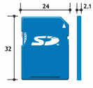 | 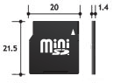 | 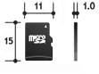
Area | 768 mm² (100) | 430 mm² | 165 mm²
Card Volume | 1,613 mm³ (100) | 602 mm³ | 165 mm³
Thickness | 2.1 mm | 1.4 mm | 1.0 mm
Weight | Approx. 2g | Approx. 1g | Approx. 0.5g
Number of pins | 9 pins | 11 pins | 8 pins
File System | FAT16/32 | FAT16/32 | FAT16/32
Operating Voltage | 2.7V - 3.6V | 2.7V - 3.6V | 2.7V - 3.6V
Write-protect Switch | YES | NO | NO
Copyright protection | CPRM | CPRM | CPRM
Compatibility | - | Yes (with adapter) | Yes (with adapter)
Capacity | Up to 2 GB | Up to 2 GB | Up to 2 GB
Table 9: Specifications of SD cards of Standard Formats

High-Capacity Formats
 | SDHC | miniSDHC | microSDHC
Size | 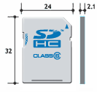 | 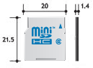 | 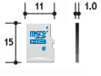
Area | 768 mm² (100) | 430 mm² | 165 mm²
Card Volume | 1,613 mm³ (100) | 602 mm³ | 165 mm³
Thickness | 2.1 mm | 1.4 mm | 1.0 mm
Weight | Approx. 2g | Approx. 1g | Approx. 0.5g
Number of pins | 9 pins | 11 pins | 8 pins
File System | FAT32 | FAT32 | FAT32
Operating Voltage | 2.7V - 3.6V | 2.7V - 3.6V | 2.7V - 3.6V
Write-protect Switch | YES | NO | NO
Copyright protection | CPRM | CPRM | CPRM
Compatibility | - | Yes (with adapter) | Yes (with adapter)
Capacity | 4 - 32 GB | 4 - 32 GB | 4 - 32 GB
Table 10: Specifications of SD cards of High-Capacity Formats
SDXC Formats
 | SDXC | microSDXC
Size | 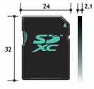 | 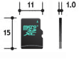
Area | 768 mm² | 165 mm²
Card Volume | 1,613 mm³ | 165 mm³
Thickness | 2.1 mm | 1.0 mm
Weight | Approx. 2g | Approx. 0.5g
Number of pins | 9 pins | 8 pins
File System | exFAT | exFAT
Operating Voltage | 2.7V - 3.6V | 2.7V - 3.6V
Write-protect Switch | YES | NO
Copyright protection | CPRM | CPRM
Compatibility | - | Yes (with adapter)
Capacity | Over 32 GB - 2 TB | Over 32 GB - 2 TB
Table 11: Specifications of SD cards of SD Extended Capacity Formats
The last consideration that must be made is how large, memory wise, do we need our microSD card to be. As we determined earlier, even with over exaggerated memory usage, the most space we would need is 10.5 MBs. Nowadays, almost any local electronics store carries a wide variety of sizes of microSD cards. Most of these SD cards tend to come in the gigabyte range. The standard, high-capacity, and extended capacity covers our memory usage needs. Nevertheless, from looking at local electronics stores, it does seem that the price of microSD cards does tend to be higher than that of a regular SD card as its size increases, meaning going to the high capacity and extended capacity formats. Therefore, we have determined it is to our advantage just to choose a microSD card from the standard format since our needs never even approach its 2GB max capacity.

4.4.4. SD Card Integration
Now that an SD card has been chosen, a method to integrate it with our microcontroller must be found. It was first considered that we would be integrating the card directly with the board using the same standards as many cameras and other electron peripherals. However, in order to use a SD card with its full speeds and capabilities, a license is required to be purchased from the SD Card Association. (32) Therefore, we have determined it in our best interests to find another means to interface the SD card into our system. We did find such a way. According to the SD Specifications of Secure Digital Input Output (SDIO) instated by the SD Card Association, Full-Speed cards and Low-Speed cards must support the Serial Peripheral Interface (SPI) transfer mode. (33) Full-Speed cards need to be able to support the full clock rates range of 0-25MHz and Low-Speed cards need to be able to support the full clock rate range of 0-400KHz. Therefore, we are using SPI mode to integrate the SD card with our microcontroller.
Now that we have method of how to interface our SD card on to our microcontroller, we must determine a way to implement it. The first thing we need to do is look at the SPI standard discussed in the sensor interfacing section and how to use it with the dsPIC33EP512MU810 for use with a SD card. A microSD cards has a layout of 8 pins. The question is, ‘How to do use these 8 pins to to create a SPI bus. Well, Microchip Technologies sheds some light on this topic for us. We first begin by going through the pin layout of a microSD card as provided by interfacebus.com. (34) When using a microSD card in SPI mode, pin 1 and pin 8 are not used. For SPI mode, a total of only four wires are used to interface two devices together. However, for the microSD card six wires must be used in order for it to function. This is because two of the pins are used to create a circuit which power the microSD card. (34) Pin 4 is used to provide the microSD card with a supply voltage of either 2.7 or 3.6 volts. Pin 6 is used as to connect the chip to ground. The four remaining pins are the ones used to create the SPI bus which is used to transfer data to and from our microcontroller to the microSD card. The SPI bus can be connected as follows: Pin 3 is used as the Serial Data Input pin, also known as the Master Out/Slave In (MOSI) pin. (34) (35) This master is the device which controls the clock signal. In our case, this is the microcontroller. The slave is the one who receives the clock signal and runs with the pulses sent by the master’s clock. Pin 7 is used as the Serial Data Output (SDO) pin also known as the Master In/Slave Out (MISO) pin. Pin 2 is used for Chip Select and pin 5 is used the serial clock (SCLK). (34) (35) An image of the pin layout can be seen in Figure 18.
Using the pin layout just described, we can connect our board to one of the SPI I/O on our microcontroller. As stated before, our microcontroller has four of these. In the hardware section of the design summary section can be found a detailed layout and description as to how the SD card is able to be connected to our microcontroller’s I/O via the printed circuit board. However, we will give a brief explanation here as well explaining our setup. The dsPIC33EP512MU810 has a multitude of pins for digital signal processing. Some of these pins are labeled RPn, for remappable with input and output functionality, with n is some integer to represent the remappable pin number. Other of these pins can be labeled RPIn, for remappable with only input functionality, with n again being some integer to represent the remappable pin number. The dsPIC33EP512MU810 is designed to run SPI on these remappable pins. Therefore, we must choose which pins we connect out microSD card to so that we may communicate with it. In addition, we must also choose which SPIx register to map our pins to on the processor, where x is the SPI register we use.
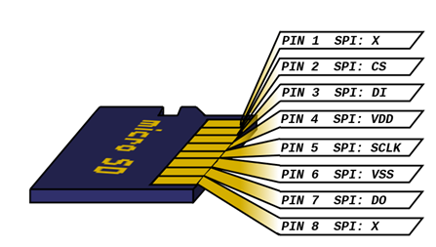
Figure 18: SPI Pin layout of a microSD card
Out of pure preference, we have decided to use SPI4 for use with the SD card so that first 3 free SPI registers may be used for our sensors. The pins on the microcontroller we have chosen to use are pins 87-90 as they are all pins that are remappable with input and output capabilities. Although we do not need all the pins to support data transfer both in and out, we have decided these pins were optimal as their physical locations were all sequential. Pin 87, identified as RP96, takes the role of serial clock (SCK4) on the SPI bus. This connects to pin 5 of the microSD card which is its serial clock pin (SCLK). Pin 88, identified as RP97, took the role of serial data out (SDO4) on the SPI bus. This connects to the data in (DI) pin on the microSD card which is the microSD card’s pin 3. Pin 89, identified as RP113, takes the role of serial data in (SDI4) on the SPI bus. This needed to connect to pin 7 on the microSD card which is used as the microSD card’s data out (DO). Lastly, pin 90, identified as RP112, takes the role of chip select (CS), also identified as slave select ($\overline{SS4}$) by the microcontroller documentation, on the SPI bus. Therefore, we connect this to pin 2 of the microSD card which is its chip select pin. Take note that there is a line above SS4 to show that it must be set low in order to activate.
In addition to just wiring the SD card to pins 87-90 on the microcontroller, we must also set the appropriate control register to set which pins are mapped to our SPI4 bus. The RPINRx registers are used to set the mappings for the inputs and the RPORx registers are used to set the mappings for the outputs. First we mapped the input registers. 7 bits of the register is used to set each of the remppable input pins. For the inputs of SPI4, Bits 14-8 of RPINR31 are used to set SCK4, bits 6-0 of RPINR31 are used to set SDI4, and bits 6-0 of RPINR32 are used to set$\overline{SS4}$. In order to set the remappable register, the 7 bits must be set to the corresponding remappable identifier that was discussed earlier. We first set RPINR3. For RPINR3, the microcontroller’s datasheet states that bit 7 and bit 15 are unimplemented and thereby always read as zero. Therefore, we just put zeros for those bits for simplicity. Now we just need to set the rest of the bits to assign SCK4 and SDI4. The corresponding bits listed in the microcontroller’s datasheet for RP96, which we assigned to SCK4, are 110 0000. The corresponding bits listed in the microcontroller’s datasheet for RP113, which we assigned to SCK4, are 111 0001. Using these values, we set RPINR31 to 0110 0000 0111 0001 so that the inputs SCK4 and SDI4 are mapped to the proper pins. Now we setup RPINR32. RPINR32’s bits 15-6 are unimplemented just as bit 7 and bit 15 were for RPINR31’s were. Therefore, just as before, we set these bits to 0. The corresponding 7 bits listed in the microcontroller’s datasheet for RP112, which we assigned to$\overline{SS4}$, are 111 0000. Using this, we set RPINR31 to 0000 0000 0000 0111 0000 so that$\overline{SS4}$ is mapped to the proper pin.
Now we move to the setting the output pins. SDO4, SCK4, and $\overline{SS4}$ must be set to output pins. As you can see, both SCK4 and$\overline{SS4}$ are being set again. This is because these two pins communicate data in and out, so these pins must be mapped both as inputs and outputs. Therefore, we are mapping them again to pins on the output registers. However, unlike the input registers which are mapped to a particular function, like SPI, the output registers represent the pins and you use a 6 bit code to tie the pin to that particular function. So, for SDO4, we are using RPOR7’s bits 13-8. The corresponding 6 bits which we use that are listed in the microcontroller’s datasheet for SDO4 are 10 0010. For SCK4 we use the same register as for SDO4; however we use bits 0-5. The corresponding 6 bits which we use that are listed in the microcontroller’s datasheet for SCK4 are 10 0011. Using the additional information that bits 15-14 and 7-6 are unimplemented, meaning they are always read as zero, we can set all the bits for register RPOR7. We set RPOR7 to 0010 0010 0010 0011 to map these output lines. For our $\overline{SS4}$ output line, we use register RPOR12’s bits 13-8. The corresponding 6 bits which we use that are listed in the microcontroller’s datasheet for $\overline{SS4}$ are 10 0100. Just as before, bits 15-14 and 7-6 are unimplemented and are always read as 0 so we just set these bits to 0. In order to allow us to show the full binary value of RPOR12 in this section, we just assume it is known bits 5-0 are 10 0000. 10 0000 are the 6 bits designated in the microcontroller’s data sheet for SCK3 which is using these bits to set RP109. SPI3s implementation is found to be discussed in the section describing the temperature sensor. Anyways, using all of this information we can set RPOR12 to 0010 0100 0010 0000 thereby assigning$\overline{SS4}$’s output line to pin 90.

4.4.5 File System I/O Library Setup
Microchip Technologies has provided several libraries which can be used when programming their microcontrollers. In particular, Microchip Technologies has a memory disk drive file system library which provides all the necessary functionality to easily implement file I/O on a SD card or other memory device. (36) Therefore we have decided it is in our best interest to use their prebuilt functions in order to create a program that provide us with the best results for our sponsor. Now that we have mapped pins 87-90 to SPI4, we can begin our communication with the microSD card using this library.
However, before we begin to use Microchip Technologies’ library, some common facts need to be made known in order to communicate with a microSD card. First, the microSD card always reads data input on the rising edge of the clock cycle. (35) Additionally, the microSD card outputs its data on the falling edge of the clock cycle. According to (35), an initialization routine is required to use SPI mode with a microSD card because when an SD card wakes up upon being powered for the first time, it sets itself in SD Bus mode. Initialization is very simple and just requires setting the chip select pin to the logical low position when the microcontroller receives the Reset command, described as CMD0, from the microSD card. Using the library provided by Microchip Technologies, we can successfully and easy follow all these guidelines in order to communicate with our microSD card as all of these factors are preprogrammed into the libraries initialization routine.
In order to use Microchip Technologies’ memory disk drive file system library we must first setup our program to use this library. The first thing that needs to be done is add an appropriate physical layer file to our project. Since we are using a microSD card, we add the physical layer files for an SD card. These files are SD-SPI.c and SD-SPI.h. Additionally, we need add the configuration information needed to use the library. The files which store the configuration macros used for the memory disk drive file system library to work are stored in the header files FSconfig.h and HardwareProfiles.h. After this the file manipulation layer must be imported. The files used for this are FSIO.h and FSIO.c. These files contain the functions which is used for manipulating files across the physical layer, i.e. our microSD card. Next we must import FSDefs.h. This file is used to provide certain function definitions which during the setting up of our file system on our microSD card. Lastly, GenericTypeDefs.h must be available to our system. This file defines the generic types that can be used for writing to our microSD card. In particular, the use of the type ‘long’.
Once we have imported all of these files, there are some initial parameters which must be defined in the configuration macros. The first one we must define for the library is the systems clock rate. Since we are not using an external crystal or other device to act as our oscillator, we have decided to use the microcontroller’s internal oscillator for the clock speed. Using the Internal Fast RC (FRC) oscillator, which has a maximum frequency of 7.37 MHz, in Phase-Locked Loop mode, we can obtain a frequency of 120 MHz. Since we have decided to use the microcontroller at its maximum capable speed, we defined the system clock frequency as such. The system clock frequency is labeled as GetSystemClock() in the HardwareProfiles.h file. Since the header file requires we define its definition in terms of hertz instead of megahertz, we define this parameter with the value 120000000.
The next thing we need to do is setup the file system library with which SPI module we are using to connect to the microSD card. In the HardwareProfies.h header file under the pin and register definitions section for “__PIC24F__” microcontrollers is where we set these options. (Note: Although we are using a microcontroller from the dsPIC33 family, since PIC24 is 16-bit microcontroller like the microcontrollers from the dsPIC33 family, these settings listed here is used for our microcontroller.) Below, in Table 12, we have listed the values we must define and the definitions we define them with to set the microSD card up to use SPI4. This must be done since the default values listen in the library are set for SPI1.
Value | Definition
SPICON1 | SPI4CON1
SPISTAT | SPI4STAT
SPIBUF | SPI4BUF
SPISTAT_RBF | SPI4STATbits.SPIRBF
SPICON1bits | SPI4CON1bits
SPISTATbits | SPI4STATbits
Table 12: Setup to use SPI4 with the memory disk drive file system library
Now, we need to set weather to use dynamic or static memory allocation for the size of our file object. Since we will not know the size that is needed for our file object at the beginning, to be safe, we set the microcontroller to do dynamic memory allocation. To do this, in the FSconfig.h file, we need to set the preprocessor directive from its default value of “#if 0”, meaning that the use of dynamic memory is false, to “#if 1”, meaning that the use of dynamic memory is true. This allows the use of a dynamic heap to be used to store the file object. However, in order to use the heap, it must first be set up in the build options. If it is not setup in the build options, then files will just be setup using a static array. We don’t want this to happen. So, in the build options’ “MPLAB LINK30” tab, we can designate we want a heap and it size. This can be seen in Figure 19 below. We set the heap up to be 64 bytes since one file object is 46 bytes and the memory allocation algorithm is stated to take slightly more memory than the actual file size.
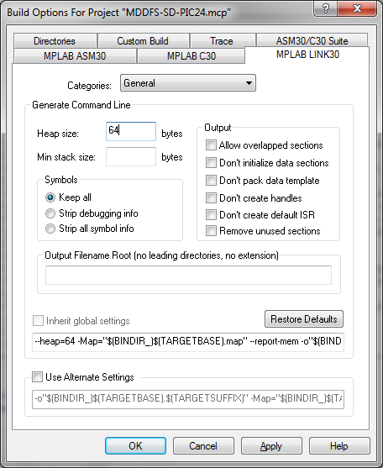
Figure 19: Heap Setup Options
After all that has been done, we need to make sure to go to the Directories tab and under “Include Search Path” make sure to include all of the directories containing the files for the file system library are listed. Listed in Error! Reference source not found.Figure 20 are all of the include paths that need to be used for use of this library. These paths must be included in the Include Spearch Path section or our program would not be able to link to the libraries it is using.
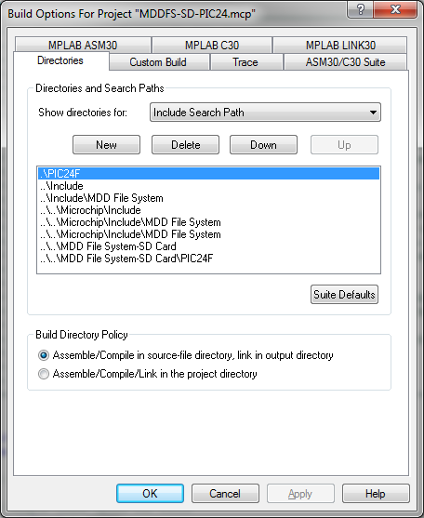
Figure 20: Library Include Paths

Last we need to set a method for timestamps on files. Since all data is recorded in order in one file, timestamps are not be of great importance. However, any time a file is created or modified, it must have a time stamp. Therefore, we must have some method to give the files timestamps. Therefore we used the INCREMENTTIMESTAMP macro for timestamps. This macro simply set a static value as the time of the file and increment it every time the file is updated. In order to enable this functionality, we must enable it in the FSconfig.h header file by uncommenting it. Since the USEREALTIMECLOCK macro is enable by default and we cannot have two timestamp methods enable at the same time, we had to comment out the USEREALTIMECLOCK macro.

4.4.6. File System I/O Library Use
Since the library is now integrated into our system, we can now begin to use it. First we must use the MDD_MediaDetect() function to confirm that there is the microSD card is present to the system. Once a value of true is returned, we can initialize the card. To do this we run the FSinit() function. This returns a value of true when it has finished. The FSinit() function first initializes the card and then load the master boot record and its boot sector.
After the card has been initialized, we can create file on the microSD card. We then assign the file to a pointer where we can write data. Using the FSopen() function we can create a new file as well as open a preexisting one. FSopen() is feed two parameters in order to be used. The first is the file name and the second is what type of acess we want to the file (i.e. “w” for write). Because we do not want to accedently write over old data, we first settup the file with read only access. Since the file shouldn’t exist, a CE_FILE_NOT_FOUND error is returned. Upon receiving this error, we can then create a new file with the FSopen() function. If a file does already exist, then we create a new file with a sequential number appended to the end of its name and check again to make sure that the file doesn’t exist. This loop continues to run until a name is found that hasn’t been used. Nevertheless, the case of this happening should be rare as we do not plan on running multiple flights on one microSD card.
No particular extension is nescissay for our file. Since we are just be storing raw bytes of data, the extention we choose with be irrelevent. However, just because having a extention is standard, the extention “.out” is used. We use a custom C program that runs on a PC to read the raw data from our custom formated file.
Now we create a buffer which is used to store the data before sending it to the microSD card. We have determined it is best for us to send the data to the microSD card in chunks containing all the values from the sensors for one cycle. Therefore, our buffer is an array of 38 longs. Data is added to the buffer in the order of the following table, Table 13.

- Force #1  - Force #2  - Force #3  - Force #4  - Force #5  - Force #6  - Force #7  - Force #8  - Force #9  - Force #10  - Force #11  - Force #12  - Force #13  - Force #14 | - Force #15  - Force #16  - Force #17  - Force #18  - Force #19  - Force #20  - Force #21  - Force #22  - Force #23  - Force #24  - Force #25  - Force #26  - Force #27  - Force #28 | - Force #29  - Force #30  - Differential Pressure  - Humidity  - Angle #1  - Angle #2  - Barometric Pressure  - Temperature  - Gyroscope  - Accelerometer
Table 13: Sensor Read Order
Once all 38 pieces of data have been added to the buffer, we use the FSwrite() function to write the data to our file. The FSwrite() function takes in 4 parameters. The first is a pointer to the buffer which contains the sensor data. The second parameter is the size of each unit to be transferred in bytes. In our case, this is a long. A long has 32 bits which is equivalent to 4 bytes. The third value in the function is how many units of the size specified in parameter two is transferred. Since we have 38 items in our array, the number of transfers of 4 bytes is 38. The last parameter is a pointer to the file we opened earlier with the FSopen() function. After the function is run, unless an error occurs, the number inputted for parameter three is returned. If the number is not equal to the number of units transferred, then that means not all of the information from the buffer was written.
Once we have finished writing the values to the microSD card, we can clear the buffer holding our sensor data. We can now use this buffer again to store a new set of data received from our sensors. The FSwrite() function can now be used just as before to store the data from the buffer to the microSD card. We continuously repeat this process until the flight is finished. At this point, a signal is sent to the file system library to close the file which allows us to safely remove the microSD card. If the file is not closed properly, it is highly possible that our data is unreadable and the work done by the microcontroller is lost.

4.5. UAV Controls Subsystem

4.5.1. Autopilot
In order to achieve maximum accuracy and simulate consistent flight for each trial, our sponsor required the use of an autopilot system to control the plan during flight. Since neither any one on our team or any of our sponsors was personally familiar with flying remote controlled aircrafts, we had to dig deep to research the options available before making any purchases. It was first suggested that we meet with UCF professor, Dr. Chew, for his advice on what approach would best meet our needs.
After speaking with Dr. Qu on several different occasions, we obtained a handful of advice concerning our autopilot requirement. At first our sponsors were making hints that we buy an autopilot system created by a large commercial company, Cloud Cap Technology. Their autopilot mechanisms, recognized as Piccolo systems, are a common piece of hardware that is made with ideals of selling to higher end customers, such as the U.S. Coast Guard and other big companies. With that in mind, our sponsors at L-3 also suggested that we review other open-source autopilots. Our last option that passed in thought was to add an autopilot system to our design and create our own, custom tailored flight management system. Before we delve into deciding which option is the best match for our project, we break down what is included in an autopilot system for remote controlled airplanes and list the common elements that make them up.
Luckily there are tons of options available for flight management systems – commercial designs and open-source autopilot systems. No matter whether designed in a factory line or in someone’s garage, an autopilot is comprised of hardware components and complex software to manipulate the system and plane’s equipment. Since the commercially designed systems are proprietary, we are unable to know for sure what components they are comprised of and how the system’s software operates. For the example of understanding the basics of the autopilot system, we review the Attopilot 2.0 RTL. The other Attopilot models are all similar with a few striking features, but we will use the simplest version just to exemplify all the basic parts that make up an autopilot.
The tagline Attopilot International inserted on their website next to the picture of the RTL version states “Designed with the hobbyist in mind”. (37) This ideal is exactly what we need for our project because although we are sponsored, we are still trying to stick to a tight budget. Even though we expected the “home made”, open source autopilots to be to be under two hundred dollars, that estimate was too low. We had to continue searching between several brands and limit the features available on the desired autopilot to stay within our desired budget. As stated this version of the Attopilot, it is the low end version with minimal features and accessories in order to make the part affordable for the average remote control plane enthusiast. Figure 21 below is a picture of the chip and sensors found inside the Attopilot RTL.
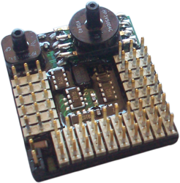
Figure 21: Attopilot Version 2.0 Control Unit
As can be noticed in Figure 21, the device is made of plenty micro embedded chips and is surprisingly small. This control unit measures only 1.5 inches wide by 2 inches long and ½ an inch tall. (38) All autopilots vary in sizes available, because they depend on so many factors – durability, accessories, capabilities desired, and other needs. Another thing that can vastly change the size of the autopilot hardware is the device they are planned to be used on. The autopilot designed for our needs may be of this size or slightly larger, where as an actual MQ-9 unmanned aerial vehicle, measuring wing spans of over 80 feet, would require a larger, more complex flight management structure. (39) As previously stated, these autopilots cannot be fully functional if they lack a set of primary sensors.
The Attopilot consists of a decent list of hardware: seven servos; five remote control inputs; stabilization system; on board data logging; two way telemetry; global positioning sensor; pressure sensors; 3-axis accelerometer; and 3-axis gyroscope. As seen in the list, although this is a simple autopilot, the internal devices are nowhere near as simple as expected. The servos serve a few different purposes in the autopilot. Four of the seven servos are to control the motor speed by limiting power supplied to the motor(s). Two more servos are designated to control gimbals that adjust the plane’s pan and tilt. The last servo is created to handle the user desired flight mode. This autopilot also allows the user three different flight modes – autopilot bypass or manual flight mode, assisted radio control, and return to launch. (38)
After the servos, the autopilot offers a stabilization system. The stabilization feature allows for automatic altitude control based upon airspeed, which is calculated through the use of one of the pressure sensors. In addition to being stabilized by an altitude altering function, the autopilot is guided by following global coordinates sent to the GPS. Without the GPS added, the system would only be a flight stabilizer rather than an autopilot. The other key piece to the use of global positioning is consistent communication to a ground system, either a remote control or an entirely separate device like an actual ground-to-air station used for real airplanes. This communication is established through two-way telemetry with room for up to three kilometers of signal radius from the home signal. As mentioned earlier, this autopilot offers the ability to automatically handle flight elevation and this is accomplished through the use of its barometric pressure sensor. (38) The only remaining sensors are the 3-axis accelerometer and gyroscope.
Our system design also uses an accelerometer and gyroscope in the sensors of our data logging system, more descriptive details concerning these sensors are available in the various sensor details section. In relation to our system, these data polling is treated very similar to the way we receive and utilize data from these sensors. Both applications of the sensors retrieve 3D acceleration and rotation data, verify validity, and determine orientation of the plane. The only difference is that the autopilot not only records this data, but also reacts to the behaviors in order to stabilize the plane’s flight pattern. Figure 22, shown below, illustrates how an Attopilot could be installed inside a remote control plane.
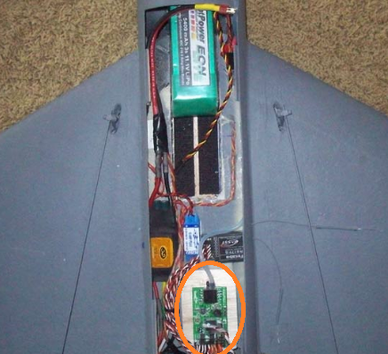
Figure 22: Attopilot Installed on Plane
The Attopilot system can be found at the bottom of Figure 22, circled in orange. That summarizes just about all of the hardware specifications for this autopilot.
Now that we know all the key pieces of hardware, we will move on to discuss the software aspect of using an autopilot. One of the very neat things about the Attopilot software, and that of other autopilots, is that it is very user friendly for the most part. It should be noted that this statement is not always the case for every autopilot. Some autopilots only offer programs with very little graphical support and other abilities. Since Attopilot is the example we are using, we will focus on the Attopilot International software – although the use of external software among all autopilots is not a set standard. Before talking about the external software used to display data to an end user, we will discuss the internal software components of the software.
Unlike external software which sometimes comes as an unnecessary add on with most autopilots, the internal programming in the autopilot system is as necessary as all of the sensors. Inner programming is best described as the software on the embedded level which establishes communication between all the hardware components. With that said, the software at this level is not directly changed by the user. The reason is because we don’t want to disable or damage any feature which might result in faulty flying or worse, crashing the plane. Although it has not been mentioned yet as to what aircrafts the autopilots can be found on, the list of planes that these devices can control is too long to list. This is because the autopilot system must utilize a configuration file that contains a thorough list of specific parameters about plain characteristics. As mentioned before, the user does not directly alter any code, but by changing the values in the autopilot’s plane configuration file, it can adjust how the autopilot performs. For example, changing the maximum motor output will force the autopilot’s controller unit to adjust the amount of power sent to the motor to properly adjust the change. Sometimes the manufacturer provides easy to use software that asks users for particulars about the aircraft that is used. In other instances, the autopilot system – mostly common in open-source systems – requires the user to manually adjust data in the configuration of the airplane profile configuration file. The Attopilot RTL system supports both operations if the user needs to change the flight profile. Speaking of external software provided, we will quickly discuss the premier software provided with the Attopilot. To start, Figure 23 shown on the next page illustrates the autopilot ground control station.
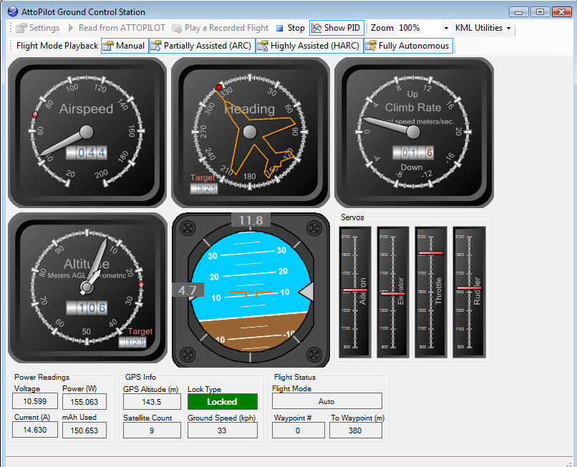
Figure 23: Attopilot Computer Software
As stated before, this software has been designed with a very nice graphical interface. The designers for this program even aimed to make the values displayed appear similar to flight controls present on actual flight readings on airplanes. It should be noted that the data for this interface is actual live data and it is only attainable if the autopilot and computer hardware includes some form of a radio communicator. Other important software that is added is waypoint marking – this is how to tell the autopilot where to go before flight. Most systems like the Attopilot that utilize GPS waypoint markers usually store a file on external memory, such as a micro SD card. A common file type for the list of waypoints is the Google Earth standard KML output file. This file is simply a list of waypoints and the autopilot’s internal software offers the ability to read this file. In the rare event that the system doesn’t support reading a KML file, there are some KML-to-Text tools available across the net. But, with the ability to set the plane’s check points, we are able to complete the same diagnostic test, time and time again. Figure 24 illustrates a flight defined through Google Earth points.
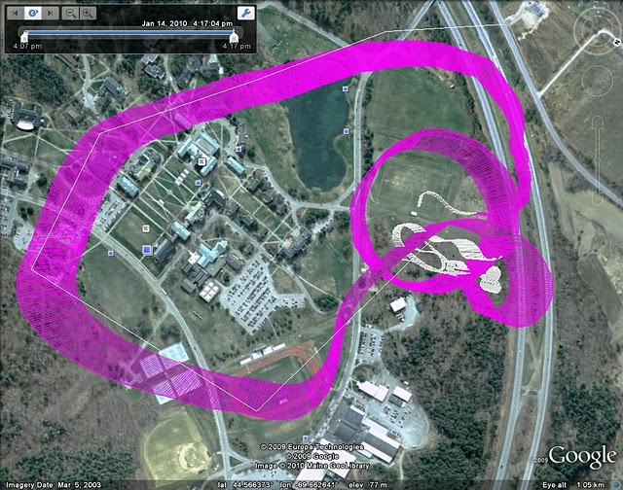
Figure 24: Path of an Airplane Using Autopilot
As seen in the figure above, there is a thin white line that is the track designated by the user and the thick purple line which illustrates the actual path taken through flight. As stated before, some autopilots offer the ability to track elevation and the Google Earth is able to display these changes made in altitude. This can be noted in Figure 4 by the thickness of the purple band – the thicker, lighter colored parts represent higher altitudes. This signifies the end of all software and hardware aspects of a generic autopilot. Now we show how we decided on the best autopilot for our system.
As already presented, there a few generic options that we have to sort through and determine the most desirable part. The first is the use a commercial autopilot; second option is using an open-source; and the final choice available would be to create our own home made version.
Strategy 1 – Commercial Autopilots
Pros: These devices are made with high end customers in mind. Cloud Cap Technology is one of the premiere companies that make top of the line autopilot systems for various cases of extreme needs. A few examples of these severe situations can be mission critical flights of a UAV over hostile enemy territory or the flight of a UAV over a forest searching for a lost person. Since most of the customer needs are so sensitive to being as perfect as possible, the equipment is usually highly durable, long lasting, and extremely accurate. Lastly, since this is manufactured by a company, there is plenty of customer support ready and available, if ever needed.
Cons: Although these top end controllers are very precise, have long lifetimes, and offer plenty of non-standard features, they all come at a cost and a very steep one at that. As of word from Dr. Chew, some of the Piccolo brand autopilot systems start out at a value of $3,000 and top out at a total of $20,000. In addition to that, they are usually a little more bulky in size. Figure 25 shows the 2.5x5.0 inch size of a Piccolo autopilot.
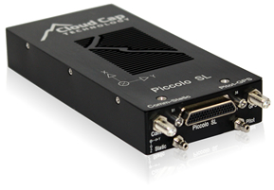
Figure 25: Piccolo Autopilot System
Although relatively small to the plane, it is a lot bigger than the Attopilot chip and its heaviness might have a drastic impact on flight patterns and cause a skew in data.
Strategy 2 – Open-source Autopilots
Pros: There are a handful of different open-source autopilots with plenty of community support. Just to name a few common ones, the options include Attopilot, ArduPilot, Paparazzi, and EasyUAV. Although it is not usually sold as a “work right out of the box” set, it allows for a lot of expansion to add accessories or change anything if necessary. Another plus to the “some assembly required” aspect is that we are able to pick only what we need and save on labor cost of the manufacturer putting parts together. Another bonus is that these parts are made with RC plane hobbyists in mind, so they try to focus on increasing functionality while trying to limit cost. And since they are made with the enthusiast’s needs as a priority, they are also very small. For example, the size of a common open-source controller is shown below.
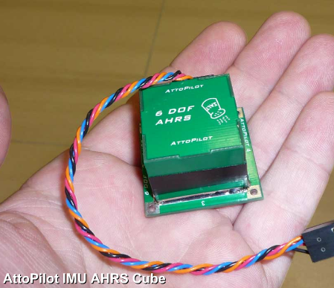
Figure 26: Attopilot Cube Control Unit
Cons: Since some of these systems are open-source, they may not be as accurate or reliable as one manufactured. To add to that, most problems is dealt with doing personal searches online for people who experienced similar problems and have them solved. Another detractor is that not all open-source autopilots are cheap. Some options, such as the Attopilot starts at almost $800 for the cheapest model available. Finally, some autopilot systems are difficult to get all the hardware for because they require specific sensor types to work, which may or may not be available. And on top of that, most of these options are not designed to work “right out the box” and the hardware and software need to be configured to work together.
Strategy 3 – Homemade Autopilot
Pros: Again, this is another cheaper route to handle the autopilot. With all the open-source autopilot projects out and available, it would be fairly easy to get good ideas for hardware and software design. And software design may not be too complicated because open-source software entitles all users to modify the code as necessary – another stipulation is being willing to share code, which would not have been a problem for us or our sponsor to approve of. Another benefit is that adding this feature would allow for more room for electrical and computer engineering design.
Cons: Although the cheapest and most educational route, it would be too time demanding to implement into our system. Another shortcoming of this method is that accuracy may be slightly lower and flight stabilization may not be as effective as one offered in an open-source package. And even more so in this method than the other two, there is no true customer support – only option is to troubleshoot and determine the root of the problem and the best solution to fix it.
Conclusion: Knowing that our sponsor is only expecting a budget of $2,000, we immediately crossed out the option of getting a professional grade autopilot. We aimed to have a very high accuracy turnaround from our final project, but it did not need to be top end quality. The next option was to use an open-source autopilot, which seemed to match our needs of something effective, yet financially feasible. So keeping that in mind, we compared this option to creating our own personal autopilot. The homemade autopilot would allow us to really personalize anything we desired from the flight manager and keep any unnecessary cost to a minimal. The only problem is that due to the demand for much additional time from the electrical engineering and software programming aspects, we would not have enough resources to build an autopilot alongside creating a data logging system. So in the end, it was determined that the best option for us is the open-source autopilot and we bought the hardware, obtain the software and create the autopilot system.
Since we decided on using open-source systems available in the market, we first limited our choices to the four main options: Paparazzi, Attopilot, EasyUAV, and ArduPilot. When going through each of the choices, some things had appealed to our likings and others detracted from their value. The first system to be scrutinized was the Paparazzi system. One perk that stood out to us is the cheap cost of building this system, but since it required so much assembly, it took away interest. (40) Since this approached seem very similar to creating a homemade autopilot, we moved onto the next to see what options were available.
After dealing with Paparazzi, we wanted to see if any of the options came ready to be used out of the box. The next option was Attopilot, which was the autopilot referred to multiple times before in this section. Although the features in it were immaculate and nice, the price was higher than expected so we continued our search. We then came across the EasyUAV, which seemed to offer a great amount of detailed documentation and a handful of support. One of the issues with this system was the complaints from other hobbyists who didn’t approve of this system. In addition, the owner’s desire to keep everything proprietary shot down our goal of having a truly open-source autopilot. (41) The final option seemed to fit perfect – ArduPilot works right out of the box (for the most part), it is 100% open-source, and a common favorite amongst a decent amount of RC plane flyers. Minor soldering is necessary for the autopilot, but the team agreed that this doesn’t detract from the value of it much. To add upon that, the total cost for a preassembled autopilot, ground control station, and a PCB shield was under $500. So in both financial and engineering terms, the ArduPilot Mega is the best fit for our project.

4.5.2 Manual Flight Override
The control of the airplane is in a hierarchy once the autopilot is installed, since now there is manual control of via the transmitter, and autonomous control via the Ardupilot Mega. The autopilot once installed is in primary control of the aircraft, and the transmitter has secondary control. However the User can override the autopilot control simply by issuing instructions via the transmitter. If the user moves the paddles or switches on the transmitter, the autopilot's control is overridden and the user will assume control, and when the transmitter becomes inactive then the autopilot will assume control again, which is simply a reflection of the programmed control its been given by the user. Furthermore because the autopilot ground station allows the user to issue new flight path commands to the aircraft thereby changing the flight course in real time. Therefore the user is always in control during flight, and the manual override of the aircraft controls can be taken in software (ground station) and hardware (R/C transmitter).
4.6 User Interface Software Subsystem
The GUI is simple, just enough to make it easier to find and create files. There is a total of three buttons, two text boxes, and two labels. The labels is above the text box describing if the file is the source or the destination file. The two browse buttons is on the side of the text box and open file finders. When a file is selected it is put in the text field. The last button is a create button. This button executes the core part of the program. Figure 27 is a screen shot of the planned GUI design done in Microsoft® Visual Studio®
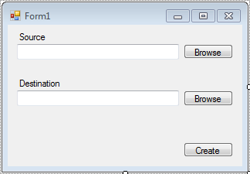
Figure 27: GUI Interface

5. Design Summary of Hardware and Software

5.1 Hardware

All of the schematics for the sensors are described in this section. Each sensor is briefly described to explain its use and operation needs. As a common note for all of the schematics, the electrical engineer followed a certain continuous layout in each schematic, where practical: all power inputs are set on the top or left side of the schematic, other inputs on the left, output signals to the right and ground to the bottom. The first schematic is the various power supplies shown in Figure 28. The figures of schematics span from Figure 28: Power Supplies to Figure 37: Altitude Sensor.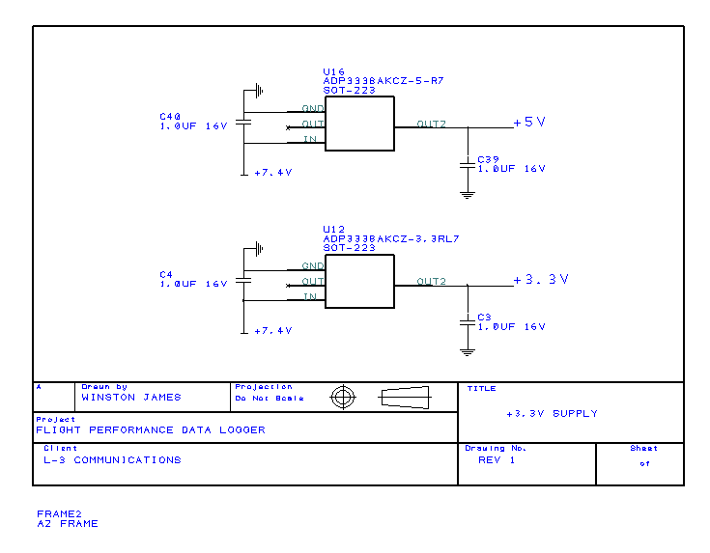
Figure 28: Power Supplies

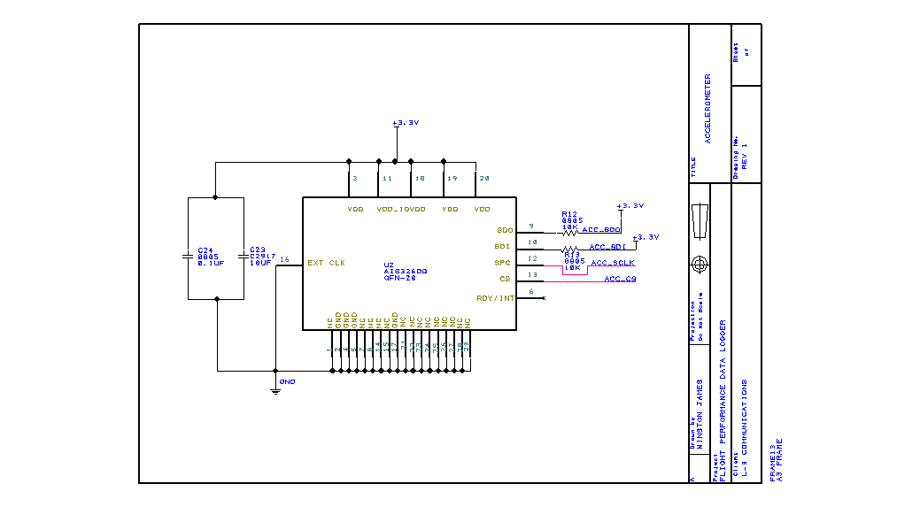
Figure 29: Accelerometer

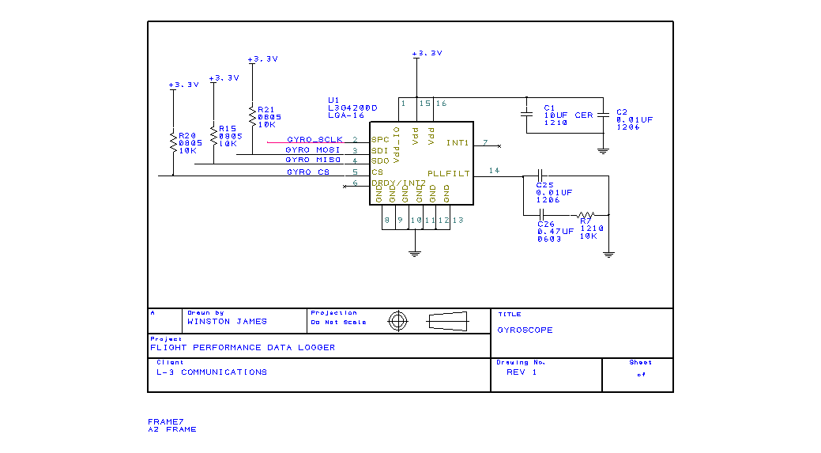
Figure 30: Gyroscope

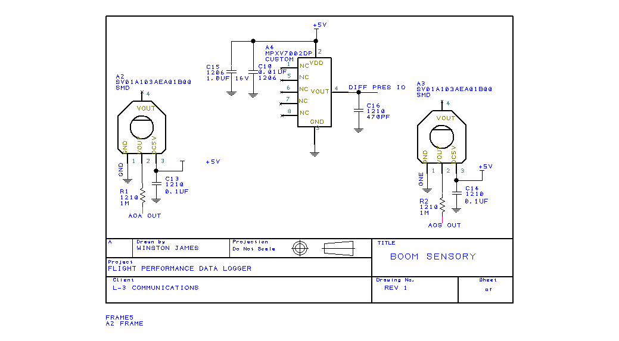
Figure 31: Angle Sensors
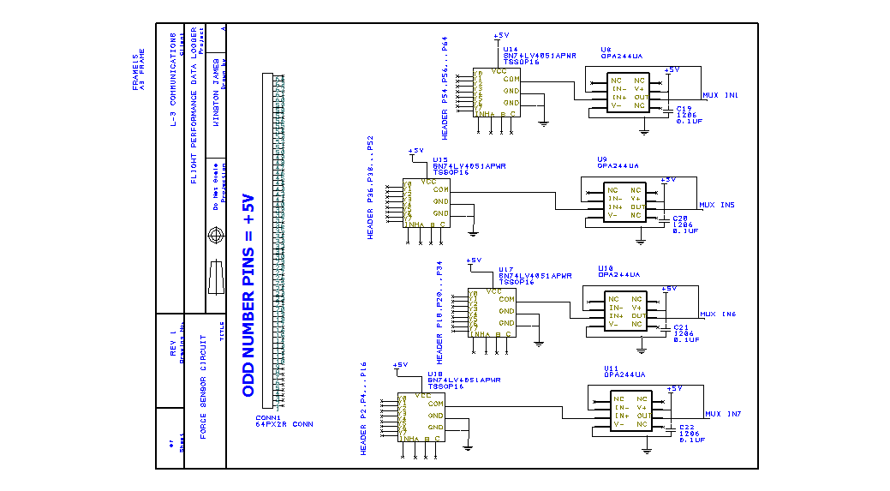
Figure 32: Force Sensors Circuit
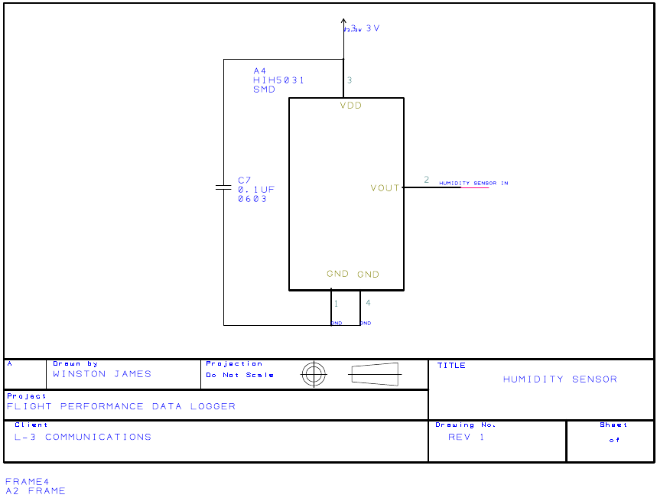
Figure 33: Humidity Sensor
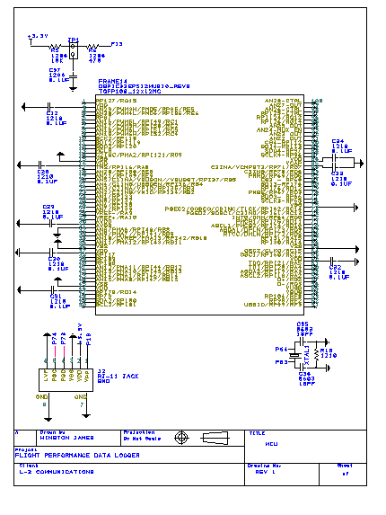
Figure 34: Microcontroller

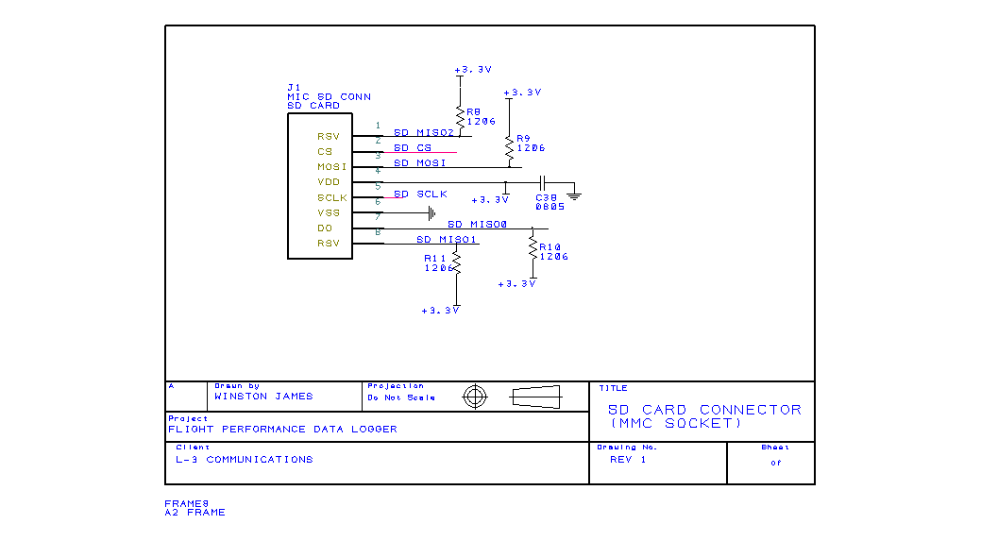
Figure 35: SD Card Connector

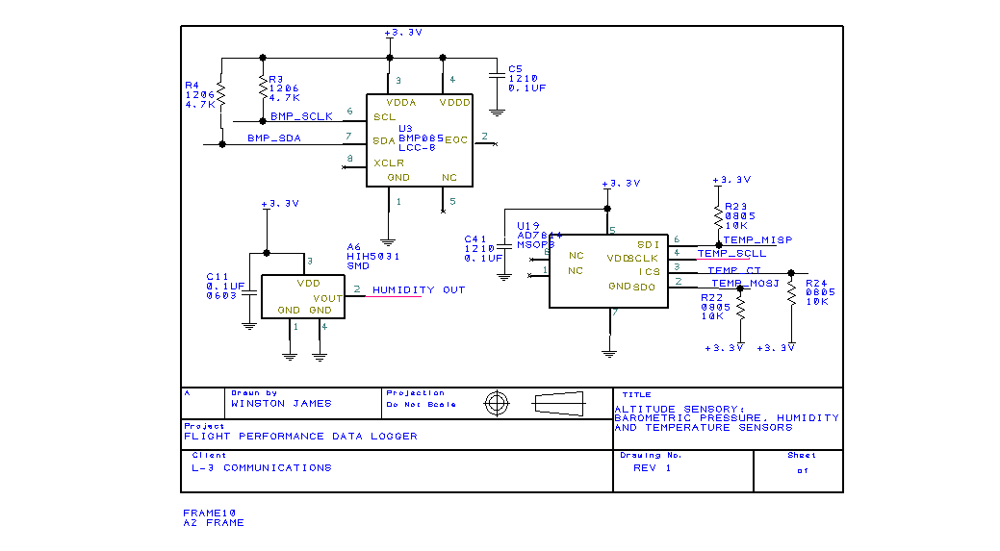
Figure 37: Altitude Sensor
5.2 Software
5.2.1 Program Overview
The program is designed as a method to take the data off of the storage device used on the sensor array. Then to take the data points and condense them to average values to allow for computation. Next the program runs mathematical functions to find any remaining values that need to be found. and finally output the results to a file.
The retrieval portion of the design first copies all the data from the file and save it. This is to avoid any problems with the file closing unexpectedly. With all the information stored the next step is to take that information and put it into meaningful structures. The program parses though the data and fill each structure with the appropriate values in the correct places. The order of the data is impotent to where everything goes in the structure. After the structures are filled the reduction isgin.
For this part a function fill a new data structure with the average values of the given data points. a series of loops achieve this easily. On top of this, some of the values needed are derivatives so in addition to finding the average values of the raw data this function find the average of the derivatives needed for calculations. All of these values is stored in a single structure for easy access later on in the program.
The next step is to compute the values needed by the client from the values collected. This is achieved through a series of functions that is specifically made to do these mathematical processes. The values is stored in the program as a structure at this point would be cumbersome. After all these values are found, with the relatively simple mathematical computation, the output is put to the user’s specified file. The format is used to make the output file look as much like the client’s simulator output file as possible. This allows for easy comparison.
5.2.2 Class Overview
Considering classes for this project there could reasonably be up to six classes. in deciding how many classes to use for this project consideration is given to complexity of the program, complexity of each class, and how much simpler a class made the building process of program. As for the classes, the ones considered potentially reasonable are a main class to call the GUI, a class counting the GUI, a class for the function calls, and a class for each of the three data structure.
The project is not considering other classes because there is no need. Every possible class cannot be discussed because there is an infinite amount of classes that could apply; granted most would do little or nothing to contribute to the project. So the six classes mentioned above are considered the most that are needed without needlessly making wasted classes.
The classes that were picked were picked to be discussed were picked because the class has potential to contribute to the program. The main class and the GUI program is automatically generated when a form is created. The functions class would make it easier to swap out functions if desired in the future. And each of the data structures could be classes to make computation easier.
5.2.3 Function Overview
There are a total of five different types of functions that is used in this program. Four have been mentioned already, the loading, computing, finding, and saving. The fifth type is the GUI functions. These are things that happen when you click buttons.
Starting with the GUI functions there is three of them. One for each browse button and one for the compute button. The compute button is going to start the main part of the program. There is two loading function. The first opens the file and load the raw data. The second takes the raw data and parse it. There is one computing function. it takes all the parsed data and average it into the one values data structure. This function is longer than it sounds. There is many finding functions, one for each value that needs to be found. Each one takes different values to find different things. The last function is the saving function. It prints the parsed and found data onto a file for the user to compare.
5.2.4 Data Structure Overview
There could reasonable be up to four data structures. In determining if a structure should be include this project has chosen to focus on if and how a structure help simplify the program, and how easy it would be to add or remove data structures if the client chooses to change the program in the future. The four structures in question is a load structure, a parse structure, a values structure, and a results structure.
5.2.5 Program Structure Overview
The program is structured in a way that allows for easy manipulation and reading. Comments is spread throughout the program. There is 3 data structures one for the file input to be saved and one for the variables in the file. The third data structure is used for the average values and derivatives found. there in the main part of the program there is a series of function calls. Each call does one specific calculation and return the answer to a variable stored in the main part of the program. After all the functions are called the program creates a file that the client can then use to compare with the simulator.
For reading the file first the client has to enter or browse for the file. This is done with as simple GUI consisting of a place for a source file, destination file, and a create button. When both the source and destination files are selected the user then clicks the create button and the program runs.
The first thing the program does is check to see if the files exist. if the source file doesn’t exist it informs the user. If the destination file does exist it asks the user if he/she wants to overwrite the file. From here the source file is opened. Once open the program copies the content of the file into the first data structure. The information is to be copied so that the file can be closed as soon as possible. The slowest part of this program is likely to be this part because it is being designed to come off an external storage device. Getting the information off all at once helps to avoid accidental removal of the source file half way through the program. After the file is read and all the content copied the file is closed.
Next the program checks that the information is in the correct format. Because of the method of storage the file has to be predictable with packet stamps and a set number of data points for each one. If the file is not in the correct format it informs the user. This could happen if there was corruption of the file for some reason. It is an important step because the program gives the wrong answer is not checked.
After the file is checked the program takes the information from the file and parse out the different variables. Each variable has a value in the second data structure. This data structure has to be a vector or linked list to hold all the information in a meaningful way. Once the information is parsed and in the second data structure the first structure is freed from memory.
The second data structure is used to find the average values of each value. This average value is needed to do the calculations. The structure is put through loops to average the values. These new values is stored the third structure. After these main averages are found the program needs to find the derivatives of some of the values. These values are also calculated and stored in the third structure. After all these values are found the second structure is freed form memory.
From here there is a series of function calls made to calculate the rest of the values. Each function call saves its calculated number in a regular variable. these variables are not being put in any structure so that is more calculations are added in the future the new programmer just needs to make the function and set a variable to it. The future programmer can avoid trying to find and change the structure.
Finally the destination file is opened and the desired information is save on the file. There is a conformation telling the user that the file was created. Once done the program frees the third data structure and wait for the user to start the process over again.
It turns out we needed two pieces of software. The second one was created in order to find the moment of inertia (I) of the plane. To do this we measured out where the force sensors were relative to the center of gravity and the angle at which they were facing. Form there we used simple torque equations solved for I and then used that content in the final software.

6. Project Prototype Construction and Coding

6.1. Various Sensor Details
The aim of this section is to dispel the difficulty in choosing the best options of different choices between SPI and I²C interface protocols. Although it has been noted that the final system has over thirty sensors in it, there is multiples of the same type. All of the sensors that are used and their purpose are shown below:
- 3-axis gyroscope – Torques and moments
- 3-axis accelerometer – Drag forces
- Rotary position sensor – Angle-of-attack, Angle-of-sideslip
- Humidity sensor – Air density
- Temperature sensor – Air density
- Barometric pressure sensor – Altitude
- Differential pressure sensor – Engine thrust
- Force sensor – Torques and forces

For each of the sensors listed above, we will discuss the various, vital specifications; why that part was chosen; data output options; and which form of output best suits our system requirements.

6.1.1. 3-Axis Gyroscope
The gyroscope chosen is ST Microelectronics’ L-3G4200D. The main purpose of this digital angle rate sensor is to determine torque and moments of the plane. There is only one gyroscope installed on the board and the main board shall be placed inside the body of the plane, most likely in the bow. Gyroscope technology has been used in a few other common forms of technology, such as Nintendo’s Wii MotionPlus controller. Nintendo used it in their system along with an accelerometer to further refine measurement of a player’s orientation and movement relative to all three axes. (42) Our project utilizes both sensors in a similar manner. More details of the two sensors working together is discussed later on in the gyroscope section.
In short, we plan to use the equation for torque given the angular velocity of the object to determine moment on the system. The equation is shown below and the meaning of each variable is defined thereafter:
$$τ= Mωd^{2}=fdsin(θ)$$
$$τ=Torque$$
M = mass of the plane
ω = instantaneous angular velocity
d = distance from center of aircraft to the point of force
f = force on the plane
θ = angle between the direction of the force and the surface normal

The gyroscope records the angular velocity and help determine the angle θ in order to solve the equation. With a few minor and simple substitutions into the equation above, the torque applied on the system by a given force can also be calculated. Note that this equation must be applied separately to each axis. It is important to know the moment and torque about the aircraft in order to be able to solve other advanced equations, such as lift and drag to name a few.
Looking at the equation for torque, one can notice that torque can be calculated based upon angular velocity or force of a given axis, assuming all other variables are already given as well. This idea may bring about doubt to the reasoning of using both an accelerometer and a gyroscope just to calculate one value. Since both sensors are not guaranteed to be 100% accurate due to certain external stimulus, the intent of using both is to compare and validate calculated data. For example, accelerometers are sensitive to vibrations. So if there is a vibration in the system, the accelerometer may spit out a lot of changes in acceleration, although it is in a fairly stable position. The gyroscope is also susceptible to error, such as drift or not reaching stasis although rotation has ceased. (43)These problems are usually minor, but it is good, common practice to combine measurements from both in order to minimize skewed data readings from just one sensor alone.
An additional feature available in our chosen gyroscope is that it has a temperature sensor. Although the feature is present and we need to attain temperature data for calculation of other flight vitals, it does not fit the needs of our project. A big concern of ours is that having the temperature sensor inside the plane, rather than on the outside, would provide us with undesired data. Since accuracy is a high priority, we have decided to use a separate temperature sensor rather than the one provided by the gyroscope.
The gyroscope allows for a voltage supply range of 2.4V to 3.6V and it matches our ideal voltage of 3.3V. Its low power requirements allows us to keep our power source size to a minimal to avoid affecting flight characteristics by offsetting weight or shape of the plane. Due to the fact that our system may go through significant brunt forces through rough flight, landing or in the undesirable event of a crash, it is a big benefit that this sensor is noted to have high shock survivability.
The gyroscope sensor is able to communicate through either the SPI or I²C communication protocols. Looking at the spec sheet for the gyroscope, communicating via SPI is much faster than the I²C approach (10 MHz SPI clock frequency versus the 400 kHz I²C clock frequency). This sensor offers the use of 3- and 4-wire SPI serial data transfer; both methods are guaranteed to send data at the prescribed rate of 10 MHZ. (44) Although, in all actuality, our project does not demand a write speed of 400 kHz or higher, it is still better for us to rely on the SPI protocol due to its higher data write rate and overall simplicity.
Once the sensor has been powered on, it initiates its boot up process which takes about 5 milliseconds. After completing the boot up procedure, the sensor powers down and remains off until called upon. To gather data from the gyroscope, the CTRL_REG1 needs to be set into a mode of operation and at least one of the axes needs to be enabled for use. When the gyroscope is reading angular rate data, the STATUS_REG is checked first to determine if there is a new set of data available to be read. If the seventh bit is equal to 1, then some data has been overwritten. This check verifies that the reading rate is adequate in comparison to the data production rate. After checking for overwritten data, the sensor continues to loop through the data reading process. (44)
In order to obtain data from the gyroscope, the microcontroller must wait for the sensor to complete the reading process. The microcontroller waits for the sensor’s data ready signal, the XYZDA bit from the STATUS_REG, to display a value of 1. By setting the I2_DRDY bit of CTRL_REG3 to 1, the signal can be delivered to the DRY/INT2 pin. Once the data is ready, the angular rates are read from the following registers: OUT_X_H, OUT_X_L, OUT_Y_H, OUT_Y_L, OUT_Z_H, and OUT_Z_L. The registers are labeled where the fourth letter in the register name represents the axis. The last letter – H or L – discerns if the byte is high-order or lower-order byte. With that data transfer format, it removes the adversity of dealing with endian type when transferring the data. Figure 37 below illustrates the timing process in which the gyroscope reads actual axes movements.
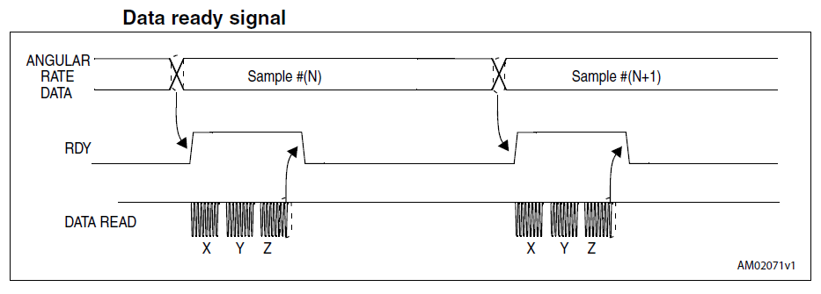
Figure 37: Gyroscope Data Reading Process
After the data has been read, the data ready bit is set back to a digital zero. In the case that the data ready register is set to 0, then there is no new data that can be obtained from it at the current time.
All of the angular rate data is output 16-bit numbers in 2’s complement form – this is slightly different than expected, but was not too hard to work around and is discussed later. Data provided by the gyroscope is in dps (degrees per second) units with a scope of ±2000 dps. The gyroscope offers the first-in, first-out (FIFO) buffer system to send data, but we only need to utilize the bypass output mode to acquire data. This is efficient for our needs because we are only occasionally polling for instantaneous data and recently recorded values can be ignored. All that needs to be done to accomplish this is to set the FIFO_CTRL_REG to bypass mode. The schematic for the gyroscope is available in Figure 38.

Figure 38: 3-Axis Gyroscope Schematic

6.1.2. 3-Axis Accelerometer
As stated in the previous section, the accelerometer is paired with the use of the 3-axis gyroscope in order to calculate values necessary to determine moment and torque on the aircraft. Similarly to the gyroscope, the accelerometer is placed on the main board, which is located inside the aircraft itself. The sensor chosen, AIS326DQ, is manufactured by ST Microelectronics.
In the accelerometer and gyroscope combination, the accelerometer finds the different forces on the plane with respect to the X, Y, and Z axes, whereas the gyroscope determines angular speeds on the system. The force found by the accelerometer is the force, f, in the torque equation shown in the gyroscope section. It was mentioned earlier that the gyroscope works alongside the accelerometer to validate results in relation to torque and forces on our device. Some manufacturers have designed a piece of equipment where accelerometer and gyroscope working together in one piece of hardware. It was not chosen for our project in order to allow for more room to design and gain experience with embedded design.
The accelerometer runs on a power supply of 3.3V. Similar to the gyroscope this part has high shock survivability, which is necessary for it to remain stable and reliable in, as well as after, any turbulent times. The accelerometer only allows communication with the outside world by utilizing SPI interfacing. Maximum SPI clock frequency for this sensor is 8 MHz – this applies to both 3 and 4 wire setups. We choose to use the 4-wire SPI setup and the SIM bit of the CTRL_REG2 is set to 0.
When obtaining acceleration data, the microcontroller is to read from the six output registers. For each axis, there are two registers that store 8 bits for acceleration data. By our choice, the accelerometer stores data in little endian mode and the BLE bit in CTRL_REG2 is set to a digital 0. The registers are all labeled identifying the axis they relate to (X, Y, or Z) and which order byte it is (H or L). The list of registers is OUTX_L, OUTX_H, OUTY_L, OUTY_H, OUTZ_L, and OUTZ_H. Although the values are only saved in 12 bits, the sensor’s data alignment selection is set to 16 bit left justified to ease data retrieval. To achieve this setting, the DAS bit of the CTRL_REG2 must be set to a digital 1. The accelerometer pin layout is in the schematic shown in Figure 39.
Figure 39: Accelerometer Schematic
The accelerometer records data in 12-bits and offers a choice of ±6 g’s or ±2 g’s resolution (accelerations of approximately 59 and 20 meters per second squared, respectively), format in 2’s complement. Depending on speeds of the aircraft during testing, we adjust the most fitting resolution. Data is output in 16-bits at the default rate of 40Hz. Since we expect to poll data at 30 Hz, this value does not need to be changed. In the event that we need to, the sensor can read acceleration data at 2560 Hz. There are a handful of features available with the ST Microelectronic accelerometer, but as of current requirements they do not impact the functionality of our project. The features include activity/inactivity sensing, freefall detection, and tapping sensing. Because we are already utilizing the gyroscope to stabilize any erratic data obtained from the accelerometer, we are not worried about utilizing the tapping detection function.

6.1.3. Rotary Position Sensors
This sensor, noted by Murata as an angle sensor and in other places as a rotary encoder, is used to calculate the angle-of-attack (AOA) as well as the angle-of-sideslip (AOS). The angle-of-attack and angle-of-sideslip are probably the most difficult values that we need to obtain from flight data. What makes them so difficult is that, unlike the other values, both must be computed by using a complex system made of sensors and other equipment. There are a few AOA/AOS sensors, also recognized as alpha-beta probes, manufactured and available for commercial use that would make this process much easier. Although the use would seem beneficial, there are two problems with the AOA/AOS sensors found today. First issue is that they are mainly designed for use on full scale passenger airplanes, hence too big for use on a remote controlled aircraft. There are a few of these sensors that are smaller and would fit into our design requirements, but the price tags on these sensors start around the $990 range. Even the larger sensors are still quite pricey, since the sensors are so intricately designed. So after researching alternatives shared by remote control airplane hobbyist, we were presented with feasible, reasonable methods to attain the angle-of-attack.
It has been decided that due to our strict requirements for lightweight, small, inexpensive equipment, it would be best to attain angle-of-attack data via using a self-designed sensor. This sensor consists of two rotary position sensors and two wind vanes. The wind vane spins based upon air speed while the rotary encoder measures how much the vane turns to determine wind direction and speed. One of the angle sensors used is to record data for angle-of-attack and the other sensor is for the angle-of-sideslip. The desired instrumentation is expected to look similar to the alpha-beta probe shown below in Figure 40.
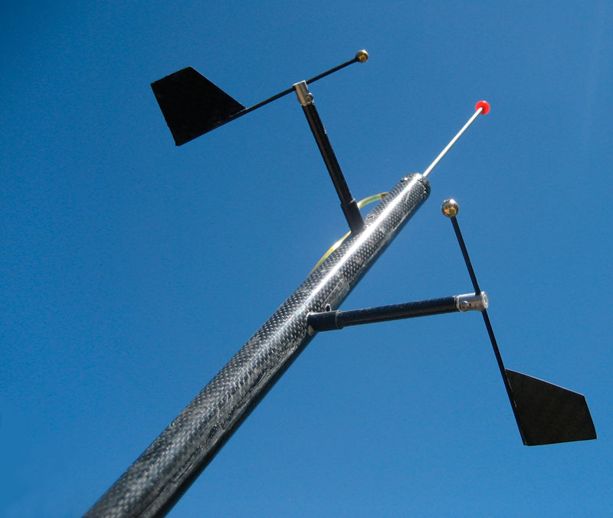
Figure 40: Manufactured Angle-of-Attack Sensor
Both of the rotary sensors is Murata’s SV01A103AEA01, which is an analog device. This signifies that data recorded is sent to the microcontroller as voltage and the controller is responsible to convert the data to a meaningful digital representation. Since our microcontroller possesses multiple Analog-to-Digital Converters (ADC) internally, we do not need to use any external ADCs. The voltage for this angle sensor shall not exceed 5 volts. Figure 41 is a copy of the of the angle position sensor schematic diagram, which is used to determine the orientation of the wind vanes.
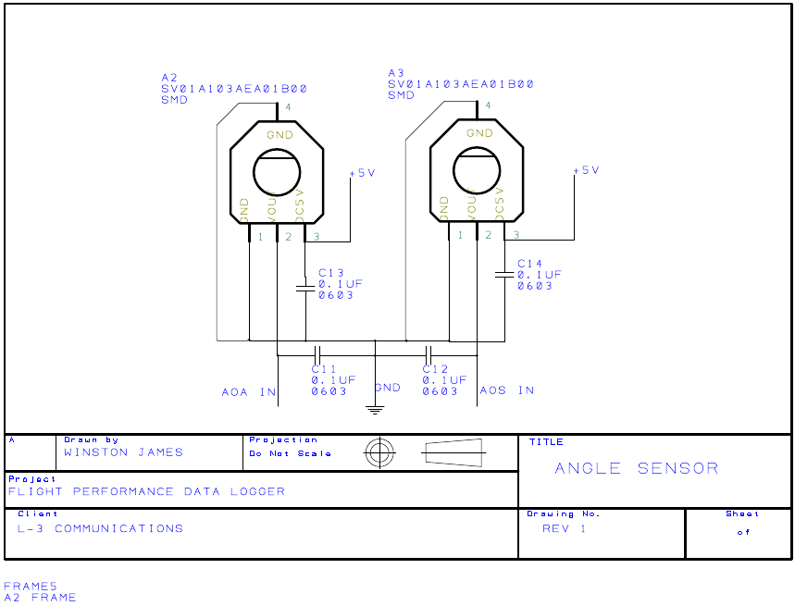
Figure 41: Angle Sensors Schematic

6.1.4. Humidity Sensor
By finding the relative humidity, we are able to find the pressure of water vapor, which is a partial pressure. In addition to determining the moist air pressure, dry air pressure can be calculated and combined with the water vapor partial pressure to determine the entire pressure on the system. By finding the entire system’s pressure, we are able to compute the geopotential altitude. (45) The equation to solve for this altitude is displayed in the following section discussing the temperature sensor. To briefly show the relation of humidity and density, the equations are shown below.
$$D=\frac{P_{d}}{R_{d}∙T}+\frac{P_{v}}{R_{v}∙T}$$
where D = density
P_{d} = dry air pressure
R_{d} = gas constant for dry air
P_{v} = water vapor pressure
R_{v} = gas constant for water vapor
T = temperature

Honeywell’s humidity sensor, HIH-5031-001, was chosen for its small design and small battery consumption. This sensor operates when voltage is provided in a range of 2.7 to 5V, with a preferred operating voltage of 3.3V. The humidity sensor is able to perform at maximum operating ability in temperatures between -40ºC to 85ºC (-40ºF to 185ºF). In order to decrease chances of water damage to the sensor due to condensation, Honeywell Sensing designed the shell to be multilayered. This is another sensor with analog output, so there is no need to worry about SPI or I²C protocol – all data transferred are converted by the microcontroller’s ADC equipment. (46) Figure 42 is a copy of the humidity sensor’s schematic.
Figure 42: Humidity Sensor Schematic

6.1.5. Temperature sensor
The temperature sensor is a fairly straightforward piece in our system which obtains the temperature of the ambient environment. Although the temperature is a valuable statistic to keep track of for flight performance and data logging, we found the necessity of this sensor to plug temperatures into the equations that calculate air density and altitude. The International Standard Atmosphere, also known as the ISA, is a scientific description of theoretical values of atmospheric properties. The values shown below uses the following constants when calculating other values: (45)
P_{o} = 101325 Pa – standard sea level pressure
T_{o} = 288.15ºK – standard sea level temperature
g = 9.80665 m/s² – gravitational constant
L = 6.5ºK/km – temperature lapse rate
R = 8.31432 J/ (mol * Kº) – gas constant
M = 28.9644 gm/mol – molecular weight of dry air

The equation to calculate the geopotential altitude as a function of density has been recognized by substituting values from multiple equations to solve for the altitude by using temperature, pressure, and density. All units are in ISA format.
$$H=\left(\frac{T_{o}}{L}\right)\left[1- {\left(\frac{1000∙R∙T_{o}∙D}{M∙P_{o}}\right)}^{\frac{L∙R}{g∙M-L∙R}}\right]$$
where T = ISA temperature in degrees Kelvin
P = ISA pressure in Pascal
D = ISA density in kg/m³
H = ISA geopotential altitude in km

After plugging in all known values and reducing the equation, it shows a simplified equation of altitude based on the ISA density.
$$H=44.3308-42.2665 (D^{0.234969})$$
Now proving that altitude can be determined by the density, it is important to remember that temperature and humidity help find the density value. The equation to solve density can be found in the humidity sensor section. In addition to density being used to solve for altitude, density is a variable commonly found in other important avionics equations such as lift and drag to name a few. Density is also used in other statistics which are important to our project to increase the accuracy and worth of our project.
The temperature sensor chosen is the AD7814 manufacture by Analog devices. This part is set to operate with a minimal voltage of 2.7 to 5.5V. It is able to measure temperatures in the range of -55ºC to 125ºC with a resolution of 0.25ºC and an accuracy of about 2ºC. The sensor has an update rate of 400 μs and a conversion rate of 25 μs, which totals to 425 μs. This allows for a sampling rate of up to 2.3 kHz. Output data is set to be 12 bits via 4-wire SPI communication protocol. To access the recorded temperature, access data from the temperature value register. This sensor does not support a FIFO buffer, so in essence data is only grabbed in bypass like mode. (47) The schematic for the temperature sensor is shown below in Figure 43.
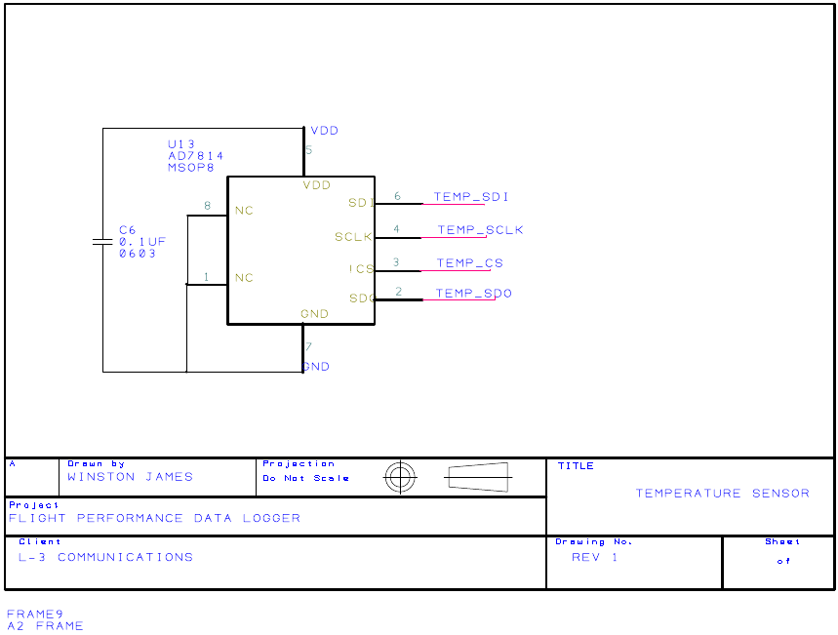
Figure 43: Temperature Schematic

6.1.6. Barometric pressure sensor
By knowing the barometric pressure of one’s current position, altitude can be determined. Although it has already been stated that elevation can be calculated by use of the temperature and humidity sensors, the barometric sensor was selected for our project in order to compare results and validate the estimated altitude. Since pressure can change based upon weather and we do not have the top class technology to validate altitude from one sensor alone, we need to double check our results and affirm their validity. Maybe in later design, we may be able to utilize only one method to calculate altitude. The equation to determine height, h, as a function of barometric pressure is shown below.
$$h= \frac{T_{o}}{L}\left[1- {\left(\frac{P}{P_{o}}\right)}^{\frac{RL}{gM}}\right] =44330\left[1- \frac{P^{0.1903}}{101325}\right]$$
All variables used in the equation have already been defined in the temperature sensor and the only unknowns are altitude, h, and barometric pressure, p.
The pressure sensor chosen is the BMP085 manufactured by Bosch Sensortec. The minimal operating voltage is 1.8 volts and a maximum operating voltage of 3.6 volts. As with the gyroscope, the pressure sensor offers the ability to record temperature. We decided that this can not be used because it doesn’t have the desired resolution and clock rate. Considering data output, the Bosch sensor provides digital output solely through I²C protocol with a maximum clock rate of 3.4 MHz. The sensor supports a sampling rate maximum of 128 times per second. Pressure is output in a range of 300 to 1100 hPa with a resolution of 0.01 hPa. The absolute pressure accuracy of the sensor is 1.0 hPa, which is good enough for our needs. Depending on the desired output, pressure data can be received anywhere from sixteen to nineteen bits.
The sensor’s data retrieval process occurs in this order: record temperature; read UT, temperature data, register; measure pressure; read UP, pressure data, register; and finally convert data to determine pressure and temperature in physical units. This sensor requires temperature measurement to calculate the pressure as well. Although it is not possible to remove the necessity to record temperature in entirety, we can change a setting to suspend the need for temperature to only be polled once per second. The sensor’s pressure calculations reuse the temperature data stored in memory until it has been polled again. So instead of adding a delay total of 135 ms per second with a measurement rate of 30 Hz, we only have to sacrifice 4.5 ms per second to record temperature. In order to reduce the temperature polling rate, we must increase the number of times that we ask the sensor for pressure above once every second. The resolution chosen of the pressure sample does not limit the sample rate, so we are open to choose any sample rate that we feel is best. Since we need our recorded data to be highly accurate, we chose to set the oversampling_setting (osrs) in the control to a value of 2 – meaning we record pressure in high resolution. In turn this signifies that we receive pressure data in 18 bits, not the normal 16. So we had to read three registers in order to get all 18 bits of the data. The total conversion time is 13.5 ms for the resolution we desire. This is the only sensor utilizing the I²C communication protocol, so there is no issue with using the few I²C microcontroller ports. Figure 44 is the barometric pressure sensor’s schematic shown below.

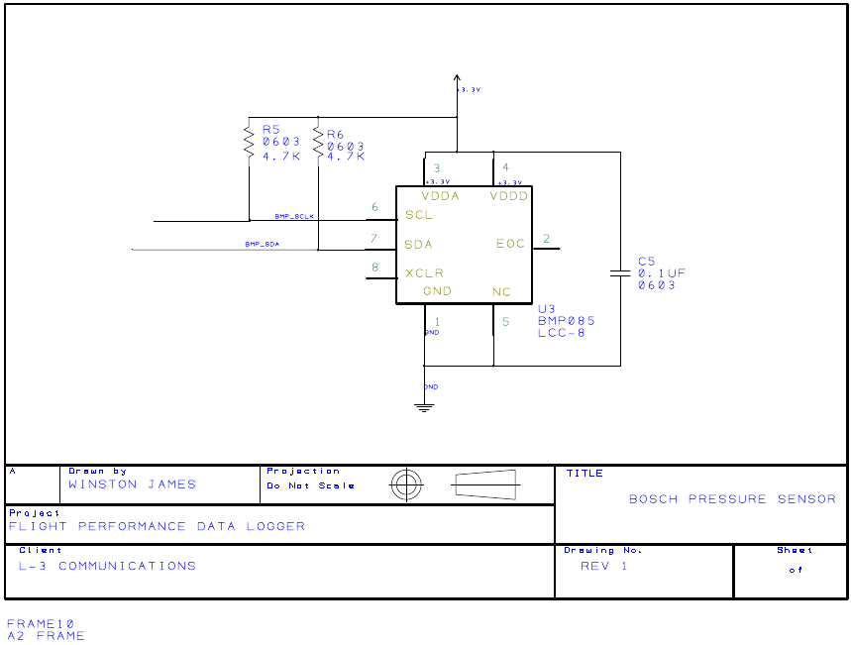
Figure 44: Barometric Pressure Sensor Schematic

6.1.7. Differential pressure sensor
This pressure sensor is meant to record airspeed from flight. Airspeed is one of the undetermined variables in the equation to solve for engine thrust. It can be seen in the list of parameters that our sponsor is in need of.
Our sensor, MPXV7002DP, is manufactured by Motorola’s Semiconductor division, now Freescale Semiconductor. This sensor requires an input of about 5V with the operation range of 4.75V to 5.25V. Since this sensor is higher than the typical supply voltage of the other sensors, we had to make particular adjustments to how the power supply runs to each sensor throughout the system. This issue is discussed and handled under the hardware section.
The maximum pressure that this sensor can record is 75 kPa and the output is in analog format. With a 5.0V input, the sensor typically outputs a signal of 4.5 volts with a 0.1 mAdc current. This pressure sensor’s schematic diagram is listed below.
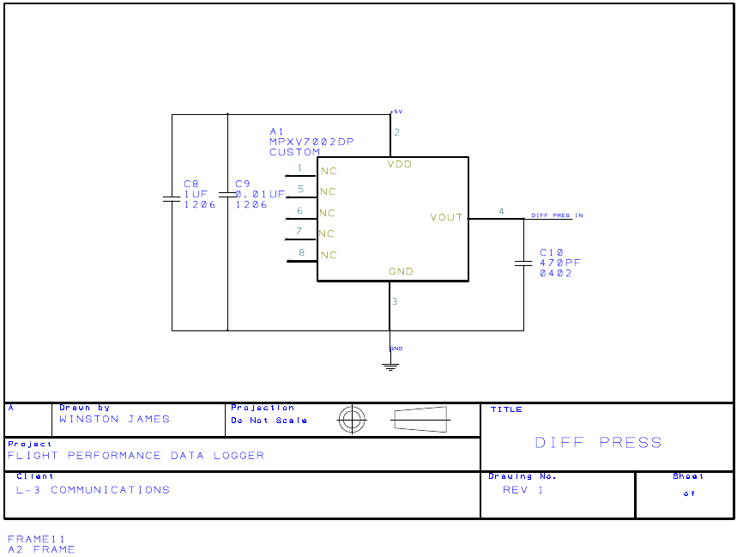
Figure 45: Differential Pressure Sensor Schematic

6.1.8. Force sensor
Since some of the aviation parameters that need to be calculated require determining the effect of force on many points of the plane, we require the use of at least thirty force sensors. The sensors are small, adhesive sensors that can be attached to multiple surfaces around the aircraft. The sensor chosen is designed by Interlink Electronics and Sensor Technologies and the part number is FSR 402. Each force sensor has the ability to record forces as small as 0.1 Newtons and up to 10 Newtons, which works for our design because we do not expect forces to be above 8N on the various positions of the plane. Another perk about this sensor is that it is supremely thin, 0.45mm, hence it did not have that big of an impact on aircraft dimensions and geometry, and furthermore actual flight. The graph shown in Figure 46 is used to determine the force in grams.

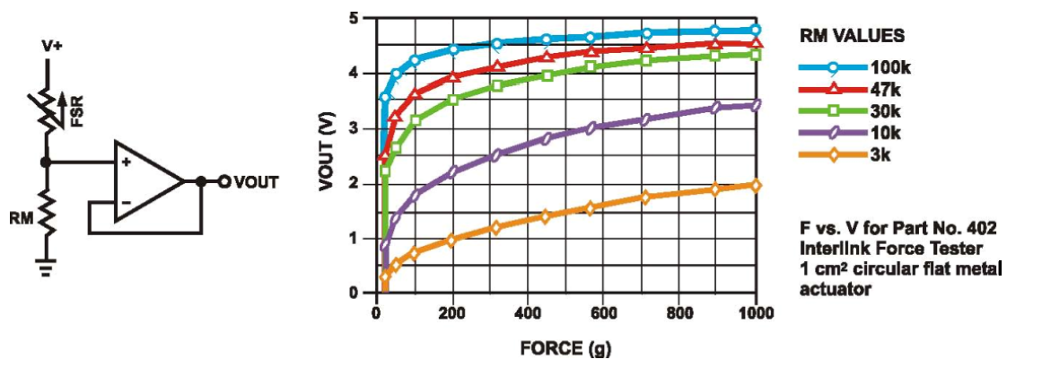
Figure 46: Force Sensor Output Chart
This sensor is another analog sensor and hence data is output via voltage readings – the higher the force, the higher the voltage. Interlink Technologies’ figure from their specification sheet, shown below, also shows that the smaller the resistor size, the more inclined it is to making noticeable changes. An image of the force sensor schematic can be seen in Figure 47 on the next page
All the data that these sensors grab is received by the microcontroller and saved onto the memory card for further analysis by our software system. The important thing is being able to understand and manipulate the format that each of the sensors put out. Table 14 below shows all recorded values from each sensor, the output format, and the size of each piece of data.
Sensor Type | Value | Digital Data Size
3-Axis Gyroscope | X-Rotation | 16 bits
3-Axis Gyroscope | Y-Rotation | 16 bits
3-Axis Gyroscope | Z-Rotation | 16 bits
3-Axis Accelerometer | X-Acceleration | 16 bits
3-Axis Accelerometer | Y-Acceleration | 16 bits
3-Axis Accelerometer | Z-Acceleration | 16 bits
Rotary Position (Angle) Sensor | Angle Displacement | 10 bits
Humidity Sensor | Humidity | 10 bits
Temperature Sensor | Temperature | 10 bits
Barometric Pressure Sensor | Air Pressure | 32 bits
Differential Pressure Sensor | Air Speed | 10 bits
Force Sensor | Force | 10 bits
Table 14: Sensor Data Output Characteristics
After now knowing all the data sizes, communication protocols and the expected speeds of these sensors, we are now ready to combine all the separate data into one section and truly determine how it all meshed together.
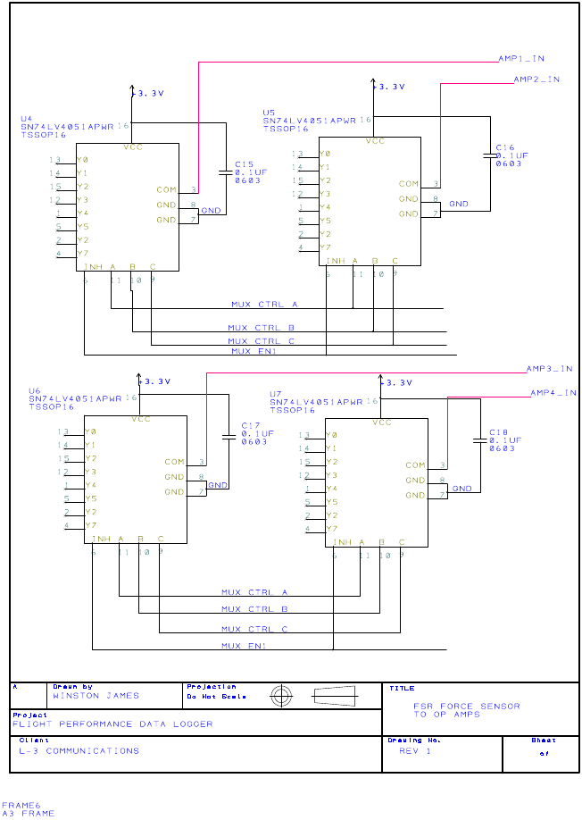
Figure 47: Force Sensor Schematic

6.1.9 Assembly Production Updates and Changes
Thus the final design had to be tweaked to fit the manufacturing capabilities of Advanced Circuits our fabricator. DFM rule checking constantly rechecked our updated gerber files until the PCB could be manufactured. We changed silkscreen text fonts, trace widths, readjusted footprint soldermask clearances, and fixed spacing violations. The “show stoppers” to manufacturing were eliminated, and we proceeded to order our PCB. Electrical impedance checks were done manually with a multimeter to validate fabrication accuracy, and the power nets were isolated, so the assembly process could start. Budget constraints forced a hand-assembly, but assembly soon revealed a list of other problems. A major problem was that +3.3V and ground were shorting after the PCB was almost completely assembled. Initial guesses suspected a connection was taking place via a part that shorted its terminals when off, but advice from the Principal Design Engineer at ZTEC Instruments quickly dismissed the idea. Visible shorts were found on our accelerometer, whose solderpaste bubbled after reflow in the senior design lab, forming shorts on some power nets. After cleaning and eventual removal, the short lingered. Finally after referencing a working breadboard circuit, the humidity sensor was the culprit with a bad footprint; shorting a power pin with a PCB ground pad. The GND pad was insulated with kapton tape then covered with copper tape and then the part resoldered.
Other checks showed that the barometric pressure sensor had a similar problem. It had all power but no ground trace, so one power trace had to be cut and the ground pin wired to ground. The SD card connector also didn’t fit perfectly and the footprint pinout belonged to an SD card, not the desired microSD pinout. So 30 and 28 AWG wires fixed that sequence problem, but yet another surfaced. The SPI modules in the datasheet for SPI ICs didn’t specify explicitly that pull-up resistors were needed on some lines, and so the PCB was designed without them. Breadboard experiments showed that they were necessary for SPI to work, thus 10K resistors were added to the gyroscope, accelerometer, and SD card’s SPI interface connections and pulled-up to +3.3V. Also, ignorance of MOSI and MISO SPI lines caused us to have MISI and MOSO connections. Fortunately for the gyroscope, mislabeling the SDI and SDO lines prior to fabrication fixed the MOSO and MISI problem. Thus two wrongs did make a right for the gyroscope lines. The accelerometer had the problem of its MOSI line going to a input line and it’s MISO going to a I/O line on the MCU. We planned a 4-wire SPI operation, but since the problem it was decided best to operate the device in 3-wire mode, allowing the slave’s SDO and SDI lines to short internally and utilize the SDO line as it now becomes an I/O pin that’s on a reprogrammable I/O pin on the master MCU.
This solution provided us an alternative to scraping the SDI and SDO traces that were less than 0.01” thick and less than 0.02” apart, and swapping them. Lastly, because high assembly costs were not known during the design phase due to our ignorance of the common manufacturing procedures of buying reels or other packaging that contains more parts than that required for a single build, and laser-cut stencils etc., we replaced small components like 0402 resistors and capacitors, in favor of larger 1210 and 1206 types in anticipation of hand soldering all parts to the board, which was the only thing we could afford. In all the problems we found solutions, and because of that, experience was had in soldering, making breakout boards, and being innovative. A 3D representation of the board is shown in Figure 48 below.

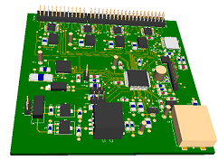
Figure 48: 3D representation of manufactured PCB Board
Thus we’ve learned to get parts as early on and test them on custom breakouts on perfboards or bread boards, then transfer circuits known to work to our PCB, rather than simply trust datasheets circuits, which can lack details about things readers are assumed to know; like SPI connections. For this reason of building before testing, we built a 4x4 sq.in PCB rather than a rectangular board. Though we fit our PCB into the RC plane, initially we didn’t have the plane to take measurements to constrain the PCB dimensions by, and thus made guesses from scale pictures of the plane, since our sponsor purchased the plane after we ordered the PCB. We fixed other problems like a badly designed on-off switch, needing a SPST instead of a SPDT switch. A toggle switch from RadioShack fixed the problem. We also built a custom RJ-11 cable for the PC interface because we had the problem of reversing the RJ-11 pinout on the PCB for ICD3. However the PCB powered on

6.2. System Output
The output of the system is a .csv. This made it easy for the user to transfer it to most software. It is designed in the same way that there simulator outputs data. The order is determined by their software but basically there is one line for each value. One column has the name of the value and the second has the value itself.
6.3. Software Functionality
The software is needed to interpret the data gathered by the array. With the data that is calculated by the software the client has a readable sheet of information. The sheet can then be used in comparisons. The results of the program must then be used by the client. This is to allow the client to compare the data collected with the data that comes from there simulator.
The software is independent of the hardware so that there is more portability of the system. Rather than doing the calculations on broad and wasting space and processor time the data is stored and then transported to a PC. The plain can then do another flight and record more data while the PC processes the mathematics quickly and without interfering with the collection points. With the on board processor free more data collection points can be made and therefor more accurate results can be produced.
The software for the sensor array is to interface the raw stored data to something readable to humans. It takes the raw data that is to be stored on board with the array and, after being transferred by hand to a PC, executes. During the execution the program takes the many points of data and condenses them, as needed, into the values that are used to find all the data points the client wants. The program reads the data and then takes the information. From there the program uses aerospace formulas to find the values needed for the client to compare.
The software easily takes the data from the file. Then it parses the data and put the many data points into data structures. From here the program runs loops to average the data points into one value for each type of information received. Once these values are found they is put though many functions. These functions carry out the mathematical processes that calculate the values that is out put to the user. These values are also saved. From there the calculated values are organized and output to a file for the comparison. The output file is formatted in a way that is easy for the user to read and compare.
Success is tested by calculating the values by hand. The data structure is tested to make sure it holds the correct values and each function is tested. Then, after the tests, each function is integrated into the main program. From here the program as a whole is tested. The output is tested to insure the format is readable for the client. The final test is to show the output to the client and insure that the format is acceptable for the comparison.
Another set of tests is to make sure the program is intuitive to a user. This is done by giving the user the ability to open the needed file and saved where and as the user wants. The limited freedom should avoid issues of wondering where a file was saved to or where a file opens from. After test from within the group the client is asked to test the program to make sure it is intuitive. So long as there is no problem finding the file and no problem saving the new file this test is passed. The client is mostly concerned with the hardware part of the project. Very little direction was given to the software portion.
6.3.1 Program Life cycle
There are many choices in choosing a life cycle for a software project. I had consider what the program needs to do, how to best create it, who is involved, and how complex the project is. Seeing is this is a school project the software is free. A cost analysis is not needed because the programmer was not be paid and there is nothing bought to help build the software.
The program needs to simply read a file, do some calculations and output a new file. A simple plug and chug, but there may be problems getting the file form the storage device as well as the human interface. Most likely a simple GUI had to be built in order to make sure the interface is easy to use.
The best way to build the program was to make a main function that contains only variables and other function calls. Those variables are then be passed into functions to obtain more variables. So essentially the main function has very little computation. This made the program easier to debug and more modular if future programmers want to add or remove functions. It also allows for others to help in the programming if needed.
Currently the only person that is planned to be involved in the programming is John Torres. It is his responsibility to plan, build, and test the program as well as make sure it meets the client’s expectations. Because there is only one person planned to work on the program it allows for flexible schedule. The programmer(s) also had to work with those involved with make sure the data is put on the storage device. The method of how the data is stored is important to creating the program.
The overall complexity of the software is relatively straight forward. the team has yet to actually interface with the storage device but research has been done on how to do it. Once the data is collected the programmer(s) need to create functions that properly do the mathematics to get the needed variables. and finally output to the users specified path. all this needs to be wrapped in a simple GUI for ease of use. Without the GUI the user either has to type the path in the command prompt, something we have long sense abandon, or be forced to use a default file name, which could easily result is loss of data.
The first consideration is the waterfall model Figure 49. With this model the project time line is easy to plot. Note the first step, requirement, is already done. a time line can be made for the design phase putting each function to be done be a certain week. Then when the program is built it can be implemented in tests, on the ground. From the test the project may go back to the design phase to work out some bugs. After tests are passed verification of the software on real collected data is in order. Again the software is not likely to pass on the first go; it is possible that the project had to go back to Implementation. After all the functions are verified this project is over. There is no maintenance on this project.
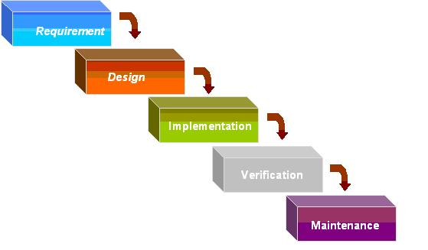
Figure 49: Waterfall model diagram
The next model is the spiral life cycle Figure 50. In this model there are four phases that the project keeps spiraling through. This project, again, is already past the first stage the project objectives have already been made clear. The second phase is to find alternatives to avoid risks. This made the building of the software very dynamic. Phase two also calls for prototypes this allows the client to tell the program team what is good and what is bad. The third is to develop. In this design it is likely that each development cycle adds one or two functions to the main program. This phase also includes testing the software as it stands so far. The last phase is to plan the next phases. in this project each cycle is planned on a weekly basis.
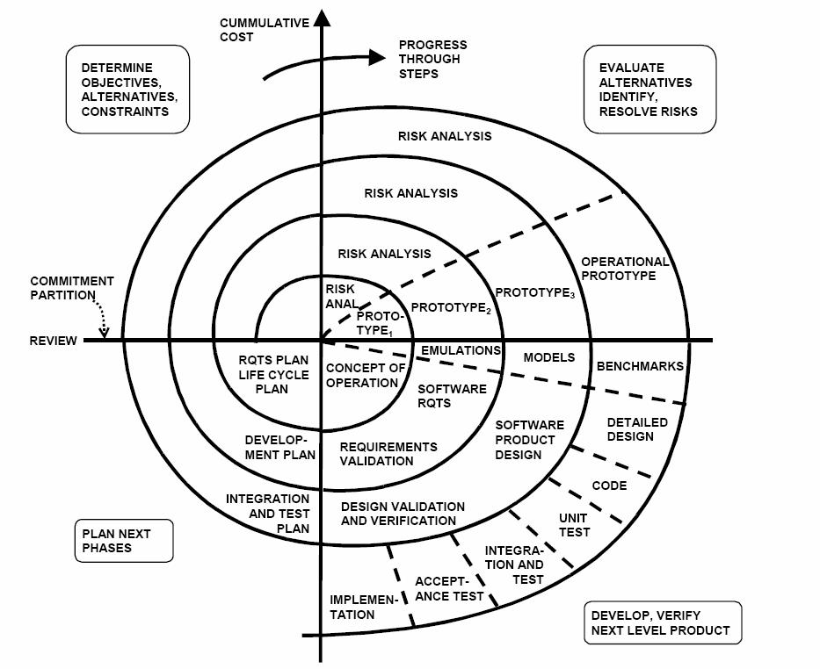
Figure 50: Spiral model diagram
The last model to be considered is the Iterative model (Figure 51). The Iterative model starts with initial planning. For this project the initial planning is already done. The next phase is requirements. Again, for this project that is already done. Next is analysis and design. In this project the team would write the program over the cores of a few weeks. Then implement it to test it. After the tests were completed the team would evaluate the performance and plan what needs to be changed or fixed. From there the cycle would repeat until all tests were passed at that time the software would be ready to be deployed to the client.
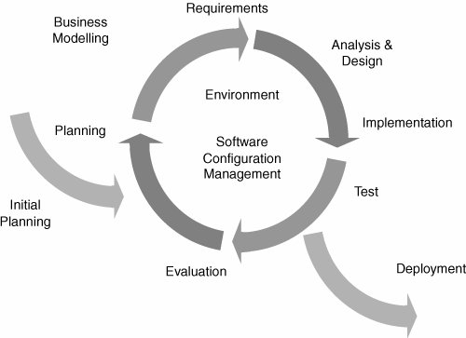
Figure 51: Iterative model diagram
Each model has its advantages. For this project the advantages for the waterfall model are that the time table is strict and the plan laid out in full. this allowed for the program to be planed and finished on time. the cons are that the plan is inflexible if there is a problem with any stage of development it may cause delays in the release of the program.
The spiral model allows for this project to have an ongoing prototype that can be shown to the client and allow for changes based on that. This can be useful because the client hasn’t been clear about what they exactly want from the program. The cons is to maintain the constantly working prototype and with the rate we have contact with the client it may slow completion of the program.
The iterative model also allows for flexible response to change by constantly testing and planning the program. This method is less reliant on the client because there is not a prototype until the end of the cycle. The cons are that the model requires consent testing and evaluation slowing down the process, also there is not definite time line for progress and completion.
The spiral model is being ruled out because the project doesn’t need progressive prototypes and the presence of them would make the project needlessly more complex. It also waste time because of the relatively little contact we have with the client. It is better to create the program and test it completely before showing it to the client. This is because most of the workings of the program are mathematical the client will not see most of the workings of the program. The only part that the client needs to make sure is okay is the interface and the programmer(s) like to make that part last.
The iterative model is also being ruled out for this project because the sequence of phases doesn’t match how the programmer(s) want to approach the problem. it is a strait forward program that doesn’t need to have scheduled changes. the consent time spent on discussing the change in the program will most likely be wasted for this project. For this project it made more sense to build the project at once, together, and test at the end.
The waterfall model is being chosen because it best fits the problem that needs to be solved as well as the programmer(s) preferred method to solve it. Thought the model is ridge and slow to change it is likely to not be a big issue. What needs to be done internally is well defined. This option gives the project a steady structure to work on and with a clear time line.
First consider the main class. It is automatically generated when Microsoft® Visual Studio® makes a form for the GUI. The class itself is completely automatically generated. The complexity of the class is close to non-existent. It adds a layer to program that do very little thus needlessly making the program more complex. But because it is auto generated it is more difficult to remove it then the keep it. The class made it much simpler to build the program as well as help others that may want edit the program.
The GUI class provides a GUI for the use to use the program. Most of this is auto generated as well. What the buttons do need have been programed but the main outline is generated. This class is fairly strait forward, program what happens when the user does something with the GUI. the complexity of the program increases, as with adding any class, but to keep this class it greatly reduces the complexity of building the program. it would be difficult to integrate this class with the main class. And because they are both auto generated it would take more effort than to keep then separate.
The function class could make it easier to inter change functions for future additions. Adding the class made the program more complex in the same way as the others but in this case the benefits don’t help. It would be easy to integrate all the functions needed into the GUI function. And the ability to edit functions have not been lost. Furthermore having the functions in the GUI class or its own class doesn’t make a difference in how easy the program is to build.
The data class is the class that stores the various levels of information. Starting with strait form the file, then the parsed data, finally the calculated values that is used. if these are classes they have no functions just the structs. seeing as each class adds complexity to the program and all of them could simply be added as structs in the GUI class there is little reason to create these classes.
From these discussions the conclusion is that there is only 2 classes. the main class that is atomically generated and the GUI class. The main class hardly has any original code in it, if any. The GUI class automatically generates a template but the majority of the class is built by the programmer(s). All the structs and functions is added to the GUI class because it is ultimately simpler to have them as a part of the GUI class then to make them have their own class.
The main class is to open the program and set up the GUI class. The main program is automatic generated and very short. it simply sets up a few things and then call the constructor on the GUI class. at that point the whole program runs in the GUI class.
The GUI class has all of the functionality of the program. first it has the 3 different data structures. These help keep track of the variables at their different points in being processed. The first one is the data that comes right off the storage device. The second is the parsed information form the first structure. And the last is the averaged values and derivatives.
The next part is the atomically generated GUI template. This part includes the two text boxes, two labels, two browse buttons, and a compute button. This is visually created in Microsoft® Visual Studio®. In the code it reflects the visual representation created. Information like where the items are placed. Also include in here is references to functions if the item needs to do something. For example when the browse button is clicked for the first text box it should bring up the file finder and the file selected should be placed in the correct text box. The text boxes is editable. The first browse button is set up to select a file where the second is set up to choose a path to save the file. The user has to enter the file name if they want a new file (more in the function description). And the create button runs the main part of the program.
The last part of the GUI class is the list of functions that run the loading, saving, computing, and findings of the program. this part can be broken into those for sections. The loading functions load the file. the computing functions find the initial values form the input file; both the averages and the derivatives. The finding functions find the calculated values form the initial values or derivatives. Finally the saving functions save the information for the client to read and compare.

6.3.2 Functions
The GUI has three functions, one for each button. The first browse button is used to find the file that the data needs to come from. It simply opens a file finder and when a file is selected writes the path to the corresponding text box.
The second browse button works similarly to the first but it won’t have to choose a file but just a path. it is up to the user to add a name to create a new file.
The create button does the work of this program. After clicking creates the first thing it does is check to see if the file to load from exist. If it doesn’t it warn the user and go back to waiting for input from the use on the GUI. Next it checks to see if there is a file given for the destination and if it is see if it already exists. If there is no file stated then the program informs the user. If the file exist it asks the user if they want to over write the file. After these checks the program executes all the following functions in the order they is presented. Rather than go thought each one here read on and keep in mind each of these are happening one after the other.
There is two loading functions. The first loading function is the one that open the file, take the raw data off of it and save it in the load struct, and close the file. The string of the file name to be opened is passed. it returns a pointer to the first node in the linked list. First this function opens the file using the string that was passed. When the file is open it takes each data set and save it in a newly created linked list. After saving all the data on the file it closes the file and return the pointer to the head of the list.
The second function takes in the pointer to the linked list and returns a new pointer to the parsing vector. Once the function has started to run it goes into each node and parse out the 38 longs of data and put them into parsing structs. Those structs is stored in a vector. When all of the points are parsed it returns the vector.
The computing function takes in the pointer the vector created in the last function and return a new pointer to the values struct. This function does two things find the average of each value in the struct and find the average of each divide. To find the average of the values the program simply add all the values and divided by the number of points. To find the derivatives at each point the program uses three points the one it is on the last one and the nest one. From these three two divide points is found for half a time interval in ether directions. Form there those two points is averaged to the derivative at the desired time point. They leave the first and last values of each derivative blank. This is clearly noted in the program as such a thing can cause incorrect answers. Once this is done the same method is used to find the average of those as well.
There is one finding function for each value that needs to be found. Right now there is planned to be 16 of these functions some may be discarded if it is found that the value is not needed or cannot be found. a list of the values that need to be found, and the name of each function is a follows: angle of attack, hysteresis limits, change in drag from ground effects, change in lift from ground effects, drag force, side force, lift force, lift from alpha, change in lift form flaps, lift from change in alpha, roll moment, pitch moment, yaw moment, normal force coefficient, and axial force coefficient.
The saving function takes in the string of the destination file and return a nothing. This function opens the file passed in the string and print out the information found in a fashion that is readable to the client. This is checked with the client to make sure it is acceptable.

6.3.3 Data Structures
There are four data structures that need to be discussed. the first structure to discuss is the load structure. This structures sole purpose would be to take the information on the storage device and save it in the program so that the file can be closed as soon as possible. Disadvantages are that it requires the memory space to do such a thing, and that the whole process may be slower because of this extra step. The advantages are that the file is closed faster because there is no parsing, calculations, or derivatives to find while reading. The ability to get the information off of a removable device as fast as possible is a good idea just in case the device is removed before the program runs to completion. Though it would be a rare occurrence the draw backs of this method is slightly slower run time and more memory use, both of which are likely not be noticed. However, if there is a noticeable speed up with removing this structure then it is likely the structure is removed. For the planning of this project this structure is planned to remain in the program.
The parse structure holds the meaningful data form the file. This is the data that has been parsed and saved as actual number that can be calculated. at this stage there is still many values of each variable. This is the stage before they are averaged together and there is no derivative yet. It is hard to imagine the program without the structure. Because each value need to be averaged together to get the working value it would be had to do this directly from the file. On top of the project also calls for the derivatives of some values. Though the team could come up with a mathematical solution to skip this step it seems much easier to keep it and let the program do the average in the normal fashion.
The values structure is to store all the working values after the averages and derivatives have been found. Because this is just a neat little place to store all the values in one place it is not needed. The values could all be stored as regular variables. That would save on making the structure and make it easier for a future programmer to edit the inputs. However, having the values in one place would make it more organized. Instead of having all the variables thorough about the main function they are in a nice neat little box. The program is being built for futures programmers to be able to edit but in the input is going to be custom to the hardware built on this project. Because of that in reading in had to be custom to this project. If a future programmer wants to edit the program to add new hardware that programmer had to change many of the inner workings of the program. there for keeping the input variables separate for easier editing is not worth the mess it creates because changing the inputs is a relatively major undertaking by itself regardless of if this structure is implemented or not.
The results structure is similar to the values structure in that it is just a simple place to store the results after the values have been calculated. it falls in the same pros and con, pros being that the structure ising organization to the program and eliminate random floating values. The con being that it is more difficult to add more output for future programmers if the program is to be edited. However in this case it is the exact opposite. More output could easily be made and added to the program with new and different equations. For this reason the structure is not going to be included in the program.
Another part that must be considered is the type of data structure that is used for each type. This project focuses on the Linked List, Stack, and Vector. The Linked List allowed for first in first out, the Stack is first in last out, and the Vector allows access to all values all the time.
For the load structure the program needs to hold the information from the file. Normally reading form a file is from front to back this would make it difficult to use a stack. Because the structure is parsed in the next step the program doesn’t need to know what is coming next so the vector doesn’t have any benefits. A linked list is used for this data structure.
For the parsing structure it is impotent to know that the in the next step the program had to find the derivative. the derivative is to be found by finding the difference between the next value and the current value. Because of this it is useful to have easy access to the next value. The simplest way to do this is with a vector. it is easy to with a linked list but even easier with a vector. There for the parsing structure is a vector of structs.
Last is the values structure. Because this is a holding place for the the computations that came before it are just the struct by itself, no linked list, no stack, no vector. a simple data type.
There is an unknown number of data points coming in from the file. in order to create the load struct the program needs to know what go into the struct. Each data point contain 38 long data types. So each node in the linked list need to hold 152 bytes of raw data (38 * 4 bytes). After this this, because this is a linked list, the next variable in the struct is a pointer to another struct of this type. Once completed there is a linked list of 152 byte nodes.
Once all the data points are collected the program knows how many points there are. This helps in making the vector for the nest data structure. the structure holds 38 floats. It is mentioned elsewhere in the paper but the values hold 30 different force readings, differential pressure, humidity, two angles, barometric pressure, temperature, gyroscope, and accelerometer readings. Seeing as this is a vector there is no need to add anything else to this struct.
Once all the data points are collected they is condensed to an average and derivatives is found. The last struct holds the original 38 floats plus the derivatives of each one. Making the struct 76 different floats in the struct. This is the extent of the data structure so there is nothing else to put in the struct. Figure 52 below is an illustration of the data structures used in the software.
Figure 52: Software Data Structures
In the end we used 44 floats for the input a time stamp, 28 force sensors, 2 angle sensors, temperature sensor, 3 gyro sensors, 3 acceleration sensors, differential pressure, and absolute pressure, and 5 control surfaces. The output sturct had 41 floats: time stamp, q, 3 forces, 3 force coefficients, 11 parts that make up that make up the force coefficients, 3 moments, 3 moment coefficients, 13 parts that make up the moment coefficients, AOA, AOS, and true air speed.

6.3.4 Supplemental software
The supplemental software was used to find the to find the moment of inertia for the plane. To do this we measured the position and the angle at which it was mounted on the plane. With that information we hung the plane and pushed on the force sensors. The program took in the force sensor data, angular acceleration, and distance that was measured. The equation used is:
t = a*I = d*F
I = d*F/a
In addition to this we used rotation matrix equations to find the force in each direction. The equations are as follows:
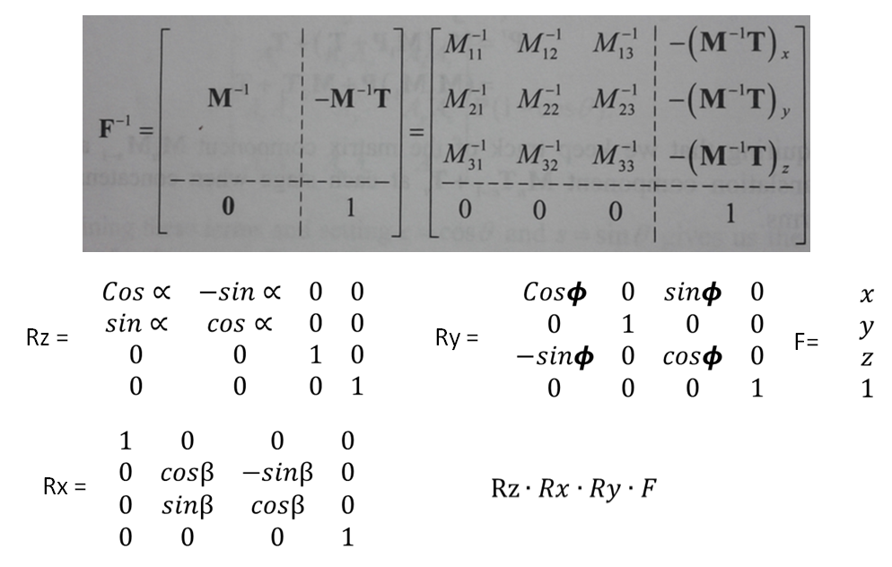
Figure 53: Rotation Matrix Equations

7. Project Prototype Testing

7.1 Hardware Test Environment
The hardware diagram shows that our hardware is composed pieces that can be bought and pieces that must be built. Because debugging is much about isolating variables, we isolate the components of our build and test them independently.
The airplane is constructed from a kit, and we will fly it without the autopilot at first to ensure that the mechanical and physical integrity of the plane is verified. This will help us know that if the plane flies unpredictably with the autopilot, the issue is the autopilot and not a mechanical problem from how we built the plane.
The autopilot hardware is tested for its weight and physical integrity since we will also have to do some soldering of the Inertial Measurement Unit (IMU) to the pilot board. Soldering would pose the problem of having bad solder joint. Thus we had someone who has soldering experience on the team to do the soldering to minimize the human error in putting the autopilot together. The ArduPilot Mega was then be taken to the lab to undergo further testing with the oscilloscopes there, as we ensured via probe testing that the voltage test points (if any) and supply pins and other key points are operating at the right voltages and that there are no short/open circuitry where there should not be.
The autopilot was then installed into the plane after it's been verified, and given control of the plane in sight of our second round of flights to ensure that we can control the plane via controlling the autopilot. Once this milestone is complete and we have flown consistent flight paths repeatedly and calibrated the software variables in the autopilot software to our satisfaction, then we'll proceed to add the last step of the entire project which is to use our manufactured hardware in the plane to grab flight data.
Our hardware, before it's mounted on the plane goes through rigorous testing, more than the other hardware parts because we know that the other hardware, those purchased, are more likely to work as they ought after manufacture. Our hardware is manufactured for the first time so that it may not work is an issue that may lie in manufacturing error, or which is more likely, a design issue. Therefore, because the manufacturing process takes a while to complete itself, we target minimizing design issues before manufacture by using various, not just one bread or perf board (because various pitches are required for various parts), and use discrete components, resistors and caps, to test in the lab each or a system of parts to ensure that we understand what the component IC or system thereof is doing, and that they behave predictably. We then modified our schematics accordingly after our experimentations to validate proper voltage supplies, and currents in/out of a pin/component. We looked at trimming and transient responses of digital and analog signals or the linear regulators for instance to ensure they are supplying the right voltages.
Another tool we plan to employ is simulation software for the electrical parts on the schematics in order to get a prediction of how the digital and analog signals should behave. The real goal here is to do a signal integrity analysis of the circuit before the PCB layout is complete so we can have clean signals and address noise, and other critical issues.
We lastly proceed to the PCB layout while paying close attention to what the datasheets say about unused pins, and how and where components are placed and traces routed. We'll be careful to obey placing decoupling capacitors close to the supply pins in order to minimize trace inductance and resistance. The trace sizes had to be considered so that they are fit to carry the more than the expected amount of currents.
In order to verify that the system has run to completion, the user must check the SD card. A good run of the system creates a working log file made in binary. To the human eye, the values in the text file seem to be invalid data. But these values are the binary values of the various floats. In another case, there may not be a file created which signifies that there is a communication problem with the SD Card. Best solution for that is to check the connections mapped out in the schematics. On the other hand, a bad or corrupt file signifies that the file did not close properly. The best solution for this is to remove the SD card, reformat it, and run again.
7.2 Software Specific Testing
Testing the software is done in stages after a basic program is made each function is specifically targeted for testing before it is considered completed. the testing of each function varies based on the function itself. To simplify it consider the five types of functions as mentioned before: GUI, Loading, computing, finding, and saving. The GUI functions need to be completed first in order to test the rest of the program easily. Simply running the program and making sure each browse button opens the file finder and that the path is put into the text box. For the create button first make sure each of the safety constraints work and if all of those work there is a message that says the function was completed. The loading function is tested by reading the data that comes in against a known file and making sure it reads it correctly. The computing function is compared against the hand worked values for accuracy. The finding function is also hand calculated to make sure the values are correct. finally the save function file is checked to make sure it is formatted correctly and that it opens easily in Microsoft® Excel®.

7.3 Data Verification

7.3.1 MicroSD Card Data Verification
Anytime a project is designed, a system must be created and used to verify that the projects components are doing what is expected. For this reason, we must develop a means to do this. Specifically, we are looking at verifying that the data stored on the microSD card is valid. We need to make sure that what we expect the system to write to the microSD card actually gets written. The only way to do this is to look at the file or files stored on the microSD card.
We have decided the easiest way to read files off a microSD card for verification purposes is to use a PC to read it. Using any computer and a microSD card to SD card adaptor, we can use the usb memory card reader owned by the group. Once the card is picked up by the operating system, we can confirm the existence of the file or files on the microSD card. However, because the file or files are formatted with just raw data, there is no easy way to read them. Therefore, we had to design a program to be able to read the file’s or files’ data. We have decided to use C++ to create a program which can read these files.
Our program made use of the fstream and iostream libraries. Using these libraries we can create an ifstream (input file stream) object which holds our file. Then, using the ifstream’s open() function, we can tell the C++ program which file to open and how to read the file. Since we are reading the raw data, we read it as binary. Therefore, the function we use to open the file sets with the mode ios::binary. This allows for reading of the file directly. In addition, we need to know the size of our file so we know how much data is left to be read. We also add the additional mode ios:ate. This sets the file pointer to the end of the file which allows us to determine its size. The function call is something along the lines of theFile.open(“theSDFile.out”, ios::binary | ios:ate).
After this, we check that the file was able to be opened with ifstream’s is_open() function. As long as the file is readable, a value of true is returned. If the value false is returned, then we need to go back to the microcontroller and determine why it is not writing the file to the microSD card as we had intended. Once this has be solved, we can retry to read the microSD card again and confirm that has be opened correctly with the is_open() function.
Once our file is open we can use the tellg() function on our file. This returns a value of the type ifstream::pos_type. This value is used as one of the parameters of the read() function I will now describe. In order to read the data from our binary file, we must use the read() function implemented by the ifsrteam object. The read() function is designed specifically to read raw binary data. The read() funtion takes in two parameters. The first one is a pointer to a char array the size of how much data to read from the microSD card. The second is the size of how much data you want to be read from the file. However, since we have stored our data using 32 bit single precision floating point numbers, we created an array of longs.
However, before reading from the file on the microSD card, we must make sure to reset the file pointer back to the beginning of the file using the seekg() function on our file and feeding it the proper parameters. The first is an offset and the second is a direction to move. We can set the position ios::beg with an offset of zero and this moves our pointer to the beginning of the file stream where we can begin reading the data.
After allocating a long array and determining the size of our file, we can feed the read() function with the pointer to this array (it is cast as a pointer to a char array) and the size of our file. This then stores all the data from the file on the microSD card into our long array. In addition, this automatically allows us access the base 10 numbers without any other conversion needing to take place. Once all the data has been stored into our long array, we can then look at the data and determine if the values are that which we expected.
Once we have confirmed that the data is being written to the card as expected, we can pass the data off to our other program which calculates the coefficients and other aeronautical information experienced by the plane based on the data provided to the microSD card by our sensors.

8. Operation Manual

8.1. Successfully Operating the FDL
The operation of the Flight Data Logger is all automatic and the user is not required to do anything to operate the system properly. The system is created with the user in mind to make it easier for them to successfully operate the Flight Data Logger, get valid data on the SD Card, and, more importantly, not risk damaging the system. The system is set to start and wait to record until it goes above 10 feet of altitude and it will stop recording once the altitude is back under 10 feet. This is what makes the system autonomous and avoids making the user to start and stop the system by use of a button or anything else.
Below is a step by step instruction on how to use the FDL.
- Turn on the ArduPilot Mega and give it 15 seconds to initialize and calibrate
- Ensure that the FDL battery is disconnected and the FDL switch is in the off position (Pointing up)
- Ensure that the SD Card has been formatted and is empty to avoid any errors in writing
- Insert the micro SD Card into the SD Card socket of the FDL
- Now connect the FDL battery to the connector located in the back
- Flip the power switch and the FDL will begin to run instantaneously
- Now, fly the plane
- Upon successful landing, remove the SD Card
- Now power down the system by placing the switch back into the off position and disconnect the battery
- Insert the SD Card into a computer with the FDL Analysis software
- Run the software and locate the log file labeled “TestFile1.txt” on the SD Card
- Now specify the location and name of the file you would like to create
- Look to the location specified and the analysis file will be printed with all of the desired coefficients
- Also, the software compiles a readable text version of the file created by the FDL. The file, “output.txt”, is located in the same folder as the executable. NOTE – “Output.txt” is overwritten with each run of the software.
Although the Flight Data Logger may be able to run without strictly adhering to these instructions, the manufacturers of the FDL suggest that the users closely follow the instructions above.

9. Administrative Content

9.1. Project Milestones
The original list of project milestones was not very detailed to give us much guideline as to how things should be done effectively. Our original list of milestones can be seen below.
Summer 2011
- Obtain all software and hardware design tools.
- Obtain sample parts and being validating them.
- Transfer block diagrams into actual code or schematic drawings.
  - Hardware schematic capture, PCB design (layout, routing, stack-up)
- Validate, simulate, and debug hardware and software designs

Fall 2011
- Test the plane, autopilot, data-logger, and software.
- Implement designs into a prototype PCB, and program with software application
- Prototype tested and working by December 15, 2011.

Looking back to the earlier set goals, it can be said that we have accomplished our set milestones for the most part. By saying that we only accomplished our milestones for the most part simply means that we were not able to achieve at completing all of them, yet the ones with the highest priority were accomplished. For illustration, we were able to obtain all necessary tools, create block diagrams and create a finalized rough draft for our design. One of the objectives that slipped through the cracks is really being able to sample some of the hardware from vendors and start some sample testing – a handful of parts were ordered and received, but time did not allow for us to test as we would have like to.
The most important thing that we have learned from our milestones is that setting milestones is a good reminder to keep one’s self on track to meet that desired goal. On the other hand, the best way to stay on top of these demands would be to create a weekly or bi-weekly schedule that sets several smaller checkpoints rather than a few large achievements. The aim of having more, minor milestones is to consistently keep ourselves engaged in the development of our prototype and not become too distracted by the wants and needs or our personal lives and eventually leaving ourselves with a large lump sum of work to accomplish in a very short period of time. Hence, this is why we devised a way to break up the targets into multiple smaller ones that can be accomplished on a bi-weekly schedule.
A detailed schedule for the fall can be found below. This agenda serves as a way to remind the team to stay in constant communication and to track progress made towards the ultimate end goal of a working prototype.

Fall Milestones | Deadline
- Acquire any remaining parts  - Test writing data to the SD card  - Begin creating software to evaluate equations and data input  - Begin test flights of the plane alone in manual flight | August 19, 2011
- Integrate autopilot into plane  - Test using all sensors individually | September 2, 2011
- Finalize PCB layout design  - Add extra features to software to make things simpler and more useful  - Configure controller to allow ability to switch between manual and autopilot flight modes | September 16, 2011
- Start combining sensors on breadboard/evaluation board  - Configure data output to SD card | September 30, 2011
- Test plane with autopilot  - Create a GUI design | October 14, 2011
- Continue combining sensors onto evaluation board | October 28, 2011
- Verify the system for timing and sampling rates  - Merge equations software with the GUI | November 11, 2011
- Print PCB board | November 25, 2011
- Test PCB board | December 9, 2011
- Have a complete working prototype, prepared for presentation | December 12, 2011
- Present our working prototype | December 15, 2011
Table 15: Future Milestones

9.2. Budget and Finance
This section shows the budget needed in order to create our flight performance data logging system. Thanks to support given from L-3 Communications, all of the parts is paid for. All cost is provided to L-3 Communications so that they were able to order the parts which then be delivered to our group. Below is a table along with a visual representation of the costs each part induces.
EQUIPMENT | DESCRIPTION | QTY | Unit Price | TOTAL
MQ-9 | Model Plane | 1 | $100.36 | 100.36
TX/RX | 9 Ch Tx and 8 Ch Rec | 1 | $53.76 | $53.76
Motor | 36-42 brushless | 1 | $23.50 | $23.50
ESC | 40A-60A max | 1 | $59.99 | $59.99
Micro servos | High Torque | 4 | $8.99 | $35.96
Std Servos | Standard | 2 | $9.99 | $19.98
Battery | 4 X 2200 mAh (8800mAh)  3S (11.1 V) | 5 | $8.49 | $42.45
Propeller | 11"-12" | 1 | $3.33 | $3.33
Spinner | Spinner | 1 | $6.24 | $6.24
Charger | Charger and Balancer | 1 | 48.36 | $48.36
 |  |  |  | $345.57
Table 16: Plane Parts List
EQUIPMENT | DESCRIPTION | TOTAL
Ardupilot Mega | Fully Assembled  -includes GPS | $250.00
Telemetry Kit | Ground Control Station  - Ability to change waypoints live  - Two way communication: monitor plane electronics status e.g., remaining flight time, battery life, altitude, onboard temp, etc.) | $150.00
Protective Case | PCB SHIELD | $24.95
 |  | $424.95
Table 17: Autopilot Parts List

EQUIPMENT | Function | QTY | Unit Price | TOTAL
3D Gyroscope | -Torque coeff. | 1 | $13.57 | $13.57
3D Accelerometer | - Drag Force  - Normal Force | 1 | $14.85 | $14.85
Rotary Position Sensor | - 333.3 DEG  - AOA, AOS | 2 | $5.50 | $11.00
Temperature Sensor | -Air Density  -Calibration of other parts | 1 | FREE  SAMPLE | $0.00
Humidity Sensor | -Air Density | 1 | $13.00 | $13.00
Force Sensor | - FSR | 30 | $6.44 | $193.20
Differential Pressure Sensor | -TAS | 1 | $12.13 | $12.13
Barometric Pressure Sensor | -Altitude | 1 | $3.81 | $3.81
 |  |  |  | $261.56
Table 18: Sensor Parts List
EQUIPMENT | DESCRIPTION | QTY | Unit Price | TOTAL
8:1 Multiplexer | -Probe for force sensor lines | 4 | FREE  SAMPLE | $0.00
AMPLIFIER | -Voltage followers for FSR sensors  -Integrator/Differentiator configs | 4 | $1.66 | $6.64
Resistors | Normal functioning of Ics | * | FREE  SAMPLE | $0.00
Capacitors | -Control Power up/down switching transients  -Normal functioning of Ics | * | FREE  SAMPLE | $0.00
Inductors | -Control Power up/down switching transients  -Normal functioning of Ics | * | FREE  SAMPLE | $0.00
Boom | -2X Small Wind Vanes  -Header Pins  -Connectors | 1 | $150.00 | $150.00
Watts Up Meter | -Watt Meter  -Power Analizer | 1 | $49.99 | $49.99
Battery Monitoring IC | -Voltage,current, and charge monitor | 2 | FREE  SAMPLE | $0.00
Current and Power Monitor | -Monitors Current and Power | 2 | $3.78 | $7.56
Voltage Regulators | -2.5V - 5V | ~8 | FREE  SAMPLE | $0.00
1GB microSD Card | -Data Storage Device | 1 | $15.00 | $15.00
microSD Card Connector for IC | -Mounts microSD card to IC | 1 | $6.00 | $6.00
 |  |  |  | $235.19
Table 19: Other Parts List
Parts List Group | TOTAL
Plane Parts | $345.57
Autopilot Parts | $424.95
Sensor Parts | $261.56
Other Parts | $235.19
 | $1267.27
Table 20: Part List Totals
The next graph, Figure 54, is a complete breakdown of the monies budgeted for the different sections of the project. As seen below, the external components ended up being more than over majority of the cost of the project.

Figure 54: Cost Totals Percentage Breakdown

10. Summary and Conclusion
L-3 Communications approached us with task of creating a simple, yet lightweight design data logger for the flight of mini aircrafts. The purpose of this project is to obtain vital flight physical information and compare it to the outputs of the FLIGHTGEAR and DATCOM. In order to fulfill the sponsor’s need, we had to learn a lot of information regarding plenty of different electronic devices both tiny and large. We encountered a plethora of different devices – pressure sensors, force sensors, microcontrollers and the likes. In addition to understanding the best way to designing a device to record flight data, it was imperative that we learned the basics, if not more, into the basics of flight and the values that we need to calculate.
Another interesting thing learned through this process is the use of autopilot technology. With the development of and publicity of unmanned aerial vehicles, autopilot systems have become pretty popular themselves. In addition to that, the hype about autopilots has bled over into the RC plane enthusiasts and has made the technology more accessible for private and personal use. Since our project demands an autopilot system and sensors, we have applied knowledge gained in the aeronautical field with the experience of the electrical and computer engineering realm.
In conclusion, now that we have prepared nearly two months’ worth of research concerning our project, with the accumulated data from plenty of online searches, contacting professors, and just plain experience with the different parts. In order to complete the senior design course we must create a working prototype, which works efficiently and we plan not to disappoint.

Works Cited
1. Deborah, Illman L. Pressure Paint Improves Airplane Design. [Online] November 1996. http://www.washington.edu/research/pathbreakers/1990d.html.
2. Kestrel Autopilot. Procerus Technologies. [Online] http://www.procerusuav.com/productsKestrelAutopilot.php.
3. Benson, Tom. National Aeronautics and Space Administration. Object Motion with a Side Force. [Online] 6 11, 2008. http://www.grc.nasa.gov/WWW/K-12/airplane/objmotion.html.
4. Adrian, Dr. Ronald J. Bernoulli's Equation. Efluids.com. [Online] http://www.efluids.com/efluids/bicycle/bicycle_pages/Bernoulli.jsp.
5. Anderson, John D. Fundamentals of Aerodynamics. s.l. : McGraw-Hill, 1991, p. 16.
6. Scott, Jeff. Lift Equation. Aerospace.org. [Online] 2 25, 2001. [Cited: 6 23, 2011.] http://www.aerospaceweb.org/question/aerodynamics/q0015b.shtml.
7. Administration, National Aeronautics and Space. Size Effect on Drag. Glen Research Center. [Online] http://www.grc.nasa.gov/WWW/K-12/airplane/sized.html.
8. Summary of Methods of Measuring Angle of Attack. Gracey, William. 1958, NACA Technical Note 4351, p. 33.
9. NASA TM X-56036. Shafer, Mary f. 1975, Stability and Control Derivative of the T-37B Airplane.
10. Kempel, Robert W. and Thompson, Ronald C. NASA TM X-2413. Edwards, California : s.n., 1971.
11. Grasmeyer, Joel. Stability and Control Derivative. Blacksburg : Virginia Polytechnic Institute and State University, 1998.
12. AVStop.com. Drag. Aviation Online Magazine. [Online] http://avstop.com/ac/thrust.html#Drag.
13. Anderson, Chris. AttoPilot review, Part 2: The software. DIY Drones. [Online] April 4, 2009. [Cited: July 28, 2011.] http://diydrones.com/profiles/blogs/attopilot-review-part-2-the.
14. —. Other autopilots. DIY Drones. [Online] August 1, 2011. [Cited: August 1, 2011.] http://diydrones.com/page/other-autopilots.
15. Interlink Electronics. Interlink Electronics FSR Force Sensing Resistor. Interlinkelectronics.com. [Online] http://www.interlinkelectronics.com/sites/default/files/94-00004A_FSR_Integration_Guide.pdf.
16. Benson, Tom. Propeller Thrust. National Aeronautics and Space Administration. [Online] 6 30, 2008. http://www.grc.nasa.gov/WWW/K-12/airplane/propth.html.
17. Davis, Leroy. MultiMedia Card Pinout. interfacebus.com. [Online] March 3, 2011. [Cited: July 20, 2011.] http://www.interfacebus.com/Multi_Media_Card_Pinout_MMC.html.
18. Texas Instruments. Signal Switch - Analog Switch/Multiplexer (less than or equal to 5V) - SN74LV4051A-Q1. TI.com. [Online] June 24, 2011. [Cited: August 2, 2011.] http://focus.ti.com/docs/prod/folders/print/sn74lv4051a-q1.html.
19. Interlink Electronics. FSR 402 Data Sheet. 2011.
20. Microchip Technologies Inc. Microchip Product Selector Tool. Microchip.com. [Online] July 20, 2011. [Cited: July 20, 2011.] http://www.microchip.com/productselector/MCUProductSelector.html.
21. —. PIC24EP512GU810. Microchip Technologies Inc. [Online] August 2, 2011. [Cited: August 2, 2011.] http://www.microchip.com/wwwproducts/Devices.aspx?dDocName=en554334.
22. —. dsPIC33EP512MU810. Microchip.com. [Online] August 2, 2011. [Cited: August 2, 2011.] http://www.microchip.com/wwwproducts/Devices.aspx?dDocName=en554307.
23. ScienceProg. Multiple controllers in one design | Scientific, embedded, biomedical, electronics contents. ScienceProg. [Online] March 21, 2007. http://www.scienceprog.com/multiple-controllers-in-one-design/.
24. Microchip Tecnologies Inc. dsPIC33E/PIC24E Family Reference Manual - Section 10. I/O Ports. 2010.
25. —. dsPIC33E/PIC24E Family Reference Manual - Section 16. Analog-to-Digital Converter (ADC). 2010.
26. Byte Paradigm. Introduction to I²C and SPI protocols. Byte Paradigm. [Online] July 30, 2010. http://www.byteparadigm.com/kb/article/AA-00255/22/Introduction-to-SPI-and-IC-protocols.html.
27. Kalinsky, David and Kalinsky, Roee. Introduction to Serial Peripheral Interface. EE Times. [Online] February 1, 2002. http://www.eetimes.com/discussion/beginner-s-corner/4023908/Introduction-to-Serial-Peripheral-Interface.
28. What every computer scientist should know about floating-point arithmetic. Goldberg, David. 1, New York : ACM, March 1991, ACM Comput. Surv., Vol. 23, pp. 5-48.
29. Toshiba America Inc. SD Memory Card Product Selection Guide - Toshiba America Electronics Components - #1. DirectIndustry. [Online] July 2007. [Cited: July 21, 2011.] http://pdf.directindustry.com/pdf/toshiba-america-electronics-components/sd-memory-card-product-selection-guide/33679-37283.html.
30. SD Card Association. SD Technology. SD Association Website. [Online] August 4, 2011. [Cited: July 23, 2011.] https://www.sdcard.org/developers/tech/.
31. SD Association. SD Card Association. SD Association Website. [Online] August 4, 2011. [Cited: July 23, 2011.] https://www.sdcard.org/developers/tech/speed_class/.
32. SD Card Association. Frequently Asked Questions. SD Association Website. [Online] August 4, 2011. [Cited: July 25, 2011.] https://www.sdcard.org/developers/faq/.
33. —. SD Specifications Part E1S DIO Simplified Specification. SD Association Website. [Online] 2, February 8, 2007. [Cited: July 2, 2011.] https://www.sdcard.org/developers/tech/sdio/sdio_spec/Simplified_SDIO_Card_Spec.pdf.
34. Davis, Leroy. microSD Card Pinout. interfacebus.com; Hardware Manufacturers, Computer Bus Descriptions, Engineering Design Information. [Online] May 20, 2011. [Cited: July 20, 2011.] http://www.interfacebus.com/MicroSD_Card_Pinout.html.
35. Singh, Gurinder. AN1003 - USB Mass Storage Device Using a PIC® MCU – PDF. USB Mass Storage Device Using a PIC® MCU – PDF. s.l. : Microchip Technologies Inc., 2005.
36. Reen, Peter and Mohanswamy, Naveen. AN1045 - Implementing File I/O Functions Using Microchip’s Memory. Implementing File I/O Functions Using Microchip’s Memory. s.l. : Microchip Technology Inc., 2008.
37. AttoPilot International, LLC. Autonomous Control Systems. AttoPilot International. [Online] July 31, 2011. [Cited: July 31, 2011.] http://www.attopilotinternational.com/products/acs.html.
38. —. AttoPilot International. AttoPilot RTL. [Online] July 31, 2011. [Cited: July 31, 2011.] http://www.attopilotinternational.com/products/acs/attortl.html.
39. GlobalSecurity.org. GlobalSecurity.org. MQ-9 Reaper. [Online] July 28, 2011. [Cited: July 28, 2011.] http://www.globalsecurity.org/military/systems/aircraft/mq-9.htm.
40. Paparazzi Wiki. The Paparazzi Project. [Online] June 21, 2011. [Cited: July 20, 2011.] http://paparazzi.enac.fr/wiki/Main_Page.
41. FLEXIPILOT 6DOF IMU autopilot and EasyUAV. RC Groups. [Online] November 4, 2009. [Cited: July 31, 2011.] http://www.rcgroups.com/forums/showthread.php?t=1137076.
42. Caron, Frank. Of gyroscopes and gaming: the tech behind the Wii MotionPlus. ars technica. [Online] 2009. [Cited: July 31, 2011.] http://arstechnica.com/gaming/news/2008/08/wii-motion-sensor.ars.
43. Starlino. A Guide To using IMU (Accelerometer and Gyroscope Devices) in Embedded Applications. Starlino Electronics. [Online] December 29, 2009. http://www.starlino.com/imu_guide.html.
44. STMicroelectonics. MEMS motion sensor: three-axis digital output gyroscope. s.l. : STMicroelectonics, 2010.
45. Shelquist, Richard. An Introduction to Air Density. Wahiduddin's Web. [Online] March 21, 2011. http://wahiduddin.net/calc/density_altitude.htm.
46. Honeywell International Inc. HIH-5030/5031 Series Low Voltage Humidity Sensors. Golden Valley : Honeywell International Inc., 2009.
47. Analog Devices, Inc. 10-Bit Digital Temperature Sensor in 6-Lead SOT-23. Norwood : Analog Devices, Inc., 2004.
48. Kahan, W. Lecture Notes on the Status of IEEE Standard 754 for Binary Floating-Point Arithmetic. Berkeley : s.n., 1997.
49. Fitzpatrick, Richard. Torque. Home Page for Richard Fitzpatrick. [Online] February 02, 2006. [Cited: August 2, 2011.] http://farside.ph.utexas.edu/teaching/301/lectures/node104.html.
50. Benson, Tom. The Lift Coefficient. National Aeronautics and Space Administration. [Online] [Cited: 6 27, 2011.] http://www.grc.nasa.gov/WWW/K-12/airplane/liftco.html.
51. Baillie, Kenneth. Altitude air pressure calculator. altitude.org. [Online] April 2010. http://www.altitude.org/air_pressure.php.
52. Cloud Cap Technology. Stabilized Micro Camera Gimbal and Autopilot Product Applications for both Manned and Unmanned Systems. Cloud Cap Technology Website. [Online] August 1, 2011. [Cited: August 1, 2011.] http://www.cloudcaptech.com/applications/.
53. Microcontroller Division Applications. MICROCONTROLLERS MADE EASY. s.l. : STMicroelectonics, 2010.
54. STMicroelectonics. MEMS inertial sensor: 3-axis, low g accelerometer with digital output. s.l. : STMicroelectonics, 2010.
55. Microchip Technology Inc. dsPIC33EPXXXMU806/810/814 and PIC24EPXXXGU810/814 Data Sheet. s.l. : Microchip Technology Inc., 2011.

Permission Emails
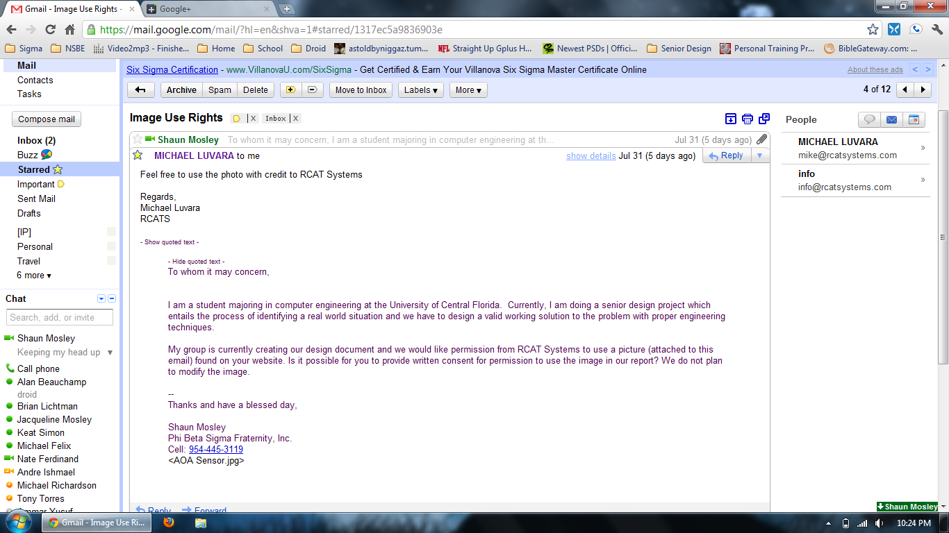

s
